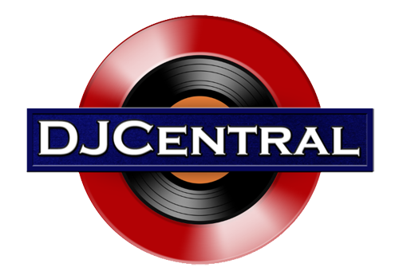
PRESS RELEASE - EFFECTIVE IMMEDIATELY – 11th July 2018

Barnacles and Stripes is now available on Amazon, go check it out!

********************************************************************************
Discover the Planet Blue Pictures Australian short film surfing hit Barnacles and Stripes. Barnacles and Stripes runs for 31 minutes, and features Taj Burrow, Mick Fanning, Brett Hardy, Lockie Caldwell, Shaun Green (of "Drift" fame), Jerome Forrest, Matt Baldock, Jacob Willcox and many more talented surfers.
As you watch, you can get on board with some of Western Australia's best surfers. Barnacles and Stripes is the first surf film from director, editor and producer, Carsten Reimers. This classic surf experience sees Western Australia’s best surfers tackle the state’s most exciting waves.
The film lets you get up and close with the surfers. The movie defines Western Australia as one of the world’s most famous surf destinations. It offers non-surfers a sneak peek in to the surf culture and is guaranteed to get surfers of all ages pumped for their next session!
Don’t wait any more and go for it, to watch it or for more information you can use the following links:
- Planet Blue Pictures: https://bit.ly/2KAHDky
- Website: www.barnaclesandstripes.com
- Amazon: https://amzn.to/2DY6t6M
********************************************************************************

ABOUT DJ CENTRAL:
DJ CENTRAL TV is a global dance and house music TV show that features lifestyle segments on all things youth, club, dance, and house music culture. The show brings the global clubbing nightlife to your TV screens, mobile phones and tablets.
DJ Central is now broadcast to over 20 countries around the world.
Hosted by a dynamic team along with a cast of industry names and artists from all over the world, each season brings you the latest in dance and house music. The show features fashion interviews with celebrities from film to music to sport. DJ Central brings you our own unique Australian feel with a complete multicultural vibe for you and the EDM music world to enjoy.
For more information, visit the official DJ Central website: www.djcentral.tv
********************************************************************************
Contact:

Press and Media Manager
DJ Central ASIA Ltd
Unit 6 No 9 Clarence Street
Moss Vale, NSW 2577
Australia
P: + 61 2 9310 0155
F: +61 2 9310 0166
W: www.djcentral.tv
E: sales@djcentral.tv
********************************************************************************

