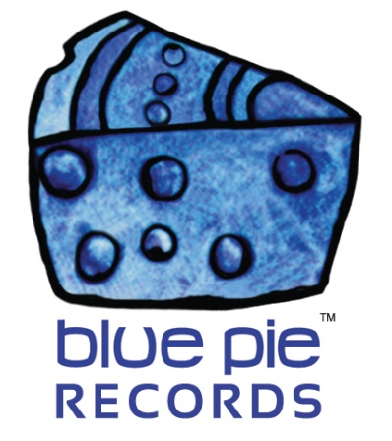
PRESS RELEASE - EFFECTIVE IMMEDIATELY – 03 July 2018

Don’t miss the movie “The Makeover”, now available on Amazon.
********************************************************************************
The Makeover is a 2009 movie written and directed by Colm O’Murchu (Dealing with Destiny), produced and distributed by Planet Blue Pictures US and starring Martin Dingle Wall, best known as Flynn Saunders in Home and Away, Lara Cox and Jeff Gannon.
This comedy and romance movie is about socially challenged man Rodger Keaton. Rodger is a typical white computer nerd and desperate for love. Patricia Bartlett is a ruthless award-winning journalist who has found her man. Brad Holloway is Hollywood’s makeover Guru, but he is facing huge obstacles and is blackmailed by the threat of bad publicity. There is only one solution for Brad- a "mission impossible" makeover, and he must prove with substantial results that his Ultimate Makeover Services are the 'Real Deal'. He must completely change Rodger. For the next 6 weeks, they are going to leave their comfort zones on a journey that is foreign even to Brad.
However, with his short deadline can Brad manage to create a true change? Is it even possible? Join Rodger and Brad on this roller coaster of fear, anxiety, disaster, celebration, discovery, reinvention and hope, with hilarious and heartwarming results at every turn.
Enjoy this movie, now on Amazon. To watch it or for more information you can use the following links:
- Planet Blue Pictures: https://bit.ly/2tMukUI
- Amazon: https://amzn.to/2Nm6LKn

********************************************************************************

ABOUT BLUE PIE THE RECORD LABEL:
Blue Pie Records are one of the world’s leading independent record Labels and publishing houses. Blue Pie's priority artists include Josh Young, Toyanna Rae, Missy Crissy, Raz B, Down3r, LadyDice, The East Side Boyz, Jah Mason, Burning the Day, Jack Derwin, Terry Oldfield, Phil Manzanera, Johnny Bennett, Suzanna Lubrano, The Objex, Gordon Waller, Dave Evans, Dale Bozzio, and Jessy Tomsko to name a few.
Blue Pie distributes over 300 smalls to medium sized labels including e ConcertHouse Music, TRAX Records, Destiny Records, Apple Media Africa, Nedjon Entertainment, Idyllium Muisc, Sugo Music, Deluxe Records, Reality Entertainment, and Raz Beatz Media Group to name a few.
Our live concert and video clip library continues to expand and includes live albums, video clips, and video concerts from artists including, Chicago, The Cars, Steve Aoki and Dave Evans for instance.
In 2018, Blue Pie's roster of artists continues to gain worldwide recognition with chart success in the USA, Canada, Europe and Australia. Blue Pie is continually developing new markets for our artists, labels, content partners to connect and reach new consumers and fans for their music.

For more information, visit the official Blue Pie Records USA website: www.bluepierecords.com

********************************************************************************
Press and Media Contact:

Press and Media Manager
Blue Pie Records USA
Unit 6 No 9 Clarence Street
Moss Vale, NSW 2577
Australia
P: + 61 2 9310 0155
F: +61 2 9310 0166
W: www.bluepierecords.com
E: pr@bluepie.com.au

********************************************************************************

