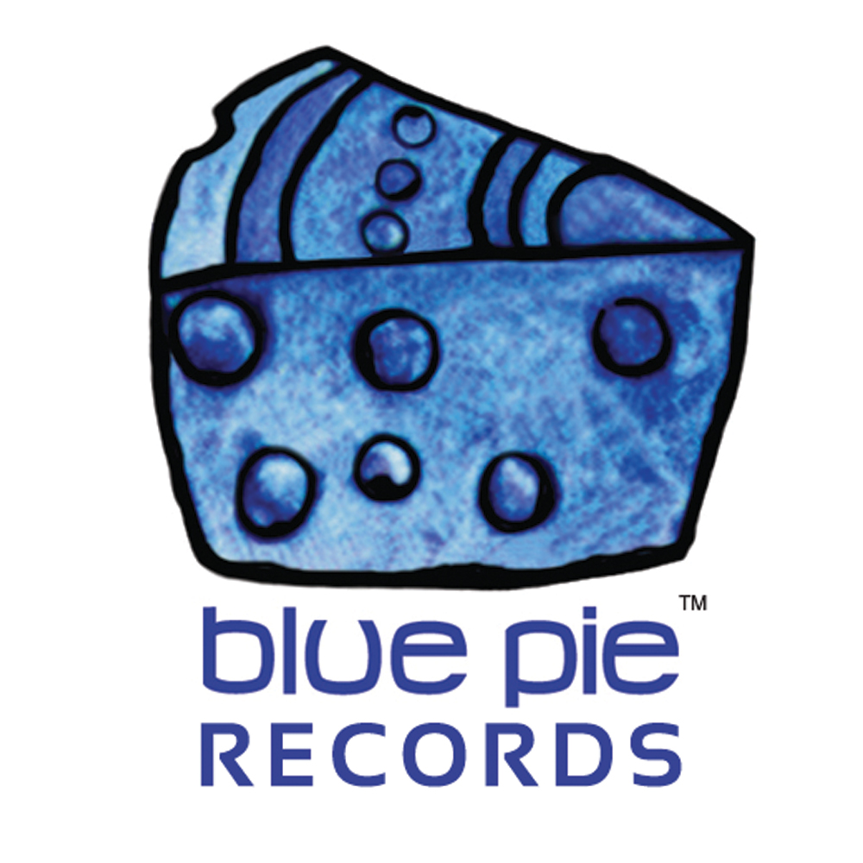
PRESS RELEASE - EFFECTIVE IMMEDIATELY – 15th May 2012
BLUE PIE LICENSE TEAM EXPANDING GLOBALLY WITH NEW FILMS and LICENSE PLACEMENTS COMPLETED
The Blue Pie Film and TV license team go into overdrive. Blue Pie's man on the ground in New York " Mr Joseph Miller Esq " has been very busy in the past month with seeking out tracks from the Blue Pie roster and catalogues for 6 new indie films. The films include:

“Last Night With the Boys” – This picture is set to be circuited around small local and regional festivals and seeking tracks to fulfil dive-bar rock cues, “Parallel Lives” – To be released via international circuits, DVD and online formats. Seeking country themed bar cues among other various sound designs, “Promise Land” – This picture is promised a huge Chicago reception, and should also do some complete some U.S.A interstate circuits. Seeking dance-pop with Hindi/Urdu lyrics tracks, “Plastic Heart” – Feature is seeking hipster rock, pop, dance, electro, synth-pop, indie and alternative cues, “Bad Parents” – an independent feature with a casting list of some of the top B-list actors is searching for temp tracks to replace a rocky theme, classical over-tunes, quirky fun pop, AND, “Untitled New Mexico” (independent short thesis project) – searching for 1 possible cue at this time, details to be advised.

Blue Pie is constantly expanding our license team and securing placements into Games, Films, TV Shows, Advertising and Corporate license sales. With partnerships now in place with companies like Planet Blue Pictures, Mango Reel, Rumblefish, Song Catalog and Music Supervisor, Blue Pie is now generating more and more license sales for our artists and labels globally.

Stay tuned for a number of new direct to TV network and direct to Film Studio catalogue license placement agreements that will mean yet more opportunity for our artists and labels. If you would like to have your catalogue earning you more income then you need to talk to Blue Pie and our license team. Send an email to license@bluepie.com.au and make sure you include all your details and one of our team will get back to you with how to get your catalogue ingested into our systems.

************************************************************************
ABOUT BLUE PIE THE RECORD LABEL:
www.bluepierecords.com
Blue Pie, the record label, is one of Australia’s leading independent labels. Founded in the early 90’s by Damien Reilly, the label has a wide and diverse range of alliances, global partnerships and proprietary technology that it makes available to all the companies artists, labels and content partners. Blue Pie is proud to represent over 200 labels and over 2000 artists worldwide.

Blue Pie's artists include: Dave Evans (AC/DC), Phil Manzanera (Roxy Music), Peter Head, Headband, Tiny Tim, Sabrina Fustaire, Funky P, Suzanna Lubrano, Benjamin Hyatt, Tony Hatch (Grammy Winner), Serge Ermoll (ARIA WINNER), Dave Sharp, Dale Bozzio, Tommy Tutone, Peter & Gordon, Gordon Chambers (Grammy Winner), Barry Crocker & Janice Marie (Grammy Winner) Search on 'blue pie' in Google for more information.
************************************************************************

************************************************************************

Press and Media Contact Details:

Blue Pie Records USA LLC
Press and Media Manager
Unit 20 No 112 McEvoy Street
Alexandria NSW 2015
P: + 61 2 9310 0155
F: + 61 2 9310 0166
E: media@bluepie.com.au
W: www.bluepierecords.com

************************************************************************

