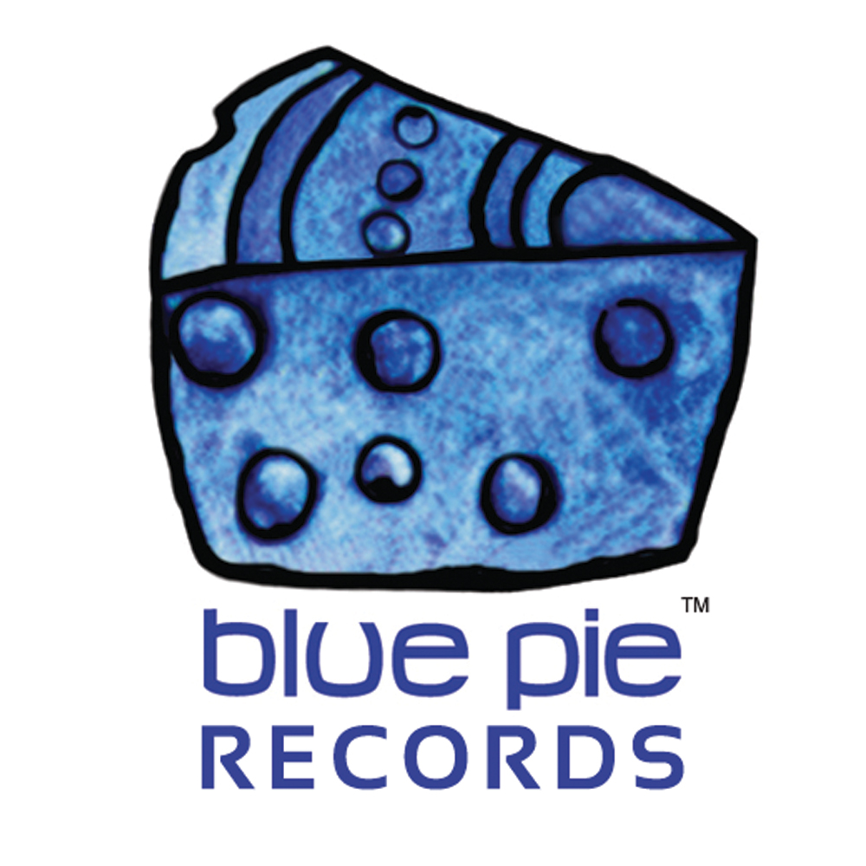

PRESS RELEASE - EFFECTIVE IMMEDIATELY – 4th May 2012
Sharp’s Jazzy Secret is 7 for the “World Jazz for the Jazz World”.
Dave Sharp’s Secret Seven is “World Jazz for the Jazz World”. With the new full length CD “7” charting for national radio airplay in the CMJ top 30, Secret Seven transcends musical, national, and ethnic boundaries by re-interpreting, non fusing, influences from Africa, Asia, the Latin world, Blue Note Jazz, and that other planet, New Orleans.
Secret Seven features Dave Sharp on electric & double bass, followed by Chris leading the tenor and soprano saxophones, along with Alex and Elden on the guitars, where Igor plays the Oud, which is all accompanied by “Chucho” and John on the drums and percussion.
Sharp leads a steady groove in laying down the foundation for the band’s irresistible melodies. He became devoted to Jazz at the University of Michigan and refined his chops under the tutelage of renowned bassist Herbie Lewis (McCoy Tyner, Cannonball Adderly, Les McCann) in San Francisco, and virtuoso bassist, composer and bandleader Marion Hayden (Straight Ahead) in Detroit. As bassist and composer for the modern jazz ensemble Spheres of Influence, and touring bassist for the seminal rock band The Melvins (Atlantic Records), Sharp has already made a mark on the national scene. Sharp lives in Ann Arbor, Michigan where he composes, records, teaches and performs.
Secret Seven performed their new album “7” live at The Kerrytown Concert House, October 28th 2011.
You can take a look their Hurricane Healing Project at www.youtube.com/sanware
For more information, including reviews, music and videos on Dave Sharp and the Secret Seven visit: www.airplaydirect.com/music/davesharpsecret7
All media and radio stations can download the album for FREE from Air Play Direct. To download all you need to do is to register and if you are a radio station, magazine or media house you will be able to get access to download a high quality 320 MP3 KBS file.
************************************************************************
ABOUT BLUE PIE THE RECORD LABEL:
www.bluepierecords.com
Blue Pie, the record label, is one of Australia’s leading independent labels. Founded in the early 90’s by Damien Reilly, the label has a wide and diverse range of alliances, global partnerships and proprietary technology that it makes available to all the companies artists, labels and content partners. Blue Pie is proud to represent over 200 labels and over 2000 artists worldwide.

Blue Pie's artists include: Dave Evans (AC/DC), Phil Manzanera (Roxy Music), Peter Head, Headband, Tiny Tim, Sabrina Fustaire, Funky P, Suzanna Lubrano, Benjamin Hyatt, Tony Hatch (Grammy Winner), Serge Ermoll (ARIA WINNER), Dave Sharp, Dale Bozzio, Tommy Tutone, Peter & Gordon, Gordon Chambers (Grammy Winner), Barry Crocker & Janice Marie (Grammy Winner) Search on 'blue pie' in Google for more information.
************************************************************************
Contact Details:

Press and Media Manager

Blue Pie Records USA LLC
Unit 20 No 112 McEvoy Street
Alexandria NSW 2015
P: + 61 2 9310 0155
F: + 61 2 9310 0166
E: media@bluepie.com.au
W: www.bluepierecords.com

************************************************************************

