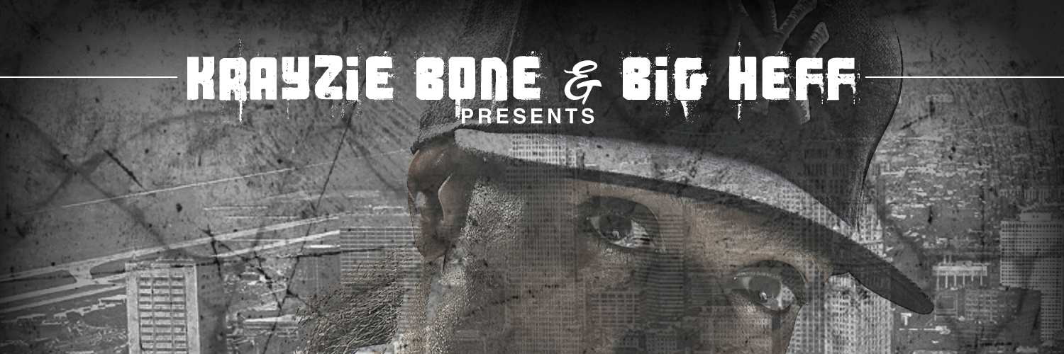
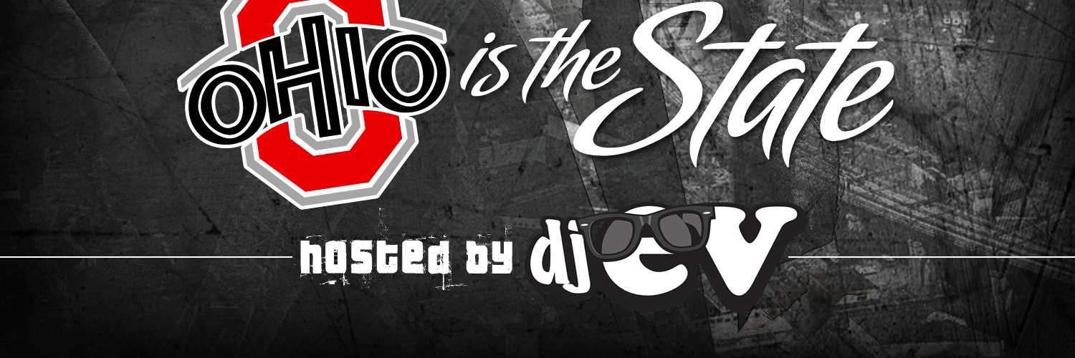

PRESS RELEASE - EFFECTIVE IMMEDIATELY – 4th April 2012

Krayzie Bone and Big Heff presents “Cleveland is the City Ohio is the State”

Krayzie Bone & Big Heff presents the long awaited project that features the members of Bone Thugs & Harmony with a host of rising talent from Ohio that includes Machine Gun Kelly, Chip Da Ripper, Ray Jr, Young Butta & more. They also recruited nationally known Kiss FM Dj E-V to host the project.

The goal of the project was to shed a national spotlight on Ohio Music and the new generation of artist. Krayzie Bone and Big Heff wanting to highlight the indie as well as major talent reaching out to surrounding area artist for the compilation “Cleveland is the City Ohio is the State” project leads off with the anticipated collaboration of Krayzie Bone and Ray Cash with the single “Go Dumb”.

This is a first time collaboration between Bone Thugs N Harmony and Ray Cash. Other highlights include the single “Sloppy” featuring rising stars Machine Gun Kelly and Ray Jr. and Krayzie Bone. Bone Thug N Haromy member Lazy Bone appears with Caine and Thin C on the melodic “Thugs Gone Hold You Down” and Bizzy Bone appears with Dayton artist “Jason D.B.K.S” on the street anthem “You Can’t Tell Me Nothing”.
Diversity strikes the album when Krayzie Bone recruits pop and rock hitmakers “Iphonic and Aaron Lafatte” on the hit records “Pain and Shut It Down”. The infectious street rage anthem entitled “Police” featuring Pooh Gutta and Machine Gun Kelly reminds Krayzie Bone of NWA founder and Bone Thugs N Harmony mentor Eazy E.

The release of this compilation bridged many gaps in Ohio Music from city to city and showed how a team effort can create and recreate hits! Together Krayzie Bone and Big Heff successfully showed love and bridged the gap in Ohio Music with the iconic release of “Cleveland is the City Ohio is the State”.

The Project Drops Feb 13th, 2012
Twitter pages: @iamKrayzieBone, @raycash_216, @BigHeff, @DjEV

Krayzie Bone & Ray Cash: New Video
“Go Dumb”
1. www.youtube.com/watch?v=2T_mmvTQwig
2. www.vimeo.com/34780091
************************************************************************
ABOUT BLUE PIE THE RECORD LABEL:

www.bluepierecords.com

Blue Pie, the record label, is one of Australia’s leading independent labels. Founded in the early 90’s by Damien Reilly, the label has a wide and diverse range of alliances, global partnerships and proprietary technology that it makes available to all the companies artists, labels and content partners. Blue Pie is proud to represent over 200 labels and over 2000 artists worldwide.

Blue Pie's artists include: Dave Evans (AC/DC), Phil Manzanera (Roxy Music), Peter Head, Headband, Tiny Tim, Sabrina Fustaire, Funky P, Suzanna Lubrano, Benjamin Hyatt, Tony Hatch (Grammy Winner), Serge Ermoll (ARIA WINNER), Dave Sharp, Dale Bozzio, Tommy Tutone, Peter & Gordon, Gordon Chambers (Grammy Winner), Barry Crocker & Janice Marie (Grammy Winner)
Search on 'blue pie' in Google for more information.

************************************************************************
Contact Details:
Quincy “Big Heff” Taylor
Director

Beyond Stars Entertainment USA
E: media@bluepie.com.au
W: www.beyondstarsent.com
P: +1 (216)632-0678

Press and Media Manager

Blue Pie Records USA LLC
Press and Media Manager
Unit 20 No 112 McEvoy Street
Alexandria NSW 2015
P: + 61 2 9310 0155
F: + 61 2 9310 0166
E: media@bluepie.com.au
W: www.bluepierecords.com

************************************************************************

