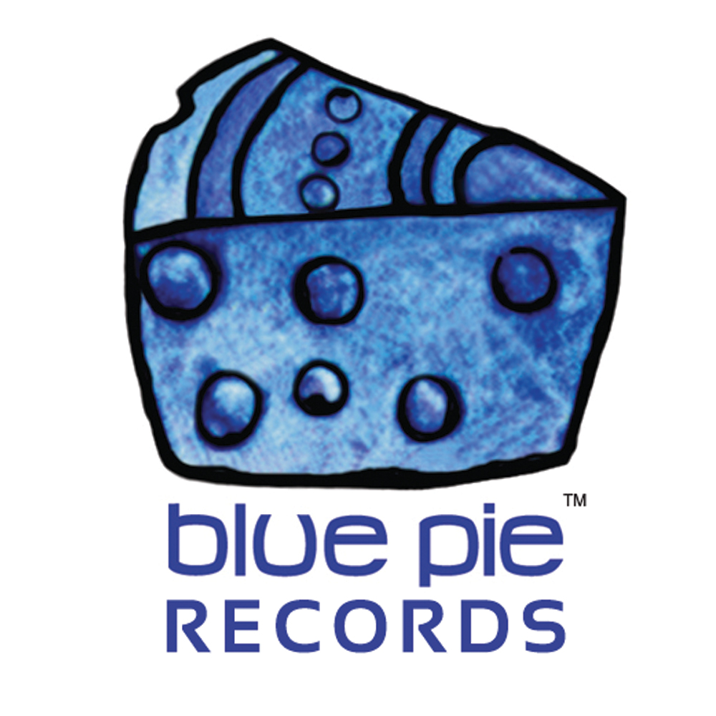


PRESS RELEASE - EFFECTIVE IMMEDIATELY – 4th May 2012
************************************************************************
Experience a fresh approach to the Americana/roots rock genre with the self-titled debut EP by The American Strays.
Suzanna Kennedy, singer/songwriter and drummer/songwriter, Matt Horner have created an uprooted form of music, straight from the rustic soil, where Americana/roots rock music is planted, while always searching for fertile ground, to create music without borders.

Matt met Suzanna when he was searching for a female voice to sing his songs. He was captured by her unique sound as he heard her sing John Prine’s “Angel from Montgomery”. He introduced himself, and since then they’ve been tethered at the souls, writing and playing music together in one incarnation or another.

Suzanna and Matt are currently working with the band, promoting their 6-song EP, and working on new songs. They have teamed up with California producer Scott Mathews, to create a novel Americana/roots rock mix with crossover appeal. Scott assisted by playing several of the instruments on the EP and has worked with many noteworthy artists such as Bonnie Raitt, Elvis Costello, Roseanne Cash, and many more.

Scott’s method showcased a stylized Americana/roots rock mix, using everything from a dulcimer to a sitar to even layering an on-the-spot, classical radio broadcast into their third track “Bound”, stamping each song with its own identity, centered by Kennedy’s distinct, bold vocals. “There is a unique vocal persona happening here that really stands out in the huge crowd of female singers,” again says A&R man Ted Myers.

If you want a little more style and punch from your Americana/roots rock music, then check out the new 6-song EP from The American Strays. The EP is just a cross section of what they can do, so look for more from them in 2012.

The American Strays are distributed to the world digitally by Blue Pie Records.

For more information, including reviews, music and clips visit: www.theamericanstrays.com

************************************************************************

************************************************************************

ABOUT BLUE PIE THE RECORD LABEL:

www.bluepierecords.com

Blue Pie, the record label, is one of Australia’s leading independent labels. Founded in the early 90’s by Damien Reilly, the label has a wide and diverse range of alliances, global partnerships and proprietary technology that it makes available to all the companies artists, labels and content partners. Blue Pie is proud to represent over 200 labels and over 2000 artists worldwide.

Blue Pie's artists include: Dave Evans (AC/DC), Phil Manzanera (Roxy Music), Peter Head, Headband, Tiny Tim, Sabrina Fustaire, Funky P, Suzanna Lubrano, Benjamin Hyatt, Tony Hatch (Grammy Winner), Serge Ermoll (ARIA WINNER), Dave Sharp, Dale Bozzio, Tommy Tutone, Peter & Gordon, Gordon Chambers (Grammy Winner), Barry Crocker & Janice Marie (Grammy Winner) Search on 'blue pie' in Google for more information.
************************************************************************
Contact Details:

Blue Pie Records USA LLC
Press and Media Manager
Unit 20 No 112 McEvoy Street
Alexandria NSW 2015
P: + 61 2 9310 0155
F: + 61 2 9310 0166
E: media@bluepie.com.au
W: www.bluepierecords.com

************************************************************************

