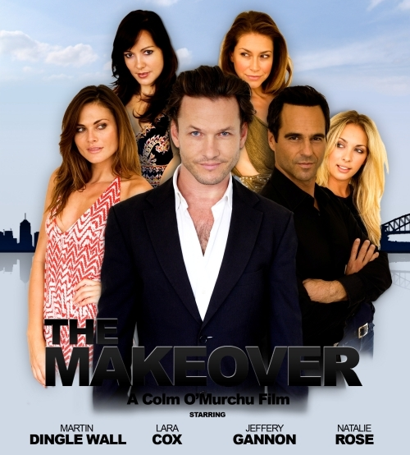

PRESS RELEASE - EFFECTIVE IMMEDIATELY – 4th April 2012

The Makeover

Blue Pie Productions are proud to announce that they will soon be involved in the distribution of the new Indie Australia Comedy “The Makeover”.

“The Makeover Moive” is the story of Brad Holloway, a Hollywood makeover guru who has just found his greatest challenge in that of Roger Keaton; a socially challenged, clinically frigid, computer nerd looking to find love. In order to save his reputation Brad must find a way to rise to the challenge and transform Roger into the perfect man, all whilst hoping that his own girlfriend finds the way to resist the charms of the new and improved Roger.

Follow Roger on his hilarious journey of fear, celebration, and re-invention combined with a soirée of hilarious dance moves made in the midst of some of Sydney’s hottest night clubs

Staring Martin Dingle Wall (“Home and Away”), Lara Cox (Heartbreak Hight”) and Jeff Gannon (Bondi Confessions), brought to you by award winning Director Colm O’Murchu, director of “The Elixir”.

The film will soon be distributed on sites such as:
- www.itunes.apple.com
- www.amazon.com
- www.netflix.com

And will also be made available on all Free To Air Networks aired around the world.
www.themakeovermovie.com

Language: English
Running Time: 91 minutes
Genre: Comedy
View Trailer: www.youtube.com/watch?v=AsjuIgl7tZ4

************************************************************************

ABOUT BLUE PIE THE RECORD LABEL:
www.bluepierecords.com

Blue Pie, the record label, is one of Australia’s leading independent labels. Founded in the early 90’s by Damien Reilly, the label has a wide and diverse range of alliances, global partnerships and proprietary technology that it makes available to all the companies artists, labels and content partners. Blue Pie is proud to represent over 200 labels and over 2000 artists worldwide.

Blue Pie's artists include: Dave Evans (AC/DC), Phil Manzanera (Roxy Music), Peter Head, Headband, Tiny Tim, Sabrina Fustaire, Funky P, Suzanna Lubrano, Benjamin Hyatt, Tony Hatch (Grammy Winner), Serge Ermoll (ARIA WINNER), Dave Sharp, Dale Bozzio, Tommy Tutone, Peter & Gordon, Gordon Chambers (Grammy Winner), Barry Crocker & Janice Marie (Grammy Winner)
Search on 'blue pie' in Google for more information.

************************************************************************
Contact Details:

Press and Media Manager

Blue Pie Records USA LLC
Press and Media Manager
Unit 20 No 112 McEvoy Street
Alexandria NSW 2015
P: + 61 2 9310 0155
F: + 61 2 9310 0166
E: media@bluepie.com.au
W: www.bluepierecords.com

************************************************************************

