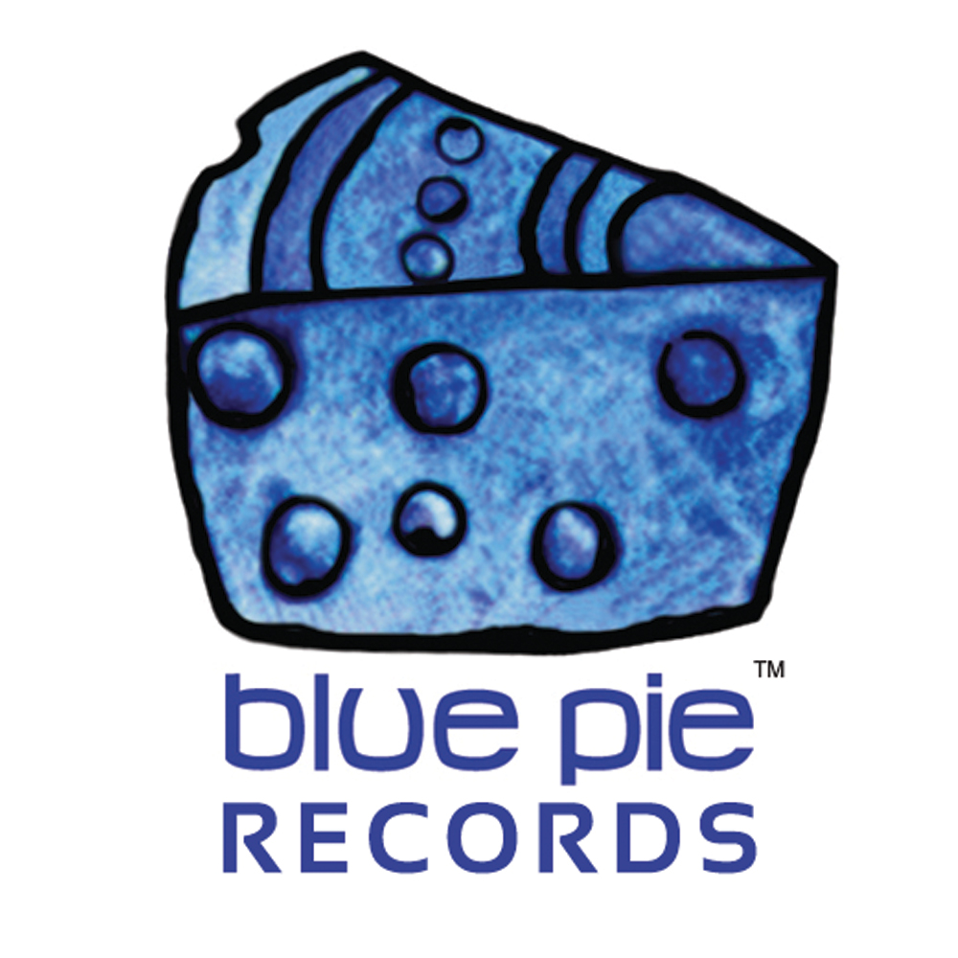


PRESS RELEASE - EFFECTIVE IMMEDIATELY – 4th April 2012

Lethal Objextion
Punk-rock band The Objex were formed in Janurary of 2006 in Las Vegas, under the vicious, sexy and soulful voice of Felony Melony, aka black American Gwen Stefani. Joined on stage by Aly 2x on bass, Jim Nasty on guitars and their new South American addition, Chile on drums.

They have come along way after their release of their first record, “Attack of the Objex” in January 2007, with many packed out shows and tours as well as successfully pushing through the loss of a band member back in May 2008, who left to pursue other interests.

They have just released their new film clip to their new single “Lethal Lips” which displays humorous, yet twisted and freaky visuals. It stars Melony as a murderous lesbian killing off the people that surround her in such a way that it becomes quite viciously humorous. Definitely not one for the kids to see, but it’s still entertaining!

Click here to view the clip: www.youtube.com/lethal lips
The Objex are currently putting the finishing touches on their upcoming album “Super Charged Lil Nova”. Due out in spring 2012
For more information, including reviews, music and videos on The Objex visit:
www.myspace.com/objexlv
************************************************************************

ABOUT BLUE PIE THE RECORD LABEL:
www.bluepierecords.com
Blue Pie, the record label, is one of Australia’s leading independent labels. Founded in the early 90’s by Damien Reilly, the label has a wide and diverse range of alliances, global partnerships and proprietary technology that it makes available to all the companies artists, labels and content partners. Blue Pie is proud to represent over 200 labels and over 2000 artists worldwide.
Blue Pie's artists include: Dave Evans (AC/DC), Phil Manzanera (Roxy Music), Peter Head, Headband, Tiny Tim, Sabrina Fustaire, Funky P, Suzanna Lubrano, Benjamin Hyatt, Tony Hatch (Grammy Winner), Serge Ermoll (ARIA WINNER), Dave Sharp, Dale Bozzio, Tommy Tutone, Peter & Gordon, Gordon Chambers (Grammy Winner), Barry Crocker & Janice Marie (Grammy Winner)
Search on 'blue pie' in Google for more information.

************************************************************************
Contact Details:

Press and Media Manager

Blue Pie Records USA LLC
Press and Media Manager
Unit 20 No 112 McEvoy Street
Alexandria NSW 2015
P: + 61 2 9310 0155
F: + 61 2 9310 0166
E: media@bluepie.com.au
W: www.bluepierecords.com
*********************************************************************

