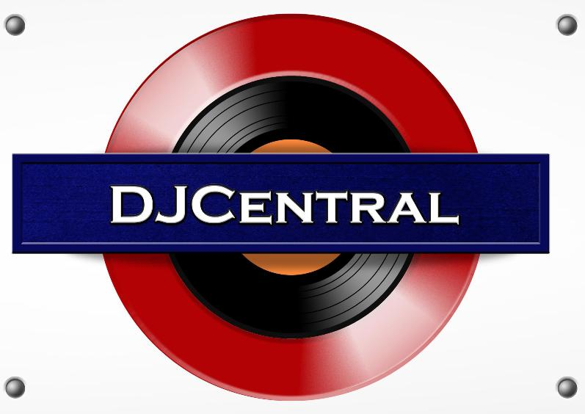
PRESS RELEASE - EFFECTIVE IMMEDIATELY – 24 NOVEMBER 2012

LUCINDA NICHOLAS JOINS THE DJ CENTRAL TEAM!

DJ Central are excited to announce Lucinda Nicholas as the newest Compare to join our team!

Lucinda will be working along side Producer, Simon Smithers, and fellow Presenters, Mitch, Desiree and Penny!

Lucinda Nicholas has been modeling since the age of 17 and was a finalist in Miss Universe Australia, 2011. Since then she has been taking on the challenges of a new passion – Presenting! The role embodied the foundations of each area she was working in; researching, talking to people, not being afraid of the camera and representing herself as a business.

The production team cannot wait to see what Lucinda will bring to DJ Central, and work with her on the upcoming shoots, so be sure to look out for her debut on the show!

For more information on Lucinda Nicholas and DJ Central, check out the Official Website: www.djcentral.tv

********************************************************************************
ABOUT DJ CENTRAL:
DJ CENTRAL TV is a new and exciting global dance and house music TV show that features lifestyle segments on all things youth, club, dance, and house music culture, bringing Sydney’s clubbing nightlife to your TV screens on FOXTEL’s heralded Aurora Channel.

Hosted by the dynamic team along with a cast of industry names and artists from all over the world, each week they’ll bring you the latest in dance and house music as well as featuring fashion interviews with celebrities from film to music and sport and bringing our own unique Australian feel to the world of dance and house music.

The shows format is built around a local club that we have selected that we feel represents the best of all the things that the show stands for. We will have segments on the venue itself, the latest music video clips, club competitions and promos, and even a latest news segment keeping you up to date with all the latest gossip in the DJ Club scene.
For more information, visit the DJ Central website: www.djcentral.tv, Word Press Blog: www.djcentralmusic.wordpress.com or Facebook page: www.facebook.com/djcentralmusic

