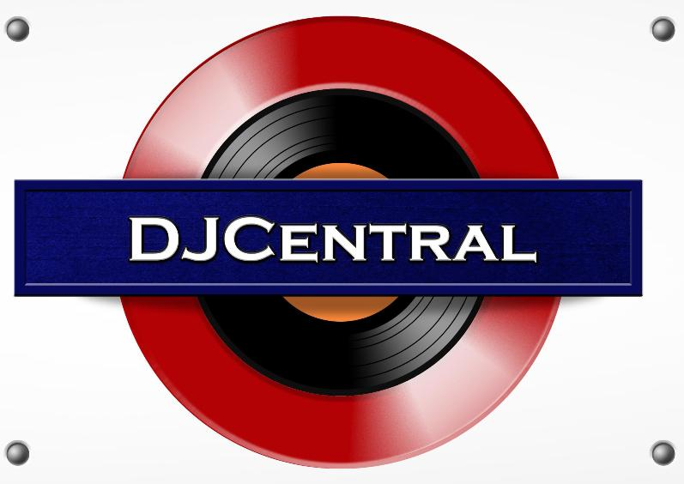
PRESS RELEASE - EFFECTIVE IMMEDIATELY – 07 DECEMBER 2012

DJ MISS TOKIO JOINS THE DJ CENTRAL TEAM!

DJ Central are excited to announce the latest addition to our team of presenters, DJ Miss Tokio also known as Swee Ling Khor. After being introduced to the art of beat mixing, Swee got stuck into performance with guest DJ spots in some of Sydney’s hottest clubs.

Since then, she has performed at a variety of recognised spots, both within Australia and internationally, including the Crows Nest Hotel, Peppermint Lounge, Blue Horizon (Shangri-La Hotel), Social Sundays @ The Roxy, Cruise Bar, VBar, Golden Palace Hotel (Coogee Beach) and more. For 3 years running Miss Tokio has played at the notoriously infamous rave in Sydney, Transmission. Making appearances at Gas Nightclub, Lost at Space Club, AKA Night Club, Candy Shop in Cabramatta, Candy's Apartment, Soho Bar, Verandah Bar, Watershed, Cohi Bar, Kobe Jones.

Swee has two upcoming shows at Sapphire Lounge in Kings Cross on the 14th and the 28th of December, where she will be tearing up the dance floor with her beat-drops!

DJ Miss Tokio's first music video of her track 'I Do What I Do' is out now on YouTube for the world! Check it out and expect more original material coming soon!

DJ Miss Tokio is exciting to be working with DJ Central, mixing her performance experience with presenting to create an explosive mix.

For more information on DJ Miss Tokio, be sure to check out her Official Website www.djmisstokio.com and www.djcentral.tv

********************************************************************************
ABOUT DJ CENTRAL:
DJ CENTRAL TV is a new and exciting global dance and house music TV show that features lifestyle segments on all things youth, club, dance, and house music culture, bringing Sydney’s clubbing nightlife to your TV screens on FOXTEL’s heralded Aurora Channel.

Hosted by the dynamic team along with a cast of industry names and artists from all over the world, each week they’ll bring you the latest in dance and house music as well as featuring fashion interviews with celebrities from film to music and sport and bringing our own unique Australian feel to the world of dance and house music.

The shows format is built around a local club that we have selected that we feel represents the best of all the things that the show stands for. We will have segments on the venue itself, the latest music video clips, club competitions and promos, and even a latest news segment keeping you up to date with all the latest gossip in the DJ Club scene.
For more information, visit the DJ Central website: www.djcentral.tv, Word Press Blog: www.djcentralmusic.wordpress.com or Facebook page: www.facebook.com/djcentralmusic

