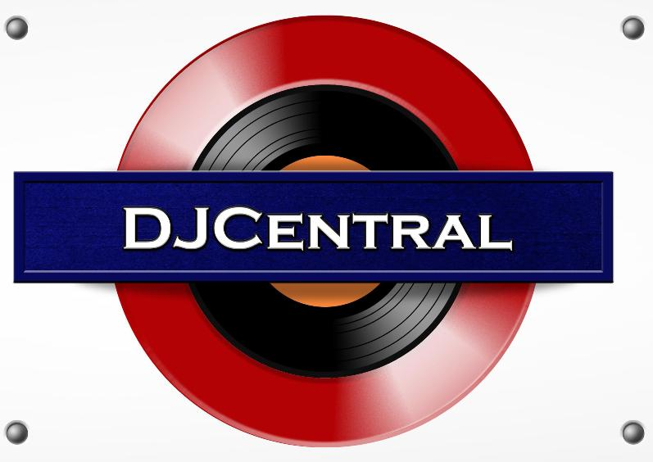
PRESS RELEASE - EFFECTIVE IMMEDIATELY – 15th DECEMBER 2012

DJ CENTRAL KICKS INTO OVERDRIVE AS VIEWERS TUNE IN TO WATCH THE SHOW FROM ALL OVER THE WORLD!
The popularity of DJ Central’s new show has been rapidly growing over the past 60 days. Foxtel viewers have tripled as the show continues to gain mainstream attention on all the Free 2 Air networks.
The show is increasing viewers each week due to the content programming and the feature segments on the hottest events and clubs that get showcased each week cut with hot new and emerging dance, house, club music as well and DJ sets from artists like “DJ Diamond” and “Tiesto”.
Up to 100,000 viewers now tune in each week to get all the new clips and news from DJ Central on Friday nights on FOXTEL’s Channel 183 on the Aurora Network. The program is now broadcast three times a week on the Aurora Network due to the growing recognition and positive responses to the show.
Social Media fanatics across the globe have been logging in for the latest news on festivals, artists and gossip within the dance and house music culture! Join the conversation through our Social Media pages including, Twitter, Facebook, Tumblr, Wordpress and more!
The show is being syndicated into the UK, USA, Canada and key markets in ASIA in 2013. For more information on DJ Central, be sure to check out the Official Website!

********************************************************************************
ABOUT DJ CENTRAL:
DJ CENTRAL TV is a new and exciting global dance and house music TV show that features lifestyle segments on all things youth, club, dance, and house music culture, bringing the global clubbing nightlife to your TV screens on FOXTEL’s heralded Aurora Channel 183.

Hosted by the dynamic team along with a cast of industry names and artists from all over the world, each week they’ll bring you the latest in dance and house music as well as featuring fashion interviews with celebrities from film to music and sport and bringing our own unique Australian feel to the world of dance and house music.

The shows format is built around a local club that we have selected that we feel represents the best of all the things that the show stands for. We will have segments on the venue itself, the latest music video clips, club competitions and promos, and even a latest news segment keeping you up to date with all the latest gossip in the DJ Club scene.
For more information, visit the DJ Central website: www.djcentral.tv, Word Press Blog: www.djcentralmusic.wordpress.com or Facebook page: www.facebook.com/djcentralmusic

CONTACT:

Alisha Frittmann
Press and Media Manager
DJ Central Hong Kong Ltd
C/O Expo112 Unit 20
No 112 McEvoy Street
Alexandria NSW 2013
AUSTRALIA
P: + 61 2 9310 0155
F: +61 2 9310 0166
W: www.djcentral.tv
E: sales@djcentral.tv

