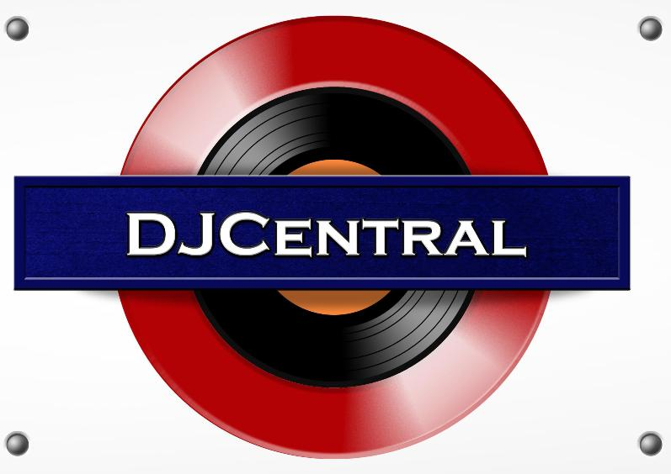
PRESS RELEASE - EFFECTIVE IMMEDIATELY – 19th JANUARY 2013

Australia Loves DJ Central TV!

Australia has spoken and the word is “Australia Loves DJ Central”. With the help of Foxtel, the producers, Blue Pie and Simon Smithers, DJ Central cures the overwhelming and crushing need that creeps its way into every true clubbers heart for all of information on the hottest music and clubbing havens.
As the go to for any curious cats looking to score the mother-load on updates, news, events, fads and hottest artists out in Sydney’s club/dance/electro and house music culture; Its former presenters, Trent Peppercorn, Aprille Love and current hosts Mitch, Desiree, Lucinda, Penny and Swee, focus on the latest video clips, interview much loved artists and DJ’s and delve into all the sordid music gossip and news.
DJ Central has landed interviews with the likes of Sneaky Sound System, Tim-O-Matic, DJ Mel and Justice Crew , Steve Aoki, covered the ARIA nomination party, created 7 compilation CD’s which are available for purchase on iTunes (search: DJ Central) and increased the website traffic by 400% in December alone.
Airing on Foxtel’s Aurora (channel 183), the network has had the biggest single night of viewers ever by running 5 episodes back to back on New Year’s Eve. Cheers Aurora!!! We love you.
The show enjoys such positive responses from our fans that they have spawned the demand for Aurora to now broadcast DJ Central twice a week; Fridays at 9pm and re-runs on Sundays 5am. On top of that, the growth in popularity of the program continually expands as its viewers reach up to 100,000 each week and social media fanatics across the globe log in to our online networks for the latest scoops in the dance/electro world.
This amazing effort into the creation and achievement of DJ Central does not belong to Blue Pie alone, the comperes, the great production skills of Simon Smithers, Damien Reilly and the Blue Pie Production team have also helped to make this show a global hit!
We would like to thank all the Record labels working in collaboration with the company including, Xelon Entertainment, Subsonic Records, ConcertMusic House and Blue Pie. Their support has allowed DJ Central to thrive beyond our wildest dreams!

It is an exciting future unfolding ahead for all of us at DJ Central and we send a high note of thanks to every single supporter, fan, raver, goat and ghost tuning in and chilling with our new presenters, Swee, Lucinda, Desiree, Mitch and Penny as we take over the air waves where ever we can and bring the best of new club house dance music to the world for you to enjoy!
So, be sure to visit our website at www.DJcentral.tv and take a look for yourself!
********************************************************************************
ABOUT DJ CENTRAL:
DJ CENTRAL TV is a new and exciting global dance and house music TV show that features lifestyle segments on all things youth, club, dance, and house music culture, bringing the global clubbing nightlife to your TV screens on FOXTEL’s heralded Aurora Channel 183.

Hosted by the dynamic team along with a cast of industry names and artists from all over the world, each week they’ll bring you the latest in dance and house music as well as featuring fashion interviews with celebrities from film to music and sport and bringing our own unique Australian feel to the world of dance and house music.

The shows format is built around a local club that we have selected that we feel represents the best of all the things that the show stands for. We will have segments on the venue itself, the latest music video clips, club competitions and promos, and even a latest news segment keeping you up to date with all the latest gossip in the DJ Club scene.
For more information, visit the DJ Central sites:
www.djcentral.tv,
www.djcentralmusic.wordpress.com
www.facebook.com/djcentralmusic
***END***
********************************************************
CONTACT:

Press and Media Manager
DJ Central Hong Kong Ltd
C/O Expo112 Unit 20
No 112 McEvoy Street
Alexandria NSW 2013
AUSTRALIA
P: + 61 2 9310 0155
F: +61 2 9310 0166
W: www.djcentral.tv
E: sales@djcentral.tv

