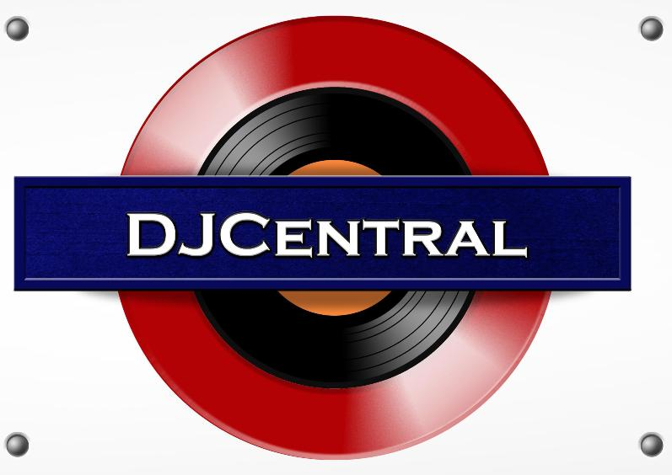
PRESS RELEASE - EFFECTIVE IMMEDIATELY – 12th FEBRUARY 2013

DIDGE ON FIRE ARE DOING AUSSIES PROUD!

‘Didge On Fire’ have become regulars on television show DJ Central, with their single ‘Didge On Fire’ featured in a number of episodes. This is a huge feat for the guys, as DJ Central reaches homes right across the world. ‘Didge On Fire’ has been causing quite a stir, receiving love and fame from fans around the globe who are suggesting the song, “be an Australian anthem”, and rightly so.

The video for their song ‘Didge On Fire’ takes you on both a spiritual and imaginative journey; discussing traditional Australian culture and themes. They make reference to the Aboriginal Dreamtime and heritage, the ever changing Australian climate and opening our hearts to bring people together. The song features the use of traditional Aboriginal instruments and vocals and the video extends the use of our cultural heritage, featuring Aboriginal dancers performing around the band on a coastal rock pool platform.

With such a wonderful representation of Australian beauty and culture, ‘Didge On Fire’ is an iconic song with massive tourism potential. It has already been used in the independent Australian film ‘The argues: The Move’, however, Blue Pie would like to see more of Didge On Fire’s music used in movies, documentaries and advertising. Blue Pie will be talking to numerous agencies to ensure this happens, so stay posted!

For more information on ‘Didge On Fire’, visit their official Myspace page:
www.myspace.com/didgeonfire

********************************************************************************

ABOUT DIDGE ON FIRE:

Didge On Fire are a concept indigenous Australian dance act emerging from the sun drenched land of Queensland Australia and spread from Sydney to Byron Bay to the Gold Coast. The band brings together Mark Hembrow, Russell Dawson and Thai Scouller AKA Tyz into one powerhouse package. The band have already created a stir with their super-hot debut single and self-titled debut called "Didge On Fire" with their lead track from this EP being also called "Didge On Fire" as their first single. This song has been licensed to a leading Australian independent film called "The Argues: The Movie".

Their debut EP was produced by legendary "Pommy Bastard" Steve James who was ARIA Producer of the year for 2000 and ARIA Engineer of the year in 2000. Steve has worked with some of the biggest names in the business including: Richard Clapton, The Screaming Jets, Cold Chisel, Monty Python and a list of credits far too long to mention. Steve has brought his distinctive talents to the production on Didge On Fire's debut release and it is smokin' hot.

Didge On Fire are a highly focused band with an extensive past history in music and film. The band brings together two vocalists with Mark Hembrow on lead and Thai Scouller AKA Tyz on the mic for the magical words of peace and harmony with this nonstop rap influences taking the band into a more cross over urban dance genre. The band also collaborates with two gurus of musical love from Byron Bay, Fergo and Shay. They know who they are and you will soon find out ….check the bands website site for details.

Didge On Fire are producers of highly infectious dance pop that is sure to have all that hear their sounds start tapping their feet and take them straight to the dance floor to stomp out their tribal love dance with their friends and partners. With a message of peace, love and conciliation as their fundamental motto, this electro pop dance outfit is now gaining rapid attention worldwide.
Check out their website for the latest news and information on "Didge On Fire" or visit their MySpace Page: www.didgeonfire.com + www.myspace.com/didgeonfire

Didge On Fire are distributed digitally to the world by Blue Pie.

********************************************************************************
ABOUT DJ CENTRAL:
DJ CENTRAL TV is a new and exciting global dance and house music TV show that features lifestyle segments on all things youth, club, dance, and house music culture, bringing the global clubbing nightlife to your TV screens on FOXTEL’s heralded Aurora Channel 183.

Hosted by the dynamic team along with a cast of industry names and artists from all over the world, each week they’ll bring you the latest in dance and house music as well as featuring fashion interviews with celebrities from film to music and sport and bringing our own unique Australian feel to the world of dance and house music.

The shows format is built around a local club that we have selected that we feel represents the best of all the things that the show stands for. We will have segments on the venue itself, the latest music video clips, club competitions and promos, and even a latest news segment keeping you up to date with all the latest gossip in the DJ Club scene.
For more information, visit the DJ Central sites:
www.djcentral.tv
www.djcentralmusic.wordpress.com
www.facebook.com/djcentralmusic

***END***
********************************************************
CONTACT:

Press and Media Manager
DJ Central Hong Kong Ltd
C/O Expo112 Unit 20
No 112 McEvoy Street
Alexandria NSW 2013
AUSTRALIA
P: + 61 2 9310 0155
F: +61 2 9310 0166
W: www.djcentral.tv
E: sales@djcentral.tv
********************************************************

