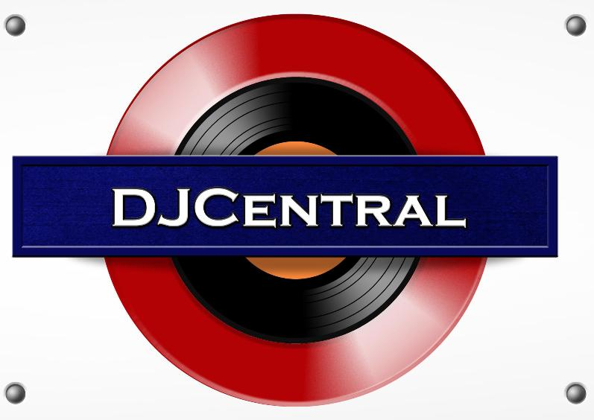
PRESS RELEASE - EFFECTIVE IMMEDIATELY – 26th FEBRUARY 2013

DJ CENTRAL PARTNERS WITH DANCE MUSIC TV!

DJ Central is thrilled to announce a new partnership with Dance Music TV! Dance Music TV (DMTV) is a division of WHOMAG Multimedia who also manage Dance Music Mag, WHO?MAG TV, WHO?MAG Distribution and Chetown Films. WHOMAG Multimedia was created by Rob Schwartz who is dedicated to bringing you the best of todays entertainment. Through Dance Music TV and Dance Music Mag he has managed to create an outlet for dance artists of all genres.
The partnership between DMTV and DJ Central fits perfectly as they share very similar values and segments. DMTV is also a show that is completely dedicated to dance music; it airs music videos, interviews, performances and events. DJ Central will be featuring artists and segments from DMTV in upcoming episodes and will also be distributing artists featured on DMTV through our DJ Central digital platforms.
Peter Bowers (Senior Vice President of DJ Central) has described the partnership as a “great opportunity” and has advised that there will be more announcements to follow. For more information, visit WHOMAG Multimedia’s website www.whomag.net or Dance Music Mag’s website www.dancemusicmag.com.

********************************************************************************
ABOUT DJ CENTRAL:
DJ CENTRAL TV is a new and exciting global dance and house music TV show that features lifestyle segments on all things youth, club, dance, and house music culture, bringing the global clubbing nightlife to your TV screens on FOXTEL’s heralded Aurora Channel 183.

Hosted by the dynamic team along with a cast of industry names and artists from all over the world, each week they’ll bring you the latest in dance and house music as well as featuring fashion interviews with celebrities from film to music and sport and bringing our own unique Australian feel to the world of dance and house music.

The shows format is built around a local club that we have selected that we feel represents the best of all the things that the show stands for. We will have segments on the venue itself, the latest music video clips, club competitions and promos, and even a latest news segment keeping you up to date with all the latest gossip in the DJ Club scene.
For more information, visit the DJ Central sites:
www.djcentral.tv
www.djcentralmusic.wordpress.com
www.facebook.com/djcentralmusic

***END***
********************************************************
CONTACT:

Press and Media Manager
DJ Central Hong Kong Ltd
C/O Expo112 Unit 20
No 112 McEvoy Street
Alexandria NSW 2013
AUSTRALIA
P: + 61 2 9310 0155
F: +61 2 9310 0166
W: www.djcentral.tv
E: sales@djcentral.tv
********************************************************

