PRESS RELEASE - EFFECTIVE IMMEDIATELY – 13th MARCH 2014

I Am Duckeye launch 50 minute single madness!

I Am Duckeye is an Australian train wreck rock metal band that can be described as spontaneous and wild, all in the good sense. The band have been creating music in the industry since 2008 and creates a comedic performances, making them so unique.

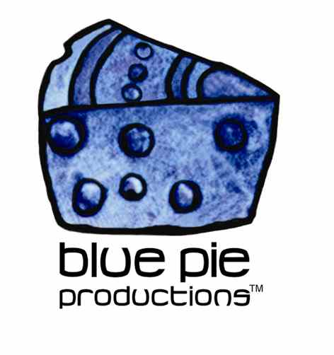
On Saturday March 22nd at the Espy Front Bar I am Duckeye are releasing a special Double A side single of "The Riff" from Husband and the lead single "Son Of A Riff" from Commando Too. The single is going to also include live tracks, remixes and interviews, just like in the 90's!!!
The night will be kicked off with High Side Driver followed by Teal, and then Greenthief launch their album at your face as main support.
Set times for the night are:
09:30-10:05 High Side Driver - 35 min
10:30-11:10 Teal (NSW) - 40 mins
11:35-12:20 Greenthief (Album Launch) - 45 mins
12:45-01:35 I Am Duckeye (Single Launch) - 50 mins
Free Entry so the price is right!
More information can be found on the Facebook event page
- www.facebook.com/events/285344521615826/
- iamduckeye.com/

***********************************************************

ABOUT BLUE PIE THE RECORD LABEL:
www.bluepierecords.com

Blue Pie Records is one of the world’s leading independent record Labels and publishing houses. Blue Pie Records has a wide range of alliance-partnerships which it calls upon to create distribution, production, marketing and promotional systems for our artists, labels and global content partners.

Blue Pie's priority artists include Sydonia, Burning the Day, Jack Derwin, The Benjamin Hyatt Band, Terry Oldfield, Phil Manzanera, Johnny Bennett, Suzanna Lubrano, The Objex, Gordon Waller, Dave Evans, Dale Bozzio, and Jessy Tomsko along with labels like ConcertHouse Music, TRAX Records, Mahoning Valley Records, Idyllium Music, Sugo Music, Deluxe Records, Reality Entertainment, and PLG Music Group to name a few. Our live concert and video clip library continues to expand and includes live albums, video clips, and video concerts from artists including, Chicago, The Cars, Tiesto, Steve Aoki and Dave Evans to name a few.

Blue Pie's roster of artists continues to gain worldwide recognition with chart success in the USA, Canada, Europe and Australia. Blue Pie is continually developing new markets for our artists, labels, content partners to connect and reach new consumers and fans for their music. The Blue Pie license team has placed over 2000 film, TV, cable show and advertising license sales over the past 3 years alone. The label provides transparent reporting and digital asset management services through its partner Blue Pie Data www.bluepiedata.com

Blue Pie has developed exclusive digital content supply agreements with many companies including: DJ Central TV, Blue Vault Digital, Magic Blue Creative and their partners. The future is bright and we are wearing shades with our expansion into ASIA, North America and Latin America from 2014 onwards. For more information on Blue Pie please visit www.bluepie.com.au

Blue Pie’s label roster includes:
- Electrik Blue Records USA
- Rock Forever Records
- Reality Entertainment (For Australian and New Zealand)
- Globalev World Music
- Deluxe Records
- Pride Music
- Concerthouse Music
- Self Made Records UK
- Media World
- UnCanny Inc
- Subsonic Records
- DJ Central Records
- Metal Central TV
- + Over 200 others. See our website for details.

Search on 'blue pie' in Google for more information.
**END***

========================================
Press and Media Contact:

Press and Media Manager
Blue Pie
Unit 20 No 112 McEvoy Street
Alexandria NSW 2015
P: + 61 2 9310 0155
F: + 61 2 9310 0166
E: pr@bluepie.com.au
W: www.bluepierecords.com
========================================

