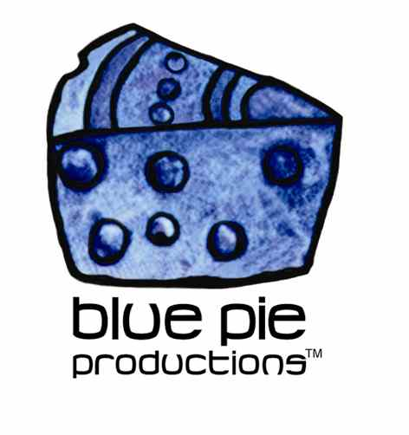
PRESS RELEASE - EFFECTIVE IMMEDIATELY – 1 September 2014

Irina Mikhailova set to enchant Australian audiences… We love Irina!!!

Blue Pie artist Irina Mikhailova has announced that after her recent batch of European shows she will be heading to Australia! Irina will be performing at the Revolt Melbourne Art Space on the 11th of October; she will be headlining Melbourne’s annual Fourcolours Music and Arts Festival.

Irina has recently completed her 2014 European tour where she performed on the main stage of the New Healing Festival (Germany), Boom Festival (Portugal) and Ozora Festival (Hungary). Irina has proven her versatility by performing numerous festival shows as both a solo act as well as a part of numerous collaborations. Her work with ensembles such as Star Sounds Orchestra, Kaya Project, Medicine Drum, Celt Islam and Vlastur, to name a few.

Irina (now based in the US) was born and raised in Kazakhstan and strives to stay true to this aspect of her heritage within her music. Fans can expect to hear her signature blend of multicultural influences when she hits the stage for Fourcolours. Irina’s music has been described as a rich blend of contemporary folk, dub-ambient, Arabic groove and tribal sounds created through a combination of traditional instrumentation sinewy vocals and digital composition.

For more information on Irina’s music and the Fourcolours festival checkout the link! www.irinamikhailova.com

****************************************************************************
ABOUT BLUE PIE THE RECORD LABEL:
www.bluepierecords.com
Blue Pie Records is one of the world’s leading independent record Labels and publishing houses. Blue Pie Records has a wide range of alliance-partnerships which it calls upon to create distribution, production, marketing and promotional systems for our artists, labels and global content partners.

Blue Pie's priority artists include Sydonia, Burning the Day, Jack Derwin, The Benjamin Hyatt Band, Terry Oldfield, Phil Manzanera, Johnny Bennett, Suzanna Lubrano, The Objex, Gordon Waller, Dave Evans, Dale Bozzio, and Jessy Tomsko along with labels like ConcertHouse Music, TRAX Records, Mahoning Valley Records, Idyllium Muisc, Sugo Music, Deluxe Records, Reality Entertainment, and PLG Music Group to name a few. Our live concert and video clip library continues to expand and includes live albums, video clips, and video concerts from artists including, Chicago, The Cars, Tiesto, Steve Aoki and Dave Evans to name a few.

Blue Pie's roster of artists continues to gain worldwide recognition with chart success in the USA, Canada, Europe and Australia. Blue Pie is continually developing new markets for our artists, labels, content partners to connect and reach new consumers and fans for their music. The Blue Pie license team has placed over 2000 film, TV, cable show and advertising license sales over the past 3 years alone. The label provides transparent reporting and digital asset management services through its partner Blue Pie Data www.bluepiedata.com

Blue Pie has developed exclusive digital content supply agreements with many companies including: DJ Central TV, Blue Vault Digital, Magic Blue Creative and their partners. The future is bright and we are wearing shades with our expansion into ASIA, North America and Latin America from 2013 onwards. For more information on Blue Pie please visit www.bluepie.com.au

Blue Pie’s label roster includes:
- Electrik Blue Records USA
- Rock Forever Records
- Reality Entertainment (For Australian and New Zealand)
- Globalev World Music
- Deluxe Records
- Pride Music
- Concerthouse Music
- Self Made Records UK
- Media World
- UnCanny Inc
- Subsonic Records
- + Over 200 others. See our website for details.

Search on 'blue pie' in Google for more information.
**END***

Press and Media Contact:

Press and Media Manager
Blue Pie
Unit 20 No 112 McEvoy Street
Alexandria NSW 2015
P: + 61 2 9310 0155
F: + 61 2 9310 0166
E: pr@bluepie.com.au
W: www.bluepierecords.com

************************************************************************

