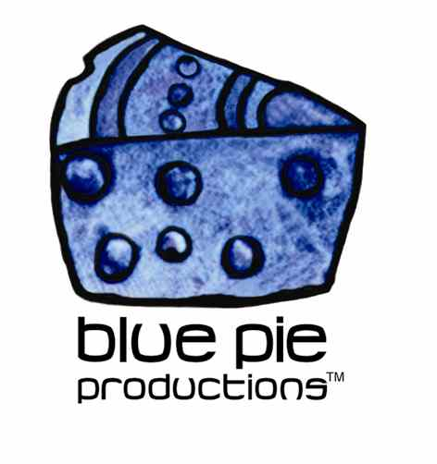
PRESS RELEASE - EFFECTIVE IMMEDIATELY – 1 September 2014

Lee Negin Premiers New Video and creates a new paradigm in music!

Lee Negin’s indefinable music is now available on youtube and Blue Pie cannot get enough! Lee has recently released two new videos and singles from his latest album “The Cheeze Chronicles: Volume V.” The two videos titled “Loan Me a Paradigm” and “The Cheeze Spreadz” showcase Lee’s quirky take on electronica and are definitely worth a listen as well as more than a few viewings.

With the release of his most recent album Lee is also acquiring new fans and excellent write-ups with reviewer Paul 'DeJay' Readman (Music World Radio (UK) Host) stating:
"Lee Negin, the soundscape master, dazzles once again, with more mind-bending sounds and hard beats shaped into his latest “Technopera” (Techno Opera). "The Chronicles of Cheeze: Volume V” is like ‘The Rocky Horror Picture Show’ on an acid trip. There are various, nicely crafted dance numbers but in many places, this adventure sounds a little like a trippy radio play. Chill to a kaleidoscope of sounds and literally, when you want to go somewhere else, like a fine wine, you get more and more from repeated tasting. At times, the album reminds me of The Orb, KLF, Talking Heads and Future Sound of London, all rolled into one but Negin started his noted career before everyone mentioned. Leave your concept of time at the front door. There is never a dull moment, and the pace is nice and steady with a few techno numbers laced with prime sound cuts. You might just forget that an alien is talking to you."

Hailing from San Francisco but currently living in Seoul in South Korea, Lee’s influences are cross-cultural and push every boundary and button imaginable! His videos are definitely a must see for anyone in need of a crazy, out of body, psychedelic, alien, musical journey. Lee’s music has been described as Electronica-Psychedelic-Techno-Ambient-Trance-Trip Hop-Post Rock- Modern Jazz-World music… and in other words, needs to be heard for yourself!

Checkout Lee Negin’s website for more info on up coming gigs and links to his music. www.leenegin.com

****************************************************************************
ABOUT BLUE PIE THE RECORD LABEL:
www.bluepierecords.com
Blue Pie Records is one of the world’s leading independent record Labels and publishing houses. Blue Pie Records has a wide range of alliance-partnerships which it calls upon to create distribution, production, marketing and promotional systems for our artists, labels and global content partners.

Blue Pie's priority artists include Sydonia, Burning the Day, Jack Derwin, The Benjamin Hyatt Band, Terry Oldfield, Phil Manzanera, Johnny Bennett, Suzanna Lubrano, The Objex, Gordon Waller, Dave Evans, Dale Bozzio, and Jessy Tomsko along with labels like ConcertHouse Music, TRAX Records, Mahoning Valley Records, Idyllium Muisc, Sugo Music, Deluxe Records, Reality Entertainment, and PLG Music Group to name a few. Our live concert and video clip library continues to expand and includes live albums, video clips, and video concerts from artists including, Chicago, The Cars, Tiesto, Steve Aoki and Dave Evans to name a few.

Blue Pie's roster of artists continues to gain worldwide recognition with chart success in the USA, Canada, Europe and Australia. Blue Pie is continually developing new markets for our artists, labels, content partners to connect and reach new consumers and fans for their music. The Blue Pie license team has placed over 2000 film, TV, cable show and advertising license sales over the past 3 years alone. The label provides transparent reporting and digital asset management services through its partner Blue Pie Data www.bluepiedata.com

Blue Pie has developed exclusive digital content supply agreements with many companies including: DJ Central TV, Blue Vault Digital, Magic Blue Creative and their partners. The future is bright and we are wearing shades with our expansion into ASIA, North America and Latin America from 2013 onwards. For more information on Blue Pie please visit www.bluepie.com.au

Blue Pie’s label roster includes:
- Electrik Blue Records USA
- Rock Forever Records
- Reality Entertainment (For Australian and New Zealand)
- Globalev World Music
- Deluxe Records
- Pride Music
- Concerthouse Music
- Self Made Records UK
- Media World
- UnCanny Inc
- Subsonic Records
- + Over 200 others. See our website for details.

Search on 'blue pie' in Google for more information.
**END***

Press and Media Contact:

Press and Media Manager
Blue Pie
Unit 20 No 112 McEvoy Street
Alexandria NSW 2015
P: + 61 2 9310 0155
F: + 61 2 9310 0166
E: pr@bluepie.com.au
W: www.bluepierecords.com

************************************************************************

