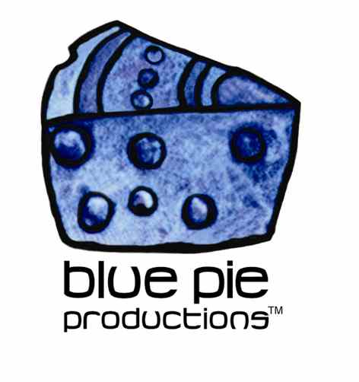
PRESS RELEASE - EFFECTIVE IMMEDIATELY – 15 September 2014

Friendship Love and Loyalty nominated for 11 ASIN awards!

Australian Film “Friendship Love and Loyalty” has been nominated for 11 Australian Screen Industry Network Awards! The huge quantity of nominations received for those who have contributed to the film in a variety of aspects is indicative of the huge success of this film.

“Friendship Love and Loyalty” is the first film written and produced by Stinga T aka Thibul Nettle. South Australian born, Stinga T has made a name for himself in the Australian music scene as an accomplished rapper, songwriter and performer. He has had success as a member of the hip-hop group The Deadly Boys aka TDB and as a solo artist, releasing his 3rd album “Shine” earlier this year.

In 2012 Stinga started the production company “Firestick Films” and has since acted in starring roles in “Alien Sons” and “49”. “Friendship Love and Loyalty” is Firestick Films’ debut film production and is co-produced by Australian Film Academy. Directed by Maryanne Patterson, “Friendship Love and Loyalty” also stars Kylie Farmer, Maha Wilson, Ezra Junata, and Christopher Facey. The film is written and produced by Stinga T who also stars as the main character.

“Friendship Love and Loyalty” is a modern day South Australian love story, which tells the tale of friendship caught up in a heartbreaking love triangle. The film is a beautiful tale coupled with its uniquely Australian setting amongst a small Australian beach town.

The ASIN Nominations for “Friendship Love and Loyalty” are:
Best Director: Maryanne Paterson
Best Producer: Marie Press and Stinga T
Best Actor: Thibul Nettle and Ezra Junter
Best Actress: Kylie Farmer, Maha Wilson and Cassandra Reed
Best Screenplay/Writer: Thibul Nettle
Best Feature Film: Friendship Love & Loyalty
Best Cinematographer: Michael Selge
Most Valued Crew Member: Nicholas Kohl, Cassie Trappit, Bruce Willoughby, Kylian Morro, Ben Mansley, Alma Kushartanti and Khallah Marro
Member's Choice: Maryanne Paterson

Make sure to get your votes in for “Friendship Love and Loyalty” and support the Australian film industry! Voting closes on the 31st of October and the awards will be announced on the 6th of September 2014!

To vote for your favourite nominations for this year’s ASIN awards follow the link to their Website. www.australianscreenindustrynetwork.com/asin-awards-2014-vote.html

For information on “Friendship Love and Loyalty” or to get updates on the film, and links to download the film or it’s sound track, check out the link to the film’s official website! www.loveandloyalty.wix.com/loveandloyalty

****************************************************************************
ABOUT BLUE PIE THE RECORD LABEL:
www.bluepierecords.com
Blue Pie Records is one of the world’s leading independent record Labels and publishing houses. Blue Pie Records has a wide range of alliance-partnerships which it calls upon to create distribution, production, marketing and promotional systems for our artists, labels and global content partners.

Blue Pie's priority artists include Sydonia, Burning the Day, Jack Derwin, The Benjamin Hyatt Band, Terry Oldfield, Phil Manzanera, Johnny Bennett, Suzanna Lubrano, The Objex, Gordon Waller, Dave Evans, Dale Bozzio, and Jessy Tomsko along with labels like ConcertHouse Music, TRAX Records, Mahoning Valley Records, Idyllium Muisc, Sugo Music, Deluxe Records, Reality Entertainment, and PLG Music Group to name a few. Our live concert and video clip library continues to expand and includes live albums, video clips, and video concerts from artists including, Chicago, The Cars, Tiesto, Steve Aoki and Dave Evans to name a few.

Blue Pie's roster of artists continues to gain worldwide recognition with chart success in the USA, Canada, Europe and Australia. Blue Pie is continually developing new markets for our artists, labels, content partners to connect and reach new consumers and fans for their music. The Blue Pie license team has placed over 2000 film, TV, cable show and advertising license sales over the past 3 years alone. The label provides transparent reporting and digital asset management services through its partner Blue Pie Data www.bluepiedata.com

Blue Pie has developed exclusive digital content supply agreements with many companies including: DJ Central TV, Blue Vault Digital, Magic Blue Creative and their partners. The future is bright and we are wearing shades with our expansion into ASIA, North America and Latin America from 2013 onwards. For more information on Blue Pie please visit www.bluepie.com.au

Blue Pie’s label roster includes:
- Electrik Blue Records USA
- Rock Forever Records
- Reality Entertainment (For Australian and New Zealand)
- Globalev World Music
- Deluxe Records
- Pride Music
- Concerthouse Music
- Self Made Records UK
- Media World
- UnCanny Inc
- Subsonic Records
- + Over 200 others. See our website for details.

Search on 'blue pie' in Google for more information.
**END***

Press and Media Contact:

Press and Media Manager
Blue Pie
Unit 20 No 112 McEvoy Street
Alexandria NSW 2015
P: + 61 2 9310 0155
F: + 61 2 9310 0166
E: pr@bluepie.com.au
W: www.bluepierecords.com

************************************************************************

