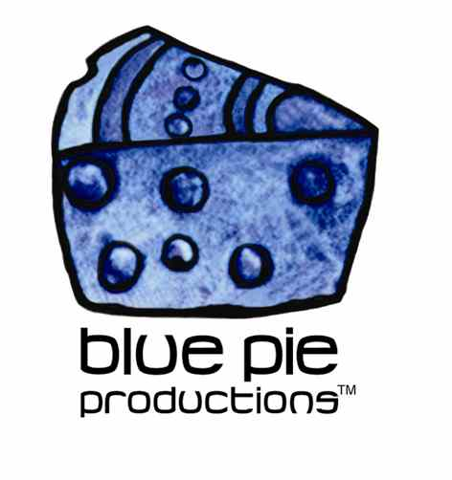
PRESS RELEASE - EFFECTIVE IMMEDIATELY – 30 September 2014

The Objex “Super Charged Little Nova”

This has been an exciting year for fans of in-your-face, high energy punk rock and roll with the release of The Objex new album “Supercharged Little Nova”. This eight track gem will grab your attention immediately and take you back to a time when punk was at its best, moshing was a must and brutally honest lyrics were a big fat “F U” to a society that expected its musicians to conform to the ways of the world.

Formed in 2006 and fronted by Felony Melony, this punk/rock band is absolutely dripping with attitude, sexual innuendos and charisma. A tight rhythm section in the form of Ch!li on drums and Ivan on bass creates a wall of sound perfectly complimented by Jim Nasty’s catchy and distinct guitar lines. The Objex took out the prize for best punk rock band in 2010 at the Vegas Rocks Awards and they have been gaining more and more momentum since then. Work began on their newest album “Super Charged Little Nova” in LA back in 2012 with producer Andy Carpenter ready for its release this year in May 2014.

The opening track “Burn” is an excellent introduction as to what we should expect for the rest of the album, slapping you in the face with its catchy melodic hooks and high energy vocals. This is followed by “Crush” and “Queen Cobra” with its No FX-esque chord progressions and super-charged, fast paced drum beats. Suffice it to say if you didn’t feel like dancing after the first track – you sure as hell will now!

Group vocals on “GG” (Get it done) really do make the song, keeping the energy levels high despite the slower pace of this song compared to other previous tracks. To follow is the hilariously and shamelessly veracious song entitled “Grrr” in which Felony Melody’s unique and confident personality shines through her lyrics which really do encompass what punk rock is all about.

Essentially this album is a must have, whether you want to use it to amp yourself up before a big night out or whether you just want some exciting and energetic music to rock out to driving in the car. Do yourself a big favour and go check it out!

www.facebook.com/objexlv/timeline?ref=page_internal
www.reverbnation.com/theobjex
https://twitter.com/TheObjex
https://itunes.apple.com/us/album/supercharged-little-nova/id889619399

****************************************************************************
ABOUT BLUE PIE THE RECORD LABEL:
www.bluepierecords.com
Blue Pie Records is one of the world’s leading independent record Labels and publishing houses. Blue Pie Records has a wide range of alliance-partnerships which it calls upon to create distribution, production, marketing and promotional systems for our artists, labels and global content partners.

Blue Pie's priority artists include Sydonia, Burning the Day, Jack Derwin, The Benjamin Hyatt Band, Terry Oldfield, Phil Manzanera, Johnny Bennett, Suzanna Lubrano, The Objex, Gordon Waller, Dave Evans, Dale Bozzio, and Jessy Tomsko along with labels like ConcertHouse Music, TRAX Records, Mahoning Valley Records, Idyllium Muisc, Sugo Music, Deluxe Records, Reality Entertainment, and PLG Music Group to name a few. Our live concert and video clip library continues to expand and includes live albums, video clips, and video concerts from artists including, Chicago, The Cars, Tiesto, Steve Aoki and Dave Evans to name a few.

Blue Pie's roster of artists continues to gain worldwide recognition with chart success in the USA, Canada, Europe and Australia. Blue Pie is continually developing new markets for our artists, labels, content partners to connect and reach new consumers and fans for their music. The Blue Pie license team has placed over 2000 film, TV, cable show and advertising license sales over the past 3 years alone. The label provides transparent reporting and digital asset management services through its partner Blue Pie Data www.bluepiedata.com

Blue Pie has developed exclusive digital content supply agreements with many companies including: DJ Central TV, Blue Vault Digital, Magic Blue Creative and their partners. The future is bright and we are wearing shades with our expansion into ASIA, North America and Latin America from 2013 onwards. For more information on Blue Pie please visit www.bluepie.com.au

Blue Pie’s label roster includes:
- Electrik Blue Records USA
- Rock Forever Records
- Reality Entertainment (For Australian and New Zealand)
- Globalev World Music
- Deluxe Records
- Pride Music
- Concerthouse Music
- Self Made Records UK
- Media World
- UnCanny Inc
- Subsonic Records
- + Over 200 others. See our website for details.

Search on 'blue pie' in Google for more information.
**END***

Press and Media Contact:

Press and Media Manager
Blue Pie
Unit 20 No 112 McEvoy Street
Alexandria NSW 2015
P: + 61 2 9310 0155
F: + 61 2 9310 0166
E: pr@bluepie.com.au
W: www.bluepierecords.com

************************************************************************

