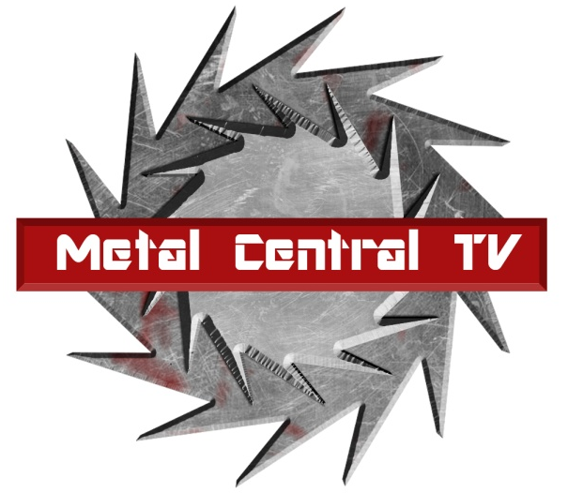

PRESS RELEASE - EFFECTIVE IMMEDIATELY – 10 September 2014

Burning The Day is blazing the way with Best Metal Act Nomination!

********************************************************************************
Metal Central TV is pleased to announce that Toronto natives, Burning The Day have been nominated for Best Metal, Punk, Ska or Surf Band at Toronto Independent Music Awards, 2014. The Metal Central TV team is wishing the band luck and we know they deserve this recognition!

There are too many amazing bands nominated for a plethora of awards so please click on the link and check out Burning The Day’s nomination as well as all the other wonderful artist being honored! www.torontoima.com/awards/tima-2014-nominees-applicants-2013-14/

Burning The Day have been making waves in the Toronto metal scene since their formation in 2005. Performing live shows, planning another European tour and writing new music are just a couple of things that will be keeping these guys busy for 2014.

Burning The Day have been developing and crafting their extreme sound and releasing four studio albums; In Fall She Sleeps (2006), Dawn Of Thorns (2007), Blacklisted (2009), and most recently, Metamorphosis (2013).

BTD are made up of:
Vocals: Cesar Silva
Rhythm guitarist: Matt Metcalfe
Lead guitarist: Maxim Shelkov
Bassist: Dmitri Skribans
Drummer: Steve "The Animal" Mitchell

Burning The Day have a loyal following and have been expanding their fan base with their recent tours across North America. The band have been selling out legendary venues in their home town, performing for over a thousand screaming fans!

Burning The Day have been building their international reputation as a hard rocking metal band through their performances sharing stages with other talented international metal acts. Acts such as Bring Me The Horizon, Obey The Brave, Soilwork, Emmure, The Black Dahlia Murder, Bury Your Dead, 3 Inches Of Blood, Beneath The Massacre, Goatwhore, Ion Dissonance, Threat signal and many more!!!

Check out Metal Central TV’s official Website for more information on all things Metal and follow the links for more information on Burning The Day’s new music news, releases and concerts!
Official Website: www.burningtheday.com
Facebook Page: www.facebook.com/burningtheday99
Youtube Channel: www.youtube.com/burningtheday99
Twitter: www.twitter.com/burningtheday99
Instagram: www.instagram.com/burningtheday99
Official merch store: http://btdstore.bigcartel.com/

********************************************************************************

ABOUT METAL CENTRAL TV:

METAL CENTRAL TV features the best international metal and rock acts from around the globe. We have documentaries, tour videos, live concerts from the global independent music scene and of course some of the finest music from your favorite rock and metal acts.

The show is focused on providing independent labels and emerging artists from all over the world the opportunity to showcase their work and gain global exposure through our network partners.

If you would like to submit your music, please submit your video link to content.mctv@gmail.com

We are constantly adding new channels each and every month. Tune into Metal Central TV at www.muzu.tv/metalcentraltv for all your edgy rift, hard hitting and head banging needs.
***END***
********************************************************************************

CONTACT:

Press and Media Manager
Metal Central TV USA LLC
C/O Expo112 Unit 20
No 112 McEvoy Street
Alexandria NSW 2013
AUSTRALIA

P: + 61 2 9310 0155
F: +61 2 9310 0166
W: www.metalcentral.tv
E: sales@metalcentral.tv

