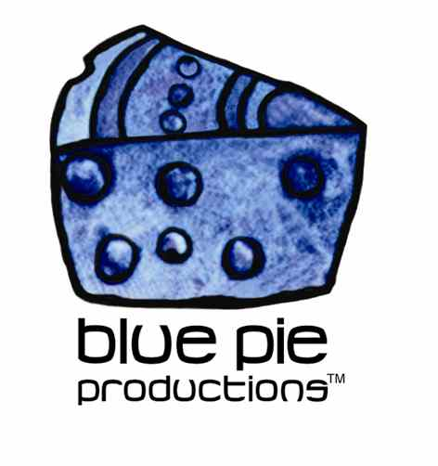
PRESS RELEASE - EFFECTIVE IMMEDIATELY – 28 October 2014

The Country Music Channel “Rocks 2015 Concert” is on sale NOW!

It's time! We know you've been hanging out to grab your tickets to the hottest country festival in the Southern Hemisphere and tomorrow is your day!

We've unveiled our massive international lineup, featuring an array of the biggest contemporary country stars including Lady Antebellum, Big & Rich, Chris Young, Kristian Bush, Lee Brice, Maddie & Tae and Laura Bell Bundy, all of whom are playing their only Queensland performances at the festival.

Our festival performers are dominating the US Country charts! Just this week you can see Kristian Bush (#37), Chris Young (#36), Lee Brice (#32), Chase Bryant (#19), Big & Rich (#13) and Maddie & Tae (#12)! It will be hit after hit after hit when these artists take the stage at CMC Rocks next year!

Festival tickets on sale tomorrow, Friday 24 October, 9am QLD time. Remember to name all your festival entry and camping tickets. Tickets will be posted from February 2015, see you at CMC Rocks QLD 2015!

CMC ROCKS QLD 2015 ARTIST LINEUP:
INTERNATIONAL ARTISTS
Lady Antebellum (USA) - Big & Rich (USA) - Chris Young (USA) - Lee Brice (USA) - Kristian Bush (Sugarland) (USA) - Laura Bell Bundy (USA) - Maddie & Tae (USA) - Charlie Worsham (USA) - Jeffrey Steele (USA) - Chase Bryant (USA) - Ryan Kinder (USA) - Wylie and the Wild West (USA) - McKay (UK)

LOCAL ARTISTS
Troy Cassar-Daley - John Williamson - Adam Brand - Adam Harvey - Catherine Britt - The Wolfe Brothers - Amber Lawrence - Adam Eckersley Band - The Viper Creek Band - Doug Bruce - Harmony James - Cameron Scott (NZ) - Cameron Luxton (NZ) - Jody Direen (NZ) - Jared Porter - Col Finley - Seleen McAlister - Dozzi - Victoria Avenue - Livi Robins - Karrie Hayward - Shanon Watkins - Mick Lindsay Band

MCs
Storme Warren (USA)
Mike Carr & Darren Carr

For More information on CMC, tourn news, music news, douwnloads and heaps more check out the links!
www.facebook.com/cmcrocks
www.cmcrocks.com/2015/
www.instagram.com/cmcrocksofficial

****************************************************************************
ABOUT BLUE PIE THE RECORD LABEL:
www.bluepierecords.com
Blue Pie Records is one of the world’s leading independent record Labels and publishing houses. Blue Pie Records has a wide range of alliance-partnerships which it calls upon to create distribution, production, marketing and promotional systems for our artists, labels and global content partners.

Blue Pie's priority artists include Sydonia, Burning the Day, Jack Derwin, The Benjamin Hyatt Band, Terry Oldfield, Phil Manzanera, Johnny Bennett, Suzanna Lubrano, The Objex, Gordon Waller, Dave Evans, Dale Bozzio, and Jessy Tomsko along with labels like ConcertHouse Music, TRAX Records, Mahoning Valley Records, Idyllium Muisc, Sugo Music, Deluxe Records, Reality Entertainment, and PLG Music Group to name a few. Our live concert and video clip library continues to expand and includes live albums, video clips, and video concerts from artists including, Chicago, The Cars, Tiesto, Steve Aoki and Dave Evans to name a few.

Blue Pie's roster of artists continues to gain worldwide recognition with chart success in the USA, Canada, Europe and Australia. Blue Pie is continually developing new markets for our artists, labels, content partners to connect and reach new consumers and fans for their music. The Blue Pie license team has placed over 2000 film, TV, cable show and advertising license sales over the past 3 years alone. The label provides transparent reporting and digital asset management services through its partner Blue Pie Data www.bluepiedata.com

Blue Pie has developed exclusive digital content supply agreements with many companies including: DJ Central TV, Blue Vault Digital, Magic Blue Creative and their partners. The future is bright and we are wearing shades with our expansion into ASIA, North America and Latin America from 2013 onwards. For more information on Blue Pie please visit www.bluepie.com.au

Blue Pie’s label roster includes:
- Electrik Blue Records USA
- Rock Forever Records
- Reality Entertainment (For Australian and New Zealand)
- Globalev World Music
- Deluxe Records
- Pride Music
- Concerthouse Music
- Self Made Records UK
- Media World
- UnCanny Inc
- Subsonic Records
- + Over 200 others. See our website for details.

Search on 'blue pie' in Google for more information.
**END***

Press and Media Contact:

Press and Media Manager
Blue Pie
Unit 20 No 112 McEvoy Street
Alexandria NSW 2015
P: + 61 2 9310 0155
F: + 61 2 9310 0166
E: pr@bluepie.com.au
W: www.bluepierecords.com

************************************************************************

