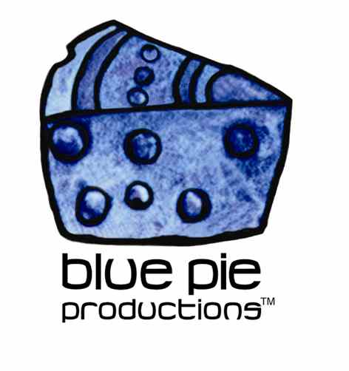
PRESS RELEASE - EFFECTIVE IMMEDIATELY – 20 October 2014

Pharmakon taps into her inner beast!

Margaret Chardiet aka Pharmakon has been awarded the Pitchfork Best New Music Award for her latest album “Bestial Burden”. The album is a voyage in clanking noise loops, sculpted feedback and experimental vocals that have been described as “caustic screaming”. With song titles such as ‘Body Betrays Itself’ and ‘Primitive Struggle’ this album is not for the squeamish. This album is a visceral, sonic body horror that is sure to shock and amaze.

New York City native Margaret Chardiet has been making power electronics/death industrial music under the name Pharmakon for over five years. As a founding member of the Red Light District collective in Far Rockaway, NY she has been a figurehead in the underground experimental scene since the age of seventeen.

Margaret has described the theme of her second LP for Brooklyn-based label Sacred Bones as “[a] desire to show the body as a lump of flesh and cells that mutate and fail you and betray you—this very banal, unimportant, grotesque aspect of ourselves.” The songs on this album were all written and recorded during a turbulent three month time period during which several fundamental life changes forced her to begin living in a completely new way and in a new space. She describes the lyrical themes of this album as being about, “Loss. Losing everything. Relinquishing control. Complete psychic abandon. Blind leaps of faith into the fire, walking out unscathed. Crawling out of the pit.”

Unlike other experimental projects, Pharmakon does not improvise when performing or recording. She is concise and exact; each song/movement is linear with a clear trajectory. Spin Magazine describes Pharmakon, stating “She glowers in measured silence as often as she shrieks, and every serrated tone cuts straight to the bone, a carefully calibrated interplay between frequency and resistance.” She describes her drive to make noise music as something akin to an exorcism where she is able to express, her “deep-seated need/drive/urge/possession to reach other people and make them FEEL something [specifically] in uncomfortable/confrontational ways.”

Superb reviews are flooding in for the new album by PHARMAKON which you can find a teaser for here and track "Body Betrays Itself" here plus HUGE features in this month's Dazed + Wire. These reviews of course don’t even take into how incredible and powerful this one-man-band's LIVE show is!

Check out Pharmakon on YouTube and experience the true impact of this phenomenal musician’s shocking and powerful live show! Follow the links for more information on Pharmakon, music releases, tour dates, music news and downloads!
www.youtube.com/watch?v=HV6iaC1kWMg
www.sacredbonesrecords.com/collections/pharmakon
www.soundcloud.com/search?q=pharmakon
www.facebook.com/pharmakonnn

****************************************************************************
ABOUT BLUE PIE THE RECORD LABEL:
www.bluepierecords.com
Blue Pie Records is one of the world’s leading independent record Labels and publishing houses. Blue Pie Records has a wide range of alliance-partnerships which it calls upon to create distribution, production, marketing and promotional systems for our artists, labels and global content partners.

Blue Pie's priority artists include Sydonia, Burning the Day, Jack Derwin, The Benjamin Hyatt Band, Terry Oldfield, Phil Manzanera, Johnny Bennett, Suzanna Lubrano, The Objex, Gordon Waller, Dave Evans, Dale Bozzio, and Jessy Tomsko along with labels like ConcertHouse Music, TRAX Records, Mahoning Valley Records, Idyllium Muisc, Sugo Music, Deluxe Records, Reality Entertainment, and PLG Music Group to name a few. Our live concert and video clip library continues to expand and includes live albums, video clips, and video concerts from artists including, Chicago, The Cars, Tiesto, Steve Aoki and Dave Evans to name a few.

Blue Pie's roster of artists continues to gain worldwide recognition with chart success in the USA, Canada, Europe and Australia. Blue Pie is continually developing new markets for our artists, labels, content partners to connect and reach new consumers and fans for their music. The Blue Pie license team has placed over 2000 film, TV, cable show and advertising license sales over the past 3 years alone. The label provides transparent reporting and digital asset management services through its partner Blue Pie Data www.bluepiedata.com

Blue Pie has developed exclusive digital content supply agreements with many companies including: DJ Central TV, Blue Vault Digital, Magic Blue Creative and their partners. The future is bright and we are wearing shades with our expansion into ASIA, North America and Latin America from 2013 onwards. For more information on Blue Pie please visit www.bluepie.com.au

Blue Pie’s label roster includes:
- Electrik Blue Records USA
- Rock Forever Records
- Reality Entertainment (For Australian and New Zealand)
- Globalev World Music
- Deluxe Records
- Pride Music
- Concerthouse Music
- Self Made Records UK
- Media World
- UnCanny Inc
- Subsonic Records
- + Over 200 others. See our website for details.

Search on 'blue pie' in Google for more information.
**END***

Press and Media Contact:

Press and Media Manager
Blue Pie
Unit 20 No 112 McEvoy Street
Alexandria NSW 2015
P: + 61 2 9310 0155
F: + 61 2 9310 0166
E: pr@bluepie.com.au
W: www.bluepierecords.com

************************************************************************

