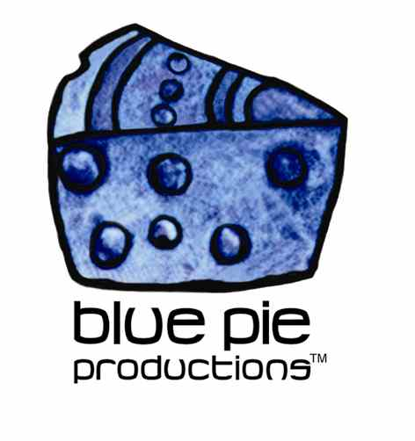
PRESS RELEASE - EFFECTIVE IMMEDIATELY – 30 September 2014

Synnika Lofton loves to talk with his new single “Talk to you”

Award winning poet, recording artist, producer and teacher Synnika Lofton has a new track available on iTunes. The song entitled “Talk to you (feat. Sam Barrett)” is an example of just how powerful the written word can really be. This song goes beyond the normal expectations when it comes to lyrics, going much further in depth, the listener will be able to connect that much more with the story.

During his years studying creative writing, Lofton took inspiration from a Gandhi quote “We must be the change we want to see in the world” and applied it to his work with an idea to revolutionize poetry and hand it over to the rest of the world. He also started his own company (Guerrilla Ignition LLC) which is an independent recording, publishing, and film company. Lofton is now known worldwide for his poetry, travelling across the globe doing workshops, poetry festivals and imparting his wisdom on how creativity can affect communities.

The simplicity of the song “Talk to you” helps accent the lyrical content directing the listener to the most important parts within the song. A beautifully charming acoustic guitar riff sets the tone of this love song, whilst the smooth vocal hook adds that pop element which really cements the relationship between popular music and poetry. His execution of the lyrics in the song are best described as spoken word as although in some aspects it is similar to rapping, it is far gentler and more beautiful with an incredible rhythmic flow that keeps you on the edge of your seat wanting to know how his story ends.

Synnika Lofton is available through AIN Distribution for the world. Checkout the links for more information on Synnika, music news, new releases, upcoming gigs and music downloads!

- https://itunes.apple.com/us/album/talk-to-you-feat.-sam-barrett/id905759399
- www.synnika.com www.reverbnation.com/synnikaloftn
- www.guerrillaignitionsuperstore.com
- www.guerrillaignitionblog.com
- www.youtube.com/synnika
- www.myspace.com/synnika

****************************************************************************
ABOUT BLUE PIE THE RECORD LABEL:
www.bluepierecords.com
Blue Pie Records is one of the world’s leading independent record Labels and publishing houses. Blue Pie Records has a wide range of alliance-partnerships which it calls upon to create distribution, production, marketing and promotional systems for our artists, labels and global content partners.

Blue Pie's priority artists include Sydonia, Burning the Day, Jack Derwin, The Benjamin Hyatt Band, Terry Oldfield, Phil Manzanera, Johnny Bennett, Suzanna Lubrano, The Objex, Gordon Waller, Dave Evans, Dale Bozzio, and Jessy Tomsko along with labels like ConcertHouse Music, TRAX Records, Mahoning Valley Records, Idyllium Muisc, Sugo Music, Deluxe Records, Reality Entertainment, and PLG Music Group to name a few. Our live concert and video clip library continues to expand and includes live albums, video clips, and video concerts from artists including, Chicago, The Cars, Tiesto, Steve Aoki and Dave Evans to name a few.

Blue Pie's roster of artists continues to gain worldwide recognition with chart success in the USA, Canada, Europe and Australia. Blue Pie is continually developing new markets for our artists, labels, content partners to connect and reach new consumers and fans for their music. The Blue Pie license team has placed over 2000 film, TV, cable show and advertising license sales over the past 3 years alone. The label provides transparent reporting and digital asset management services through its partner Blue Pie Data www.bluepiedata.com

Blue Pie has developed exclusive digital content supply agreements with many companies including: DJ Central TV, Blue Vault Digital, Magic Blue Creative and their partners. The future is bright and we are wearing shades with our expansion into ASIA, North America and Latin America from 2013 onwards. For more information on Blue Pie please visit www.bluepie.com.au

Blue Pie’s label roster includes:
- Electrik Blue Records USA
- Rock Forever Records
- Reality Entertainment (For Australian and New Zealand)
- Globalev World Music
- Deluxe Records
- Pride Music
- Concerthouse Music
- Self Made Records UK
- Media World
- UnCanny Inc
- Subsonic Records
- + Over 200 others. See our website for details.

Search on 'blue pie' in Google for more information.
**END***

Press and Media Contact:

Press and Media Manager
Blue Pie
Unit 20 No 112 McEvoy Street
Alexandria NSW 2015
P: + 61 2 9310 0155
F: + 61 2 9310 0166
E: pr@bluepie.com.au
W: www.bluepierecords.com

************************************************************************

