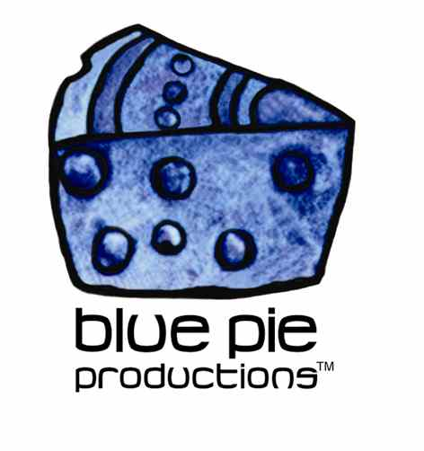
PRESS RELEASE - EFFECTIVE IMMEDIATELY – 28 October 2014

The Immortal Camel Rides……Fringo release their following EO to Ones Nature!!!

Sydney 23rd of October 2014, Fringo releaser their new ep called “The Immortal Camel”. The EP is the band’s first official release since “One's Nature in 2007”.

The Immortal Camel EP features 3 hard hitting classic Fringo tracks, Scraps, Just Like You & Keeping Fit. These tracks pack and punch get you jumping higher than Joe Cocker loaded on Greek Mountain Tea.

As the band says:

”If you can’t handle this then we suggest everyone goes back to breast feeding for a while. If you're concerned that these 3 tracks are all you are going to hear from Fringo for a while, don't be. The band is hard at work on the next installment of “The Immortal Camel” as a full album. This EP represents the first half of a double EP, with its sequel to be unleashed early 2015... That’s a promise!!!

So, for all of you who have continued to read this press release the band extends their gratitude and thanks. Fringo would like to thank all those who have been loyal to the band over the years and to all those who are discovering the band now, a huge welcome to the club.

For more information on Fringo you can visit the bands official website at:
www.fringomusic.com

ABOUT FRINGO
During 2003 in the Eastern Suburbs of Sydney, two brothers Mark "Snappa" Gellin (drums) & Paul Gellin (guitar/vocals) with their close mate Pete (bass guitar) formed the band Fringo. Within their parent’s garage in Little Bay, they built a small rehearsal studio. Equipped with a PA, an old Tascam 4-track recorder and a bar fridge, the three started jamming. It wouldn't take long before music with a new sound had been forged.

For 2 years Fringo hit the stages of Sydney’s live music scene impressing the audiences with their own style of hard rock and charismatic, high energy live shows. The unfortunate departure of Pete on Bass Guitar, led to the brother’s joining forces with their long-time mate and musician - Ashley.

This was the change that kicked the band’s music into another gear. Fringo was now complete and with it, their sound took on a brand of it’s own. January 2005, and the band began work on their first recording. With the help of a friend and engineer, tracks were recorded between Q-Studio’s in Sydney and the bands own studio in Little Bay. Within a few months, Fringo’s first recording was complete. Titled One’s Nature, the album consisted of ten songs that brought to life every characteristic the band had become well known for.

Right from the start the EP hits you with such a powerful riff driven by a groove that would easily compare to such great bands as Pantera. From the beginning, it wasn't hard to recognise that trademark Fringo sound. Without a doubt the track What You Want has always been a crowd favourite. Paul Gellin brings his harsh but melodic vocals to the forefront & pushes the song into a new space.

The Immortal Camel EP is the band’s first official release since One’s Nature in 2007. The EP features a fresh new sound mixed with the Fringo style that has been polished over the years. Fringo have personally promised The Immortal Camel material will have you standing higher than “Joe Crocker loaded on Greek
Mountain Tea”.

Fringo’s music comes from a place where there are no boundaries, no rules or trends that need to be conformed to. It’s raw and it’s honest and that’s why it will stand out!

QUOTES:

“We are a heavy-rock band, there is no doubting that, but it’s in our nature to experiment, & delving into styles like Funk & Blues is a part of our personalities & our music.”-
Fringo

“This is one very cool album (One’s Nature). The performance of the band on these songs is world class and delivery a freight train to your head of pure metal bliss. I am a fan and I am bias but here is what I know .... they rock and have a solid fan base and you would be hard pressed to pass on this album without having played this end to end at least twice. My opinion stands that this is one of the best metal releases for 2007. Rock on !!!”
5/5 Pies of Blue, ITunes

WEBSITE AND LINKS
www.fringomusic.com
www.airplaydirect.com/fringo
www.myspace.com/fringo
www.twitter.com/fringo_music
www.soundcloud.com/fringo-music

****************************************************************************
ABOUT BLUE PIE THE RECORD LABEL:
www.bluepierecords.com
Blue Pie Records is one of the world’s leading independent record Labels and publishing houses. Blue Pie Records has a wide range of alliance-partnerships which it calls upon to create distribution, production, marketing and promotional systems for our artists, labels and global content partners.

Blue Pie's priority artists include Sydonia, Burning the Day, Jack Derwin, The Benjamin Hyatt Band, Terry Oldfield, Phil Manzanera, Johnny Bennett, Suzanna Lubrano, The Objex, Gordon Waller, Dave Evans, Dale Bozzio, and Jessy Tomsko along with labels like ConcertHouse Music, TRAX Records, Mahoning Valley Records, Idyllium Muisc, Sugo Music, Deluxe Records, Reality Entertainment, and PLG Music Group to name a few. Our live concert and video clip library continues to expand and includes live albums, video clips, and video concerts from artists including, Chicago, The Cars, Tiesto, Steve Aoki and Dave Evans to name a few.

Blue Pie's roster of artists continues to gain worldwide recognition with chart success in the USA, Canada, Europe and Australia. Blue Pie is continually developing new markets for our artists, labels, content partners to connect and reach new consumers and fans for their music. The Blue Pie license team has placed over 2000 film, TV, cable show and advertising license sales over the past 3 years alone. The label provides transparent reporting and digital asset management services through its partner Blue Pie Data www.bluepiedata.com

Blue Pie has developed exclusive digital content supply agreements with many companies including: DJ Central TV, Blue Vault Digital, Magic Blue Creative and their partners. The future is bright and we are wearing shades with our expansion into ASIA, North America and Latin America from 2013 onwards. For more information on Blue Pie please visit www.bluepie.com.au

Blue Pie’s label roster includes:
- Electrik Blue Records USA
- Rock Forever Records
- Reality Entertainment (For Australian and New Zealand)
- Globalev World Music
- Deluxe Records
- Pride Music
- Concerthouse Music
- Self Made Records UK
- Media World
- UnCanny Inc
- Subsonic Records
- + Over 200 others. See our website for details.

Search on 'blue pie' in Google for more information.
**END***

Press and Media Contact:

Press and Media Manager
Blue Pie
Unit 20 No 112 McEvoy Street
Alexandria NSW 2015
P: + 61 2 9310 0155
F: + 61 2 9310 0166
E: pr@bluepie.com.au
W: www.bluepierecords.com

************************************************************************

