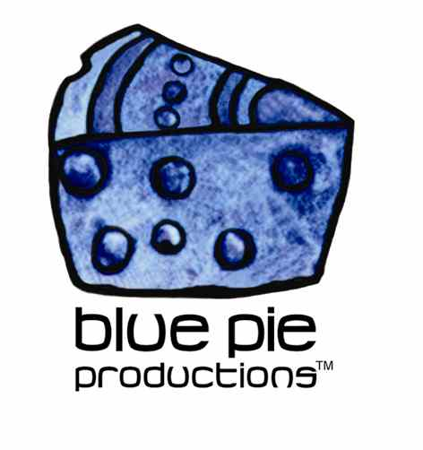
PRESS RELEASE - EFFECTIVE IMMEDIATELY – 05 November 2014

Circle give fans One more reason to get up and dance!

Attention all synthpop lovers! Sydney production duo Circle have just shared their latest single One with us, and we’re spreading their good vibes with the world. Circle have dropped their first studio single in 2 years, along with a sneaky little bootleg video. Circle's first single in 2 years 'One' premiered on Happy last week and fans are already raving about this upbeat, joyous synth pop gem! With a finely tuned recipe of snappy snares, square wave sequences and tape delay, their return to the studio after two years is a testament to the band’s ethos that there’s no shame in loving good, honest pop music!

Circle are an Australian rock band who formed in Enmore, NSW who first began capturing the hearts of fans in 2005. The band currently consists of Radi Safi and Dan Shaw. Circle’s music has been described as alternative, indie rock, indie pop, synth-pop. The band have since branched out to include electronic elements in their music in their experimental production approach and focus on songs as individual singles with a unique life of their own with no one specific ‘sound’.

“One” is an ode to Circles many and varied pop influences. The band pay homage to the pop idioms which defined musical history and have combined them to create something truly unique, which is indicative of a new era of pop music! Influences ranging from neo-twee of the 00’s, the microchip music era of the 80’s and even a little bit of the croontastic 50’s is all referenced in “One”. Alongside the release Circle have released a bootleg stop-motion video! The video is an eerie ode to cult film culture and uses footage is taken from a 1989 cult film “He Was Once”. Digitally distressed, the footage is made to look like something from the original (terrifying) Gumby cartoons.

The band has released three albums and one EP as Circle. The track Fashion me a Drum from their debut studio album The Middle has been featured on several TV shows both locally and in the USA. The video for Fashion me a Drum reached over 100,000 views not long after being published thanks to a placement with fashion retailer ASOS.

The song “One” is the first release from the upcoming “Capital City Cross Word Puzzle” album, which is yet to be given a release date. Listen to the Soundcloud link below and keep your ears peeled for the official album and tour schedule due to be released later this month! For more information on Circle, music news, tour news, new releases and downloads follow the links provided!

Official Website: www.ilovecircle.com
Official Facebook Page: www.facebook.com/ilovecircle
Soundcloud: www.soundcloud.com/mondayrecords/circle-one/
iTunes: itunes.apple.com/us/artist/circle/id349223779
YouTube Channel: www.youtube.com/watch?v=pBEcHREg4uE

****************************************************************************
ABOUT BLUE PIE THE RECORD LABEL:
www.bluepierecords.com
Blue Pie Records is one of the world’s leading independent record Labels and publishing houses. Blue Pie Records has a wide range of alliance-partnerships which it calls upon to create distribution, production, marketing and promotional systems for our artists, labels and global content partners.

Blue Pie's priority artists include Sydonia, Burning the Day, Jack Derwin, The Benjamin Hyatt Band, Terry Oldfield, Phil Manzanera, Johnny Bennett, Suzanna Lubrano, The Objex, Gordon Waller, Dave Evans, Dale Bozzio, and Jessy Tomsko along with labels like ConcertHouse Music, TRAX Records, Mahoning Valley Records, Idyllium Muisc, Sugo Music, Deluxe Records, Reality Entertainment, and PLG Music Group to name a few. Our live concert and video clip library continues to expand and includes live albums, video clips, and video concerts from artists including, Chicago, The Cars, Tiesto, Steve Aoki and Dave Evans to name a few.

Blue Pie's roster of artists continues to gain worldwide recognition with chart success in the USA, Canada, Europe and Australia. Blue Pie is continually developing new markets for our artists, labels, content partners to connect and reach new consumers and fans for their music. The Blue Pie license team has placed over 2000 film, TV, cable show and advertising license sales over the past 3 years alone. The label provides transparent reporting and digital asset management services through its partner Blue Pie Data www.bluepiedata.com

Blue Pie has developed exclusive digital content supply agreements with many companies including: DJ Central TV, Blue Vault Digital, Magic Blue Creative and their partners. The future is bright and we are wearing shades with our expansion into ASIA, North America and Latin America from 2013 onwards. For more information on Blue Pie please visit www.bluepie.com.au

Blue Pie’s label roster includes:
- Electrik Blue Records USA
- Rock Forever Records
- Reality Entertainment (For Australian and New Zealand)
- Globalev World Music
- Deluxe Records
- Pride Music
- Concerthouse Music
- Self Made Records UK
- Media World
- UnCanny Inc
- Subsonic Records
- + Over 200 others. See our website for details.

Search on 'blue pie' in Google for more information.
**END***

Press and Media Contact:

Press and Media Manager
Blue Pie
Unit 20 No 112 McEvoy Street
Alexandria NSW 2015
P: + 61 2 9310 0155
F: + 61 2 9310 0166
E: pr@bluepie.com.au
W: www.bluepierecords.com

************************************************************************

