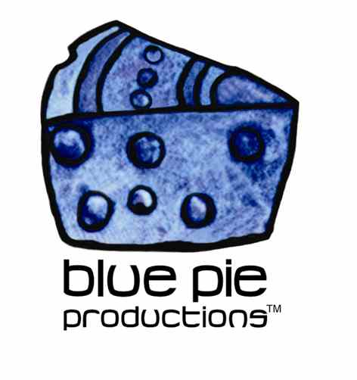
PRESS RELEASE - EFFECTIVE IMMEDIATELY – 12 November 2014

I am Duckeye rock out at The Prince of Wales Bandroom!

Australian punk metal trainwreck and Sydonia expats are excited to announce that they will be performing at Melbourne’s The Prince of Wales Band room on Friday December 5th, 2014. These hard hitting jovial punk rockers will be hitting the stage at the Bandroom in St Kilda at 8pm, so don’t miss out!!

I Am Duckeye is an Australian train wreck rock metal band that can be described as spontaneous and wild, all in the good sense. The band is made up of Sam Haycroft (Vocals, Guitar), Matt Haycroft (Guitar), Julian Medor (Bass), Sean Bailey (Drums). The band has been creating music in the industry since 2008 and creates comedic performances, making them so unique.

Rod Whitfield of Beat Magazine describes I Am Duckeye stating; “Featuring two members of one of Melbourne’s best known alternative/heavy acts Sydonia, I Am Duckeye are a ‘side project’ that have absolutely no worries about being compared to the main band. They are quite the opposite in many ways. While Sydonia destroy all in their path with their intense, metal tinged alternative heavy rock, I Am Duckeye make you roll on the floor, pissing yourself with laughter. They are as much a comedy act as a rock’n’roll band, and their lyrics, antics and onstage banter put a constant smile on your face. At the same time, however, their brand of good-natured thrashy/punky rock is tight, powerful and a whole lot of fun. Definitely a band to check out for a rollicking good time.”

For more information on I Am Duckeye, music news, downloads, gig updates and to watch their “Duckisodes” on YouTube. Check out the links!
www.iamduckeye.com
www.facebook.com/pages/I-am-Duckeye
www.youtube.com/user/iamduckeye
www.instagram.com/iamduckeye
www.twitter.com/IamDuckeye
www.reverbnation.com/iamduckeye

Press:
"COMMANDO TOO, it's the best! Haven't got anything but good things to say. Honestly! Production is perfect! "Grip it" rocks my world! And Panchow is epic. Each song stands next to each on their own. Hard to make an album that flows yet every song is it's own entity, but you have done it! This album will do great things for Duckeye!!! I can feel it. Exciting times ahead."
- Daniel Silk (Obviously deaf) of RED BEE,RED BEE Tour Sedan

****************************************************************************
ABOUT BLUE PIE THE RECORD LABEL:
www.bluepierecords.com
Blue Pie Records is one of the world’s leading independent record Labels and publishing houses. Blue Pie Records has a wide range of alliance-partnerships which it calls upon to create distribution, production, marketing and promotional systems for our artists, labels and global content partners.

Blue Pie's priority artists include Sydonia, Burning the Day, Jack Derwin, The Benjamin Hyatt Band, Terry Oldfield, Phil Manzanera, Johnny Bennett, Suzanna Lubrano, The Objex, Gordon Waller, Dave Evans, Dale Bozzio, and Jessy Tomsko along with labels like ConcertHouse Music, TRAX Records, Mahoning Valley Records, Idyllium Muisc, Sugo Music, Deluxe Records, Reality Entertainment, and PLG Music Group to name a few. Our live concert and video clip library continues to expand and includes live albums, video clips, and video concerts from artists including, Chicago, The Cars, Tiesto, Steve Aoki and Dave Evans to name a few.

Blue Pie's roster of artists continues to gain worldwide recognition with chart success in the USA, Canada, Europe and Australia. Blue Pie is continually developing new markets for our artists, labels, content partners to connect and reach new consumers and fans for their music. The Blue Pie license team has placed over 2000 film, TV, cable show and advertising license sales over the past 3 years alone. The label provides transparent reporting and digital asset management services through its partner Blue Pie Data www.bluepiedata.com

Blue Pie has developed exclusive digital content supply agreements with many companies including: DJ Central TV, Blue Vault Digital, Magic Blue Creative and their partners. The future is bright and we are wearing shades with our expansion into ASIA, North America and Latin America from 2013 onwards. For more information on Blue Pie please visit www.bluepie.com.au

Blue Pie’s label roster includes:
- Electrik Blue Records USA
- Rock Forever Records
- Reality Entertainment (For Australian and New Zealand)
- Globalev World Music
- Deluxe Records
- Pride Music
- Concerthouse Music
- Self Made Records UK
- Media World
- UnCanny Inc
- Subsonic Records
- + Over 200 others. See our website for details.

Search on 'blue pie' in Google for more information.
**END***

Press and Media Contact:

Press and Media Manager
Blue Pie
Unit 20 No 112 McEvoy Street
Alexandria NSW 2015
P: + 61 2 9310 0155
F: + 61 2 9310 0166
E: pr@bluepie.com.au
W: www.bluepierecords.com

************************************************************************

