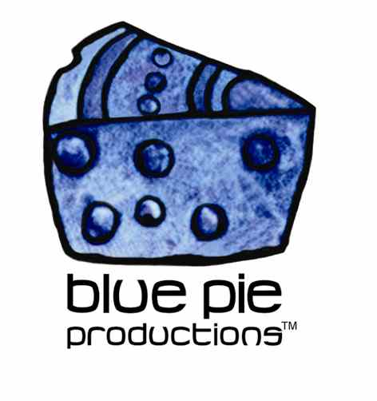
PRESS RELEASE - EFFECTIVE IMMEDIATELY – 12 November 2014

Let Henry Turner Jr & Flavor treat you to dinner… We know they have some tasty treats in store for you!

It is Time To Have Dinner With Henry Turner jr. and flavor again Poor Boy LLoyd's Seafood Restaurant This friday Night 7pm 201 Florida St, Baton Rouge, LA 70801
(225) 387-2271 Make a reservation so you have a table , See You There !!!

Henry Turner jr. and flavor are performing on top of their regular headline slot for the Downtown Saturday Night Concert series. The Downtown Saturday Night Concert series headliner, Henry Turner Jr. & Flavor are well known for their brand of Louisiana Reggae, Soul, Funk and Blues. Make sure you head down every Saturday night for the best music in town!

The band is Henry Turner Jr. on guitar and vocals, Joshua Chang on bass, drummers and percussionists Keith Lewis and Brian Davidson with background vocals by Jenessa Nelson and Diana Mendes. Additional highlights include an array of special guest performers such as blues/folk soloist Johnny Midnite, the jazz funk group Almost Human and rocker and guitarist Ashton Proctor.

Touring extensively throughout the United States for the last fifteen years, some of their Hit City Digital releases include “2 Many Women,” currently playing on 88.1FM, the Caribbean influenced “Smile of Her Face” and “I Like to Limbo,” as well as ballads that include “Love Me or Leave Me” and “I Might Just Let You Go.” Funky dance tunes are “Big Butt Girl” and “Ugly Man,” to mention a few.

Don’t miss out on this unique and intimate perofmance by Henry Turner Jr and Flavor wich is sure to compliment any course! To keep up to date with the band, tune into Henry’s weekly radio show on Tuesdays at www.blogtalkradio.com/hcrgoldenvibes

You can also find out more at www.henryturnerjr.com

For more Henry Turner Jr & Flavor music news, gig updates, new music releases and downloads checkout the links to their official Facebook and ReverbNation pages!
www.facebook.com/HenryTurnerJrAndFlavor
www.reverbnation.com/henryturnerjrandflavor

****************************************************************************
ABOUT BLUE PIE THE RECORD LABEL:
www.bluepierecords.com
Blue Pie Records is one of the world’s leading independent record Labels and publishing houses. Blue Pie Records has a wide range of alliance-partnerships which it calls upon to create distribution, production, marketing and promotional systems for our artists, labels and global content partners.

Blue Pie's priority artists include Sydonia, Burning the Day, Jack Derwin, The Benjamin Hyatt Band, Terry Oldfield, Phil Manzanera, Johnny Bennett, Suzanna Lubrano, The Objex, Gordon Waller, Dave Evans, Dale Bozzio, and Jessy Tomsko along with labels like ConcertHouse Music, TRAX Records, Mahoning Valley Records, Idyllium Muisc, Sugo Music, Deluxe Records, Reality Entertainment, and PLG Music Group to name a few. Our live concert and video clip library continues to expand and includes live albums, video clips, and video concerts from artists including, Chicago, The Cars, Tiesto, Steve Aoki and Dave Evans to name a few.

Blue Pie's roster of artists continues to gain worldwide recognition with chart success in the USA, Canada, Europe and Australia. Blue Pie is continually developing new markets for our artists, labels, content partners to connect and reach new consumers and fans for their music. The Blue Pie license team has placed over 2000 film, TV, cable show and advertising license sales over the past 3 years alone. The label provides transparent reporting and digital asset management services through its partner Blue Pie Data www.bluepiedata.com

Blue Pie has developed exclusive digital content supply agreements with many companies including: DJ Central TV, Blue Vault Digital, Magic Blue Creative and their partners. The future is bright and we are wearing shades with our expansion into ASIA, North America and Latin America from 2013 onwards. For more information on Blue Pie please visit www.bluepie.com.au

Blue Pie’s label roster includes:
- Electrik Blue Records USA
- Rock Forever Records
- Reality Entertainment (For Australian and New Zealand)
- Globalev World Music
- Deluxe Records
- Pride Music
- Concerthouse Music
- Self Made Records UK
- Media World
- UnCanny Inc
- Subsonic Records
- + Over 200 others. See our website for details.

Search on 'blue pie' in Google for more information.
**END***

Press and Media Contact:

Press and Media Manager
Blue Pie
Unit 20 No 112 McEvoy Street
Alexandria NSW 2015
P: + 61 2 9310 0155
F: + 61 2 9310 0166
E: pr@bluepie.com.au
W: www.bluepierecords.com

************************************************************************

