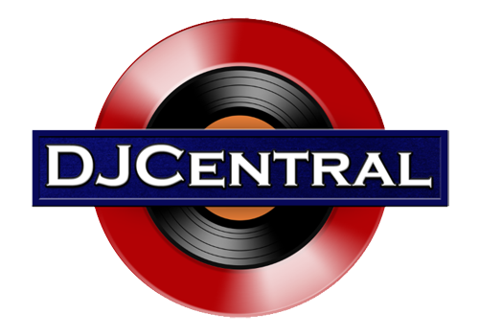
PRESS RELEASE - EFFECTIVE IMMEDIATELY – 7 December 2015

Downer walks the streets of life with his hit song "Suga Boom Boom"

********************************************************************************
7 December 2015 — “Suga Boom Boom” is effectively a journey. A journey that Downer takes us, the listeners, on as we walk with him through the streets of his life.

Downer has walked down roads that many people never travel and in some cases would never want to. His life stories delivered at the pace of a heartbeat, “Suga Boom Boom” has resonated with fans the world over. With over 16,000,000 YouTube plays and counting, constant downloads on all major retailers and a touring schedule that does not stop this is not the 1st or last time you will be hearing Downers stories of life. With the release of his hot new song “Suga Boom Boom” out now on Blue Pie Records, life has never been better.

As Downer says, “I am ready to take my music to the world and make a positive impact on everyone who comes in contact with it. One day I recorded my song Suga Boom Boom using a beat I did off of the refrigerator and uploaded it on Facebook and overnight it went viral. It now has over 10 million views and counting. The song has taken on its own life and continues to grow everyday.”

Downer is building on this momentum and creating and writing new material. He is constantly touring and performing in his home land of California. You can check out live dates via these media channels:

Official Website: www.down3r.com
Air Play Direct: www.airplaydirect.com/music/downer
ReverbNation: www.reverbnation.com/dldowner
Facebook: www.facebook.com/dldownerandlaleazy
Soundcloud: https://soundcloud.com/bluepie/downer-and-suga-boom-boom

James Williams aka Downer is a Blue Pie Records USA artist and “Suga Boom Boom” is available now at all leading digital retailers on the planet.

iTunes: https://itunes.apple.com/us/album/suga-boom-boom-feat.-james/id1020741706

********************************************************************************

ABOUT DJ CENTRAL:

DJ CENTRAL TV is a new and exciting global dance and house music TV show that features lifestyle segments on all things youth, club, dance, and house music culture, bringing the global clubbing nightlife to your TV screens on FOXTEL’s heralded Aurora Channel 183.

Hosted by the dynamic team along with a cast of industry names and artists from all over the world, each week they’ll bring you the latest in dance and house music as well as featuring fashion interviews with celebrities from film to music and sport and bringing our own unique Australian feel to the world of dance and house music.

The shows format is built around a local club that we have selected that we feel represents the best of all the things that the show stands for. We will have segments on the venue itself, the latest music video clips, club competitions and promos, and even a latest news segment keeping you up to date with all the latest gossip in the DJ Club scene.
For more information, visit the official DJ Central website: www.djcentral.tv
***END***

********************************************************************************

CONTACT:

Press and Media Manager
DJ Central ASIA Ltd
C/O Expo112 Unit 20
No 112 McEvoy Street
Alexandria NSW 2013
AUSTRALIA

P: + 61 2 9310 0155
F: +61 2 9310 0166
W: www.djcentral.tv
E: djcentralmusic@gmail.com

