PRESS RELEASE - EFFECTIVE IMMEDIATELY – 7 December 2015

Suzanna and Machel get to STAY on the global radio charts with the release of their duet " Stay "
********************************************************************************
7 December 2015 — Proving that she has staying power, Suzanna Lubrano has dropped her brilliant new single “Stay”

This hot track not only has the soaring vocals of Miss Lubrano herself but it features powerhouse Machel Montano. Machel has over 159,000 followers on Twitter, a staggering 40M plays on Youtube and over 83,000 subscribers. Add to this already impressive following tens of millions in streams on Spotify and Deezer, Machel brings a punch to this hot new record.

Suzanna has won just every award you can in Africa and has amassed over 20M combined plays on YouTube. In September 2015 she had up to 6 singles in the iTunes charts for Africa at any one time. Suzanna is widely loved throughout Europe and Africa and is now constantly touring. This amazing new song is being added to radio play lists world wide.

You can check out live dates via these media channels:

Official Website: www.suzannalubrano.com
Twitter: www.twitter.com/SuzannaLubrano
Facebook: https://www.facebook.com/SuzannaLubranoMusic
Soundcloud: https://soundcloud.com/bluepie/01-stay

Suzanne Lubrano is a Blue Pie Records USA artist and “Stay” is available now at all leading digital retailers on the planet.

iTunes: https://itunes.apple.com/us/album/stay-feat.-single/id1039510394
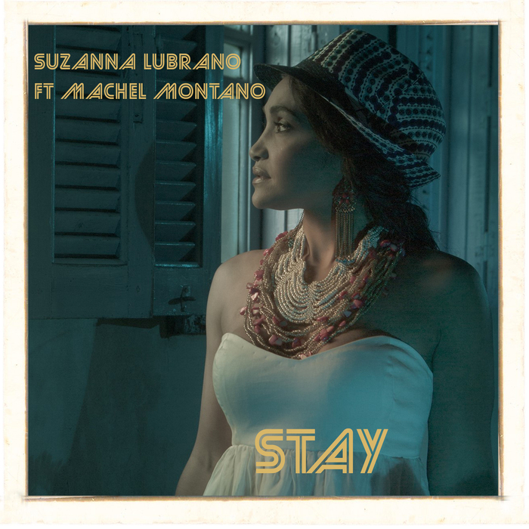
********************************************************************************
ABOUT SUZANNA LUBRANO:
The Netherlands based Suzanna Lubrano is one of the most popular female Zouk artists in the Lusophone markets, incorporating various styles of music from Coladeira to Batuqu to her now recent expression of Latin Pop. With her ever-growing popularity amongst the “Brazilian Zouk” dance worldwide and the “Kizomba Love” Dance scene, Suzanna Lubrano and her Netherlands-based band have performed in countries across the globe, sometimes reaching crowds of up to 80,000 people.

********************************************************************************
ABOUT DJ CENTRAL:
DJ CENTRAL TV is a new and exciting global dance and house music TV show that features lifestyle segments on all things youth, club, dance, and house music culture, bringing the global clubbing nightlife to your TV screens on FOXTEL’s heralded Aurora Channel 183.

Hosted by the dynamic team along with a cast of industry names and artists from all over the world, each week they’ll bring you the latest in dance and house music as well as featuring fashion interviews with celebrities from film to music and sport and bringing our own unique Australian feel to the world of dance and house music.

The shows format is built around a local club that we have selected that we feel represents the best of all the things that the show stands for. We will have segments on the venue itself, the latest music video clips, club competitions and promos, and even a latest news segment keeping you up to date with all the latest gossip in the DJ Club scene.
For more information, visit the official DJ Central website: www.djcentral.tv
***END***

********************************************************************************

CONTACT:

Press and Media Manager
DJ Central ASIA Ltd
C/O Expo112 Unit 20
No 112 McEvoy Street
Alexandria NSW 2013
AUSTRALIA

P: + 61 2 9310 0155
F: +61 2 9310 0166
W: www.djcentral.tv
E: djcentralmusic@gmail.com

