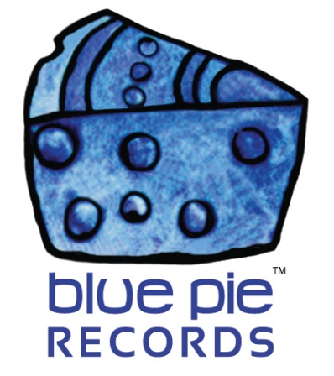

PRESS RELEASE - EFFECTIVE IMMEDIATELY – 20 June 2018

SONGTRADR LOVES BLUE PIE RECORDS OVER 2.9 MILLION TIMES. THE BLUE PIE SYNC LICENSE TEAM LANDS OVER 60 PLACEMENTS WITH SONGTRADR IN JUST A FEW MONTHS!

********************************************************************************
The Blue Pie Records Sync Team has been extremely busy working away on the development of our Songtradr store. Feel free to check out the site here www.songtradr.com/user/profile/bluepierecords.

In a few short months we have secured more than 60 license sales and shortlisted over 900 others. The system is great and we feel there will be an amazing future ahead with the platform. It is now embedded as one of the main ways that we service all our production teams, film studios and media partners with the thousands of hits we have in our catalogue.
We highly recommend this system to all our label partners. It is time consuming to develop which is why the Blue Pie Sync Team can help and support both you and your label with our talented teams in our Australia, Canada, India and China offices.
The team has landed over 100 new placements using the system with over 60 coming direct via Songtradr.

WE LOVE YOU SONGTRADR!!!
From the Sync Team at Blue Pie Records USA
www.songtradr.com/user/profile/bluepierecords
********************************************************************************
ABOUT BLUE PIE THE RECORD LABEL:
Blue Pie Records are one of the world’s leading independent record Labels and publishing houses. Blue Pie's priority artists include Josh Young, Toyanna Rae, Missy Crissy, Raz B, Down3r, LadyDice, The East Side Boyz, Jah Mason, Burning the Day, Jack Derwin, Terry Oldfield, Phil Manzanera, Johnny Bennett, Suzanna Lubrano, The Objex, Gordon Waller, Dave Evans, Dale Bozzio, and Jessy Tomsko to name a few.
Blue Pie distributes over 300 small to medium sized labels including e ConcertHouse Music, TRAX Records, Destiny Records, Apple Media Africa, Nedjon Entertainment, Idyllium Muisc, Sugo Music, Deluxe Records, Reality Entertainment, and Raz Beatz Media Group to name a few.
Our live concert and video clip library continues to expand and includes live albums, video clips, and video concerts from artists including, Chicago, The Cars, Steve Aoki and Dave Evans for instance.
In 2018, Blue Pie's roster of artists continues to gain worldwide recognition with chart success in the USA, Canada, Europe and Australia. Blue Pie is continually developing new markets for our artists, labels, content partners to connect and reach new consumers and fans for their music.

For more information, visit the official Blue Pie Records USA website: www.bluepierecords.com

********************************************************************************
Press and Media Contact:

Press and Media Manager
Blue Pie Records USA
Unit 6 No 9 Clarence Street
Moss Vale, NSW 2577
Australia
P: + 61 2 9310 0155
F: +61 2 9310 0166
W: www.bluepierecords.com
E: pr@bluepie.com.au

********************************************************************************

