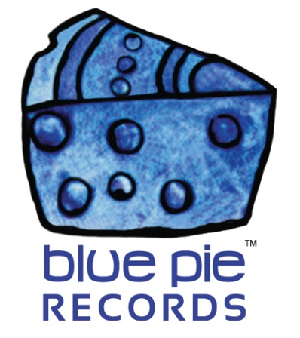
PRESS RELEASE - EFFECTIVE IMMEDIATELY – 02 July 2018

The Argues: The Movie is now available on Amazon!
********************************************************************************

The Argues: The Movie is a 2010 Australian comedy/mockumentary produced by Egmond Productions and distributed by Planet Blue Pictures US. It was directed by Mark Hembrow and starring Patricia Argue, Steven Tandy, Stuart Thompson, and David Argue, best known for his role as Snowy in Gallipoli. The film was written by David Argue and Hembrow with improvisation by David Argue, Patricia Argue and Thompson.
The Argues: The Movie is a story of how a son, a mother, and a duck named Leon Skank assault the Hollywood star system in an attempt to secure one of the biggest international actors’ agents in the world, Ed Tomato at ICU Management Los Angeles. However, things don’t go so well and it results in a chase around the world leading them to Hollywood, New York, Florence, Venice, Dubai and Melbourne.
This movie is a story which leads the actors into outrageous situations that offer a bizarre insight into the world of showbiz and the struggles of an out of work actor.
The movie is also based on the true life of Argue’s mother as she loves America and Europe, where she ice skated in many famed shows.

The film is now available on ITunes and Amazon, to watch it or for more information you can use the following links:
- Planet Blue Pictures: https://bit.ly/2MHXGL1
- Amazon: https://amzn.to/2lJLj5s
- ITunes: https://apple.co/2MDb1Ek
- Website: http://www.thearguesthemovie.com

********************************************************************************

ABOUT BLUE PIE THE RECORD LABEL:
Blue Pie Records are one of the world’s leading independent record Labels and publishing houses. Blue Pie's priority artists include Josh Young, Toyanna Rae, Missy Crissy, Raz B, Down3r, LadyDice, The East Side Boyz, Jah Mason, Burning the Day, Jack Derwin, Terry Oldfield, Phil Manzanera, Johnny Bennett, Suzanna Lubrano, The Objex, Gordon Waller, Dave Evans, Dale Bozzio, and Jessy Tomsko to name a few.
Blue Pie distributes over 300 small to medium sized labels including e ConcertHouse Music, TRAX Records, Destiny Records, Apple Media Africa, Nedjon Entertainment, Idyllium Muisc, Sugo Music, Deluxe Records, Reality Entertainment, and Raz Beatz Media Group to name a few.
Our live concert and video clip library continues to expand and includes live albums, video clips, and video concerts from artists including, Chicago, The Cars, Steve Aoki and Dave Evans for instance.
In 2018, Blue Pie's roster of artists continues to gain worldwide recognition with chart success in the USA, Canada, Europe and Australia. Blue Pie is continually developing new markets for our artists, labels, content partners to connect and reach new consumers and fans for their music.
For more information, visit the official Blue Pie Records USA website: www.bluepierecords.com
********************************************************************************
Press and Media Contact:

Press and Media Manager
Blue Pie Records USA
Unit 6 No 9 Clarence Street
Moss Vale, NSW 2577
Australia
P: + 61 2 9310 0155
F: +61 2 9310 0166
W: www.bluepierecords.com
E: pr@bluepie.com.au

********************************************************************************

