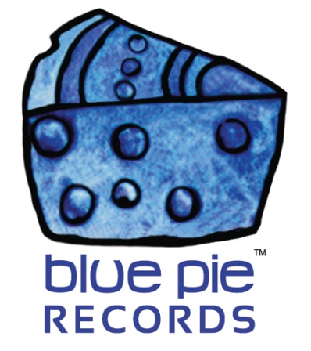
PRESS RELEASE - EFFECTIVE IMMEDIATELY – 03 July 2018

The successful movie “Who pays the Hitman” is everything but a waste of time!

********************************************************************************
Remember this movie’s name: Who pays the Hitman. A 2010 movie written by Andrew Hartley, directed by Rod Milner and starring mainly Shalane Connors and Matthew Burke, Who pays the Hitman has been produced by Bondiwood Films and distributed by Planet Blue Pictures US.
This comedy/drama movie is the story a doctor, two patients, a priest and an assassin, who are all thrown together in the emergency room of a hospital one late Saturday night. The Hitman slowly reveals his purpose but due to the law of patient confidentiality, and the priest’s vows, they can’t say or do anything. Moral and ethical dilemmas are intensified when a badly mutilated prostitute is brought in by the man responsible for her condition. He must be stopped. Will the doctor and the priest sacrifice everything they believe in to call upon the right man for the job that is in the room with them? If only it were that simple; the Hitman has ethics too. Killing for free would make him nothing more than a common murderer.
This movie has encountered success several time as it was the Winner of the Honorable Mention at the Los Angeles New Wave International Film Festival US in 2011, then was nominated in the category ‘Best Narrative Feature’ at the Macon Film Festival in 2011 and also won the Honorable Mention in 2012 at the Sunset Film Festival Los Angeles.

Do not hesitate anymore and run to watch it! You can find it here as well as other information:
- Website: www.whopaysthehitman.com
- Facebook: www.facebook.com/whopaysthehitman
- Vimeo: https://vimeo.com/155923726
- Planet Blue Pictures: https://bit.ly/2KHERH8
- Amazon: https://amzn.to/2pGYJRo

********************************************************************************

ABOUT BLUE PIE THE RECORD LABEL:
Blue Pie Records are one of the world’s leading independent record Labels and publishing houses. Blue Pie's priority artists include Josh Young, Toyanna Rae, Missy Crissy, Raz B, Down3r, LadyDice, The East Side Boyz, Jah Mason, Burning the Day, Jack Derwin, Terry Oldfield, Phil Manzanera, Johnny Bennett, Suzanna Lubrano, The Objex, Gordon Waller, Dave Evans, Dale Bozzio, and Jessy Tomsko to name a few.
Blue Pie distributes over 300 small to medium sized labels including e ConcertHouse Music, TRAX Records, Destiny Records, Apple Media Africa, Nedjon Entertainment, Idyllium Muisc, Sugo Music, Deluxe Records, Reality Entertainment, and Raz Beatz Media Group to name a few.
Our live concert and video clip library continues to expand and includes live albums, video clips, and video concerts from artists including, Chicago, The Cars, Steve Aoki and Dave Evans for instance.
In 2018, Blue Pie's roster of artists continues to gain worldwide recognition with chart success in the USA, Canada, Europe and Australia. Blue Pie is continually developing new markets for our artists, labels, content partners to connect and reach new consumers and fans for their music.
For more information, visit the official Blue Pie Records USA website: www.bluepierecords.com
********************************************************************************
Press and Media Contact:

Press and Media Manager
Blue Pie Records USA
Unit 6 No 9 Clarence Street
Moss Vale, NSW 2577
Australia
P: + 61 2 9310 0155
F: +61 2 9310 0166
W: www.bluepierecords.com
E: pr@bluepie.com.au

********************************************************************************

