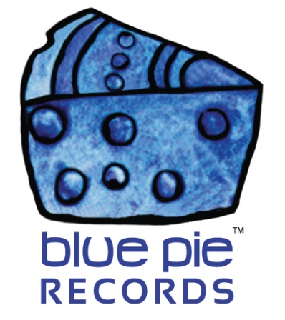

Get to know Black Dawn!

PRESS RELEASE EFFECTIVE IMMEDIATELY 24 May 2019:

Black Dawn’s rich guitar compositions, loud bass and intense lyrics are the perfect energy riser for any occasion. Black Dawn produces music that bleeds raw emotion and reflects the best of the Heavy Metal genre. They’ve been with us for over 10 years, and we’ve loved to have them for that long- we wouldn’t want to ever lose their unique brand of talent!
Black Dawn has been producing and performing music in the Long Island/New York region since 1996. The band currently consists of Matt Kotten (Lead Guitar / Vocals), Tom Kelly (Rhythm Guitar), Shawn Cox (Bass Guitar – formerly of New York City’s Sworn Enemy), and Enzo DiPaolo (Drums). They have produced two albums “Absence of Time” (1999) and “Age of Reason” (2004), and the EP “Until We Meet” (2014). With several of these tracks being selectively chosen by numerous digital radio stations, podcasts and colleges globally, showcasing the talent and reach of this band.
The band draws inspiration from Godsmack, White Zombie, and Five Finger Death Punch, utilising traits from each of these artists to create an eclectic range of heavy metal that encompasses Black Dawn’s identity.
So it’s no surprise how much of an absolutely insane song their latest hit is!
BLACK DAWN – “UPON YOUR LIPS”: https://www.youtube.com/watch?v=UccJ_ID6T_Y
The intense thrashing of that guitar and those awesome gritty vocals set the scene perfectly for the dramatic military story showcased in the music video. It’ll have you on the edge of your seat, get you invested, and send the adrenaline flushing through your veins… much like the song itself. And that’s just one example of Black Dawn’s talents! There are plenty more on their website, linked below.
Check them out for yourself:
- Website – blackdawnmusic.com
- Facebook – facebook.com/blackdawnpage
- Twitter – twitter.com/blackdawnband
- YouTube – youtube.com/user/blackdawntube
- iTunes – itunes.apple.com/au/album/until-we-meet-ep/id891653273
- SoundCloud – soundcloud.com/blackdawnband
- MySpace – myspace.com/blackdawnband
- Reverbnation – reverbnation.com/blackdawnband
But if that list of links doesn’t satisfy you, allow us to recommend certain hits to you! Rock on, metal fans.
BLACK DAWN- I WANNA FLY: https://www.youtube.com/watch?v=Us7e8jNCXPw
BLACK DAWN- OPEN THE GATES:
https://www.youtube.com/watch?v=jwXhjVz9Jz8
BLACK DAWN- I COULD NEVER BE: https://www.youtube.com/watch?v=IKW8IQ5N1Vo

============================================
ABOUT BLUE PIE THE RECORD LABEL:

Blue Pie Records are one of the world’s leading independent record Labels and publishing houses. Blue Pie's priority artists include Josh Young, Toyanna Rae, Missy Crissy, Raz B, Down3r, LadyDice, The East Side Boyz, Jah Mason, Burning the Day, Jack Derwin, Terry Oldfield, Phil Manzanera, Johnny Bennett, Suzanna Lubrano, The Objex, Gordon Waller, Dave Evans, Dale Bozzio, and Jessy Tomsko to name a few.

Blue Pie distributes over 300 small to medium sized labels including e ConcertHouse Music, TRAX Records, Destiny Records, Apple Media Africa, Nedjon Entertainment, Idyllium Muisc, Sugo Music, Deluxe Records, Reality Entertainment, and Raz Beatz Media Group to name a few.

Our live concert and video clip library continues to expand and includes live albums, video clips, and video concerts from artists including, Chicago, The Cars, Steve Aoki and Dave Evans to name a few.

In 2019, Blue Pie's roster of artists continues to gain worldwide recognition with chart success in the USA, Canada, Europe and Australia. Blue Pie is continually developing new markets for our artists, labels, content partners to connect and reach new consumers and fans for their music.

For more information, visit the official Blue Pie Records USA website: www.bluepierecords.com

Press and Media Contact:

Press and Media Manager
Blue Pie Records USA
Clarence House
Unit 6 No 9 Clarence Street
Moss Vale NSW 2015
AUSTRALIA
P: + 61 2 9310 0155
F: + 61 2 9310 0166
E: pr@bluepie.com.au
W: www.bluepierecords.com

============================================

