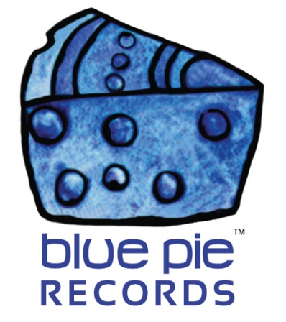

J Young’s “Lit” playcount is surging into the thousands!

PRESS RELEASE EFFECTIVE IMMEDIATELY 24 May 2019:

Does this sound familiar?
J YOUNG, AFTER 5- LIT:
https://open.spotify.com/album/0mddcJkQ56yMMGD0AZVQ5D
Probably does from this article of ours:
https://www.bluepierecords.com/news/j-young-and-after-5-are-getting-lit-with-their-new-single/
It’s been stuck in all our heads since the last time we talked about it, and we’re not complaining! And it seems the rest of the internet is following suit with that, because in just the short time in which Lit by J Young and After 5 has been released, it has already amassed 4,179 plays on Spotify! We’re expecting more swings in the duo’s popularity coming soon too… 2019 ain’t over yet, and there’s plenty of time to skyrocket Lit into popularity, so share it round to everyone you know who likes good music!
If you’re just discovering J Young for the first time and this is your gateway, allow me to open the door for you fully with this playlist.
J YOUNG TOP TRACKS PLAYLIST:
https://open.spotify.com/artist/3iknmBe6fYGh6YDVJebTbE
It’s the kind of music that you just get hungry for more of and can’t stop listening to new tracks that you come across! Enjoy your journey!
“Lit” official links:

- iTunes: https://itunes.apple.com/us/album/lit-single/1450249676
- Spotify: https://open.spotify.com/album/0mddcJkQ56yMMGD0AZVQ5D?si=7KwaS_3CS-KSlKacY5IwKA
- Amazon: https://www.amazon.com/Lit-After-5-J-Young/dp/B07QHFKXK3/ref=sr_1_4?keywords=j+young+lit&qid=1554777990&s=dmusic&sr=1-4
- Google Play: https://play.google.com/store/music/album/J_Young_Lit?id=Bwy42mmfucrlooa57diaxfiiwju
- Deezer: https://www.deezer.com/en/album/92565702
We hope you enjoy this music video of Oxygen too! Let yourself indulge in J Young’s many talents-
https://www.youtube.com/watch?v=QMHisEx_KuE
J Young is a DJ Central artist and is published by DJ Central for the world. You can check out more information and the latest news on J Young at the following links:
https://www.youtube.com/channel/UCOrLNJiDxWgOcQUudGCy9vQ
https://www.facebook.com/Josh-Young-219005524963800

============================================
ABOUT BLUE PIE THE RECORD LABEL:

Blue Pie Records are one of the world’s leading independent record Labels and publishing houses. Blue Pie's priority artists include Josh Young, Toyanna Rae, Missy Crissy, Raz B, Down3r, LadyDice, The East Side Boyz, Jah Mason, Burning the Day, Jack Derwin, Terry Oldfield, Phil Manzanera, Johnny Bennett, Suzanna Lubrano, The Objex, Gordon Waller, Dave Evans, Dale Bozzio, and Jessy Tomsko to name a few.

Blue Pie distributes over 300 small to medium sized labels including e ConcertHouse Music, TRAX Records, Destiny Records, Apple Media Africa, Nedjon Entertainment, Idyllium Muisc, Sugo Music, Deluxe Records, Reality Entertainment, and Raz Beatz Media Group to name a few.

Our live concert and video clip library continues to expand and includes live albums, video clips, and video concerts from artists including, Chicago, The Cars, Steve Aoki and Dave Evans to name a few.

In 2019, Blue Pie's roster of artists continues to gain worldwide recognition with chart success in the USA, Canada, Europe and Australia. Blue Pie is continually developing new markets for our artists, labels, content partners to connect and reach new consumers and fans for their music.

For more information, visit the official Blue Pie Records USA website: www.bluepierecords.com

Press and Media Contact:

Press and Media Manager
Blue Pie Records USA
Clarence House
Unit 6 No 9 Clarence Street
Moss Vale NSW 2015
AUSTRALIA
P: + 61 2 9310 0155
F: + 61 2 9310 0166
E: pr@bluepie.com.au
W: www.bluepierecords.com

============================================

