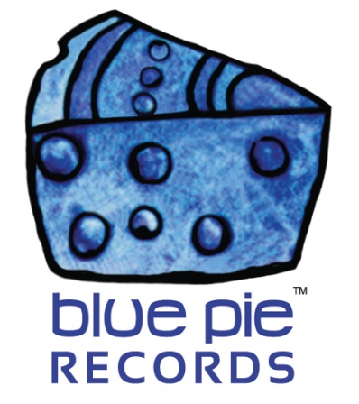

Kay L nominated for artist of the year award for Zimbabwe!

PRESS RELEASE EFFECTIVE IMMEDIATELY 24 May 2019:

“An individual or group who have demonstrated great musicianship, quality and uniqueness of music, and performances throughout the year. They will have a huge presence and impact on their audience/listeners on multiple channels.”
Does that sound like Kay L to you? It sure does to me! So it makes sense that he took the number four nomination slot of that very category, that being “Music Artist of the Year”!
As seen in this story: https://allafrica.com/stories/201904220076.html ZAA Canada (Zimbabwe Achievers Awards) have just nominated Kay L for the award alongside Ruvarashe Mutseka, Napitapi, Ekhaya Music, and Melissa Natasha – Rain Akai. For the full nominations list for each category and more information, click here: https://allafrica.com/stories/201904220076.html The official awards ceremony dinner gala will be held Saturday 29th June 2019 in Edmonton at the Radisson Hotel! We’ll be waiting with bated breath to see if he can take the award proper- just a month or so away! Kay L is no stranger to winning awards for his excellent talent, but we’ll still be rooting for him with our whole hearts! To read more about Kay L’s past awards, click here: https://www.bluepierecords.com/news/kay-l-nominated-three-times-at-yycma-wins-best-urban-recording-of-2018/
If you need to re-familiarise yourself with Kay L, click here to read more about one of his latest singles!
https://www.bluepierecords.com/release/kay-l-has-teamed-up-with-bobby-blastem-bobby-soul-to-bring-you-love-from-me/
Or if you wanna just jump straight into his music, we have you covered!
The chill flow in Love From Me is not to be missed! Check it out on our Soundcloud right here!
https://soundcloud.com/bluepie/kay-l-ft-bobby-blastem-bobby-soul-love-from-me
Kay L’s Facebook can be found HERE: www.facebook.com/thekayl
Speaking of Facebook, check out this teaser from Kay L himself… a video accompaniment to Love From Me!
https://www.facebook.com/kaylmusic/videos/10161507364130473/
============================================
ABOUT BLUE PIE THE RECORD LABEL:

Blue Pie Records are one of the world’s leading independent record Labels and publishing houses. Blue Pie's priority artists include Josh Young, Toyanna Rae, Missy Crissy, Raz B, Down3r, LadyDice, The East Side Boyz, Jah Mason, Burning the Day, Jack Derwin, Terry Oldfield, Phil Manzanera, Johnny Bennett, Suzanna Lubrano, The Objex, Gordon Waller, Dave Evans, Dale Bozzio, and Jessy Tomsko to name a few.

Blue Pie distributes over 300 small to medium sized labels including e ConcertHouse Music, TRAX Records, Destiny Records, Apple Media Africa, Nedjon Entertainment, Idyllium Muisc, Sugo Music, Deluxe Records, Reality Entertainment, and Raz Beatz Media Group to name a few.

Our live concert and video clip library continues to expand and includes live albums, video clips, and video concerts from artists including, Chicago, The Cars, Steve Aoki and Dave Evans to name a few.

In 2019, Blue Pie's roster of artists continues to gain worldwide recognition with chart success in the USA, Canada, Europe and Australia. Blue Pie is continually developing new markets for our artists, labels, content partners to connect and reach new consumers and fans for their music.

For more information, visit the official Blue Pie Records USA website: www.bluepierecords.com

Press and Media Contact:

Press and Media Manager
Blue Pie Records USA
Clarence House
Unit 6 No 9 Clarence Street
Moss Vale NSW 2015
AUSTRALIA
P: + 61 2 9310 0155
F: + 61 2 9310 0166
E: pr@bluepie.com.au
W: www.bluepierecords.com

============================================

