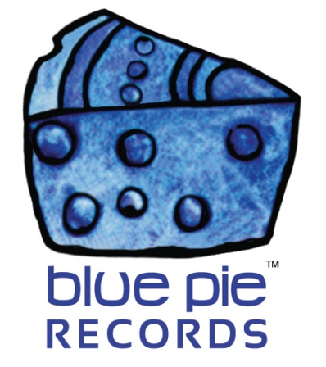

Live at Off-Corso- live in the comfort of your home!

PRESS RELEASE EFFECTIVE IMMEDIATELY 24 May 2019:

Earlier this year, we brought your attention to four fantastic concerts, live on Qello… those being Headband: Live, Silver Mountain- A Reunion Live, Freakhouse- No Way Down, and of course Suzanna Lubrano- Live At Off-Corso! And we’re forever grateful for Qello preserving important pieces of musical history for the world like they are! But today we’d like to look at one of these monumental concerts under a spotlight, and of course, that would be Suzanna Lubrano’s Live At Off-Corso (2010).
Suzanna Lubrano’s debut Film, Live at Off-Corso, features a stunning live performance.
Live at Off-Corso was originally a TV concert, which has now been televised in numerous countries around the world including Brazil, Portugal and many more. Released in June 2010 this incredible performance stars a line-up of special guests and dancers including; Dutch saxophonist Candy Dulfer, Dutch idol contestant David Goncalves, Lantuna, the Lamba Zouk Dance team and the Brazilian Zouk Dance team. It is like a fiesta on stage, filled with unstoppable music and dancing.
SUZANNA LUBRANO SPOTIFY PLAYLIST: https://open.spotify.com/user/djcentraltv/playlist/6hIq9MakmRuXQsVATwg09T?si=X2Jw6eGYQEqRTcpC5yw2Sg
As you can see, Suzanna carries a stunning aura and her musical talents extend beyond the norm. She has been compared to some of the greatest pop divas of our world; Celine Dion, Beyonce, Mariah Carey and J-Lo. Her talent has been recognised by many, and has won her awards around the globe.
Originally from Cape Verde, West of Africa, Suzanna moved to The Netherlands at the age of four. Like many superstars, she started singing as a young child, but was quickly recognised and encouraged to start singing professionally at the age of eighteen. And that degree of constant experience shows, most prominently through the true quality of her work- her combined global plays have exceeded 40 million! Her amazing talents are still roping in the fans, new curious ones and nostalgic veterans alike!
https://www.youtube.com/watch?v=7MP6Mj6lftM
So what better way to be part of the magic than to experience it in your living room, or on your phone’s screen while kicking back in bed, or any other place that’s convenient to you? All of the wonderful promises of the above is what Qello promises to deliver you. It doesn’t matter if you weren’t around for the magical experience the first time around, make your own magic by streaming any concert in the comfort of your home- and we recommend Suzanna as the perfect place to start discovering. Check out some of our concert recommendations below, including the link to the Suzanna concert, and Suzanna’s social media!
SOCIAL MEDIA
- Facebook
- Twitter
- Instagram
QELLO CONCERTS
- Suzanna Lubrano- Live at Off-Corso (2010) https://qello.com/concert/Live-at-Off-Corso-5537
- Headband: Live (1999) https://qello.com/concert/Headband-Live-5538
- Silver Mountain- A Reunion Live (2010) https://qello.com/concert/A-Reunion-Live-5586
- Freakhouse- No Way Down (2008) https://qello.com/concert/No-Way-Down-5536
============================================
ABOUT BLUE PIE THE RECORD LABEL:

Blue Pie Records are one of the world’s leading independent record Labels and publishing houses. Blue Pie's priority artists include Josh Young, Toyanna Rae, Missy Crissy, Raz B, Down3r, LadyDice, The East Side Boyz, Jah Mason, Burning the Day, Jack Derwin, Terry Oldfield, Phil Manzanera, Johnny Bennett, Suzanna Lubrano, The Objex, Gordon Waller, Dave Evans, Dale Bozzio, and Jessy Tomsko to name a few.

Blue Pie distributes over 300 small to medium sized labels including e ConcertHouse Music, TRAX Records, Destiny Records, Apple Media Africa, Nedjon Entertainment, Idyllium Muisc, Sugo Music, Deluxe Records, Reality Entertainment, and Raz Beatz Media Group to name a few.

Our live concert and video clip library continues to expand and includes live albums, video clips, and video concerts from artists including, Chicago, The Cars, Steve Aoki and Dave Evans to name a few.

In 2018, Blue Pie's roster of artists continues to gain worldwide recognition with chart success in the USA, Canada, Europe and Australia. Blue Pie is continually developing new markets for our artists, labels, content partners to connect and reach new consumers and fans for their music.

For more information, visit the official Blue Pie Records USA website: www.bluepierecords.com

Press and Media Contact:

Press and Media Manager
Blue Pie Records USA
Clarence House
Unit 6 No 9 Clarence Street
Moss Vale NSW 2015
AUSTRALIA
P: + 61 2 9310 0155
F: + 61 2 9310 0166
E: pr@bluepie.com.au
W: www.bluepierecords.com

============================================

