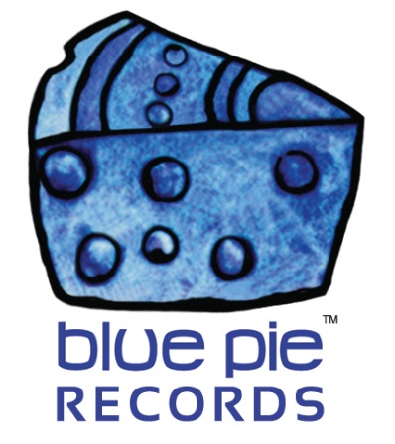

Meet BlackFaceNaija!

PRESS RELEASE EFFECTIVE IMMEDIATELY 24 May 2019:

BlackFaceNaija, sometimes known simply as “Blackface”, is an artist we’ve been signed with since 2006, and we’ve enjoyed every single day. Since he broke into the market with 2Baba (who was known as 2Face at the time) with their incredible co-written album “African Queen”, he’s been making quality music and reaching his dreams, and his fans have loved to hear the amazing dancehall tunes that have resulted from that. If you’re not familiar, have this album so you can number among these satisfied fans!
AFRICAN QUEEN: https://open.spotify.com/album/3O8nDOFmsRDkkCIFqOqDBo?si=U_AuQNmJQZOP0tfr6b3ipQ
An easy classic for anyone’s library, the amazing rhythm, beats, and fantastic chill vibe are sure to make anyone smile. This is an album compiling different versions of the song that the duo were most known for, and it’s easy to see why they were known for it. But neither of them stopped there. In particular, BlackFaceNaija went on to see success elsewhere with his inclusion in albums dedicated to his hits, with a few other artists contributing as well! And of course he had several other brilliant albums such as “Twist and Turn” and “WAR (2face Diss)”.
THE HITS, VOL. 1: https://open.spotify.com/album/7LzvOwVpZxqOhZl8XCti9P?si=p5iEP-rKQRCwkq0Djc_3sg
THE HITS, VOL. 2: https://open.spotify.com/album/0NOe8wUnSJUYMTXplgUgbQ?si=XEphmO_ZQTSGwAiuRPsB5Q
BLACKFACENAIJA REVERBNATION:
www.reverbnation.com/blackfacenaija
Many more exist beyond these of course! An artist that’s been active since 2000 is bound to have countless contributions to the musical scene, and plenty of hits too! Blackface has also been featured on our very own Afrobeatz and Sound Waves From Africa compilations!

AFROBEATZ VOL, 4:
https://open.spotify.com/album/2b120fvG31KqqTfF7AEmK4?si=yd9gh4FyStqewdT-bd02Bg

Blackface broke into the industry properly in 2004, and is one of the lucky African artists to get widespread international recognition. We’re happy to have worked with him all these years and hope you folks at home enjoy his special brand of music!

BLACKFACENAIJA OFFICIAL LINKS:
www.facebook.com/MrBFN
www.twitter.com/Blackfacenaija

LIFE TIME OFFICIAL VIDEO:
https://www.youtube.com/watch?v=5NDjpkxSLQc

============================================
ABOUT BLUE PIE THE RECORD LABEL:

Blue Pie Records are one of the world’s leading independent record Labels and publishing houses. Blue Pie's priority artists include Josh Young, Toyanna Rae, Missy Crissy, Raz B, Down3r, LadyDice, The East Side Boyz, Jah Mason, Burning the Day, Jack Derwin, Terry Oldfield, Phil Manzanera, Johnny Bennett, Suzanna Lubrano, The Objex, Gordon Waller, Dave Evans, Dale Bozzio, and Jessy Tomsko to name a few.

Blue Pie distributes over 300 small to medium sized labels including e ConcertHouse Music, TRAX Records, Destiny Records, Apple Media Africa, Nedjon Entertainment, Idyllium Muisc, Sugo Music, Deluxe Records, Reality Entertainment, and Raz Beatz Media Group to name a few.

Our live concert and video clip library continues to expand and includes live albums, video clips, and video concerts from artists including, Chicago, The Cars, Steve Aoki and Dave Evans to name a few.

In 2019, Blue Pie's roster of artists continues to gain worldwide recognition with chart success in the USA, Canada, Europe and Australia. Blue Pie is continually developing new markets for our artists, labels, content partners to connect and reach new consumers and fans for their music.

For more information, visit the official Blue Pie Records USA website: www.bluepierecords.com

Press and Media Contact:

Press and Media Manager
Blue Pie Records USA
Clarence House
Unit 6 No 9 Clarence Street
Moss Vale NSW 2015
AUSTRALIA
P: + 61 2 9310 0155
F: + 61 2 9310 0166
E: pr@bluepie.com.au
W: www.bluepierecords.com

============================================

