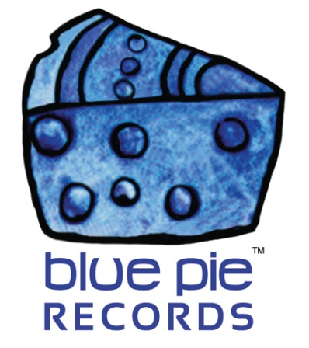

Mike C tears it up with his steamy hit, Sophisticated!

PRESS RELEASE EFFECTIVE IMMEDIATELY 24 May 2019:

Mike C, the head honcho at Miracle West Entertainment, has worked closely with DJ Central and Blue Pie for some time now, and it’s nothing short of an injustice that a banger like Sophisticated hasn’t been heard by more people. Today, we’re gonna change that!
MIKE C- SOPHISTICATED: https://www.youtube.com/watch?v=F0uhmzO3AsY
Listen to the flow, that bass, that beat, that hook! The sensual lyrics paired with the chill beat perfectly suit a night out hooking up. It ain’t a party song for no kids, and its smooth beats and lyrics will transfix you.
Sophisticated… so underrated… shining bright like her body’s gold plated… sweet like some caramel… silky Philapina hair… that body’s tight while I’m peeling off her underwear…
It’s got some tight beats and a tight hook, just how Mike C and his friends like it. You can see the same sorta flow in their older hit, California, but ramped up to match the pace of a faster beat!
MIKE C & LIL THROWDOWN- CALIFORNIA: https://www.youtube.com/watch?v=prlMEOq5IKs

Mike C and his crew are here to stay, and we got big news coming regarding Miracle West, so stay tuned fam!
For more information on Mike C and the rest of the crew at Miracle West Entertainment, check out their website: www.miraclewestent.com

============================================
ABOUT BLUE PIE THE RECORD LABEL:

Blue Pie Records are one of the world’s leading independent record Labels and publishing houses. Blue Pie's priority artists include Josh Young, Toyanna Rae, Missy Crissy, Raz B, Down3r, LadyDice, The East Side Boyz, Jah Mason, Burning the Day, Jack Derwin, Terry Oldfield, Phil Manzanera, Johnny Bennett, Suzanna Lubrano, The Objex, Gordon Waller, Dave Evans, Dale Bozzio, and Jessy Tomsko to name a few.

Blue Pie distributes over 300 small to medium sized labels including e ConcertHouse Music, TRAX Records, Destiny Records, Apple Media Africa, Nedjon Entertainment, Idyllium Muisc, Sugo Music, Deluxe Records, Reality Entertainment, and Raz Beatz Media Group to name a few.

Our live concert and video clip library continues to expand and includes live albums, video clips, and video concerts from artists including, Chicago, The Cars, Steve Aoki and Dave Evans to name a few.

In 2019, Blue Pie's roster of artists continues to gain worldwide recognition with chart success in the USA, Canada, Europe and Australia. Blue Pie is continually developing new markets for our artists, labels, content partners to connect and reach new consumers and fans for their music.

For more information, visit the official Blue Pie Records USA website: www.bluepierecords.com

Press and Media Contact:

Press and Media Manager
Blue Pie Records USA
Clarence House
Unit 6 No 9 Clarence Street
Moss Vale NSW 2015
AUSTRALIA
P: + 61 2 9310 0155
F: + 61 2 9310 0166
E: pr@bluepie.com.au
W: www.bluepierecords.com

============================================

