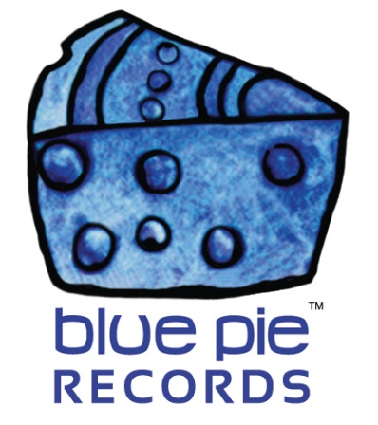

Nedjon, our man on the ground in Lagos and Africa!

PRESS RELEASE EFFECTIVE IMMEDIATELY 24 May 2019:

Nedjon is a man of many talents, not only is he a musician with fantastic hits such as Green Light and You Be God, but he is a logistical professional, and we’re excited to announce his contributions to our catalogue promise to be quite impressive!
An example of Nedjon’s musical talent, his most popular song on Spotify, Green Light:
https://open.spotify.com/album/0MQJ6pp3lGNPLCy7eDuTVD
Nedjon has not only provided us with his own musical talent, but has introduced us to many African acts that we are glad to have discovered! These diamonds in the rough have signed on with multiple labels that Nedjon has contributed to managing, such as M & O Records, One House Music and Sound, Royal Sound Entertainment, and Tizzle Nation, just to name a few! His proficiency with customer relationships has allowed him to expand his roster for his label Nedjon Media, with over 300 artists now signed and growing!
Nedjon works day to day with managing and supporting a label network of over 50 of Africa’s leading independent labels. Here are some of the amazing Spotify hits that Nedjon’s connections have graced us with!

Up Nepa by DJ Ice Cream ft Seyi Shay, Mr. Real:
https://open.spotify.com/album/61RDJ90g5qvBf2NpxC2J84

In My Head by Sean Tizzle ft DJ Prince:
https://open.spotify.com/album/4427h0y7UqaHyWWUBfN2ug

As you can see, Nedjon is truly an asset to our little global community worth celebrating, and we are grateful for his stellar contributions to our mission to bring fantastic music to the world. People like Nedjon give artists a chance where they might otherwise struggle due to difficulties maintaining clear communication with Africa’s music industries. Truly he is a bridge between worlds and a proficient talent hunter, and one we are glad to have discovered!
If you are an African artist and wish to get noticed to work with Blue Pie and DJ Central, or know someone who fits the bill, give us an email at africa@bluepie.com.au
To check out all the latest news on Nedjon Media, check out his official website at www.nedjonmedia.com

============================================
ABOUT BLUE PIE THE RECORD LABEL:

Blue Pie Records are one of the world’s leading independent record Labels and publishing houses. Blue Pie's priority artists include Josh Young, Toyanna Rae, Missy Crissy, Raz B, Down3r, LadyDice, The East Side Boyz, Jah Mason, Burning the Day, Jack Derwin, Terry Oldfield, Phil Manzanera, Johnny Bennett, Suzanna Lubrano, The Objex, Gordon Waller, Dave Evans, Dale Bozzio, and Jessy Tomsko to name a few.

Blue Pie distributes over 300 small to medium sized labels including e ConcertHouse Music, TRAX Records, Destiny Records, Apple Media Africa, Nedjon Entertainment, Idyllium Muisc, Sugo Music, Deluxe Records, Reality Entertainment, and Raz Beatz Media Group to name a few.

Our live concert and video clip library continues to expand and includes live albums, video clips, and video concerts from artists including, Chicago, The Cars, Steve Aoki and Dave Evans to name a few.

In 2019, Blue Pie's roster of artists continues to gain worldwide recognition with chart success in the USA, Canada, Europe and Australia. Blue Pie is continually developing new markets for our artists, labels, content partners to connect and reach new consumers and fans for their music.

For more information, visit the official Blue Pie Records USA website: www.bluepierecords.com

Press and Media Contact:

Press and Media Manager
Blue Pie Records USA
Clarence House
Unit 6 No 9 Clarence Street
Moss Vale NSW 2015
AUSTRALIA
P: + 61 2 9310 0155
F: + 61 2 9310 0166
E: pr@bluepie.com.au
W: www.bluepierecords.com

============================================

