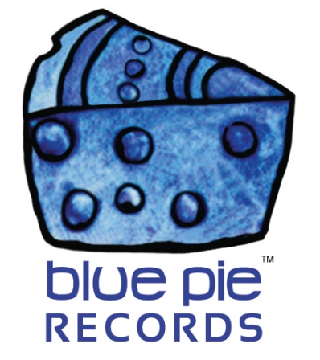

Rock To The Top! Paul Le Rocq nominated for two Choice Award categories!

PRESS RELEASE EFFECTIVE IMMEDIATELY 24 May 2019:

Best newcomer, or best Rock music? Tough choice, both are quite honourable awards for Paul Le Rocq to receive should he win them. Should be be awarded for being at the top of his music category? Or should he be awarded for being the best newcomer, the latest spring chicken to take everybody by surprise and shake the game up with all the new things he brings to the table? That’s the tough choice his fans have to make for the South African Radical FM Choice Awards this November. And we’ll have links to help you make it too! But before that, let’s give you a taste of the awesome rock that Paul is all about.

PAUL LEROCQ- ROCK TO THE TOP: https://www.youtube.com/watch?v=w3BdTss7ssk

Catchy, right? Takes you back a bit to some of the old days. You’ll be glad to know that his work doesn’t end there either. While Rock To The Top may be a fantastic smash hit that everyone loves, the rest of his work is equally high quality and all available on his Spotify for your listening pleasure! Here’s a taster- the album by the same name that that particular single came from.

ROCK TO THE TOP- THE ALBUM:
https://open.spotify.com/album/7qj1q2jkHRyr4r1YaSZGiv?si=lBhd5Xg6SDWxBfnAUPKkQQ

Paul and his team were overjoyed upon seeing the nominations, as were we! In our humble opinion, he definitely deserves to win at least one of them! Check out the links below to see the happy news!
https://www.bluepierecords.com/wp-content/uploads/2019/05/20190516_163543.jpg
https://www.bluepierecords.com/wp-content/uploads/2019/05/Radical-FM-Music-Awards-South-Africa.-Nomination.jpg
https://www.bluepierecords.com/wp-content/uploads/2019/05/20190516_182039.jpg

So now you’re well acquainted with his talented prowess, what now? How can ordinary folks like you and I help a rockstar out? We can vote.
Radical FM – Nomination voting link – limited to one vote per voter! Deadline: November 30 th. 2019:
http://www.easypolls.net/poll.html?p=5cd3f1bce4b0d3b476bdf1a9&fbclid=IwAR1YMXq0ewUkuwo6hx6fnRQgGMwYNkp3Y_jY5VcPViQpcqdT0B5ETBYmpmE
Throw your hat in the ring and vote which nomination you think suits this great artist best. And if you’re feeling particularly diplomatic, there’s some more polls you can contribute to if you so desire! This year Paul continues to run in the South African Top 30 and in Spain’s Top 10 from Radio San José. In case you wish to support any of his campaigns, you can vote once a week in the links below for the track we shared above… that’s right, “Rock to the top” is in the running for stardom too! So be sure to support it weekly if you really really love it!
South Africa – Position 3. 16 Months. Week 18 – vote once a week:
http://www.easypolls.net/poll.html?p=5cdd8fede4b0d3b476be1461&fbclid=IwAR101vTtgg-qDxkK4CPr9UyRkOPIYyJWebwV_oQNX51PFlSKqRHFdWPD67o
Spain: Number 1 this week. 9th Month – vote once a day:
https://votaciones.miarroba.com/poll/2aZp/

We already shared Paul’s YouTube link above, but here’s a direct link to his channel in case you’re burning for more. https://www.youtube.com/channel/UCJmuH1XIBe6pVwegE1E6YYw

And if you wanted even more than that and crave getting as involved with this rockstar as possible, you’re in luck- click here for his Facebook!
https://www.facebook.com/Paul-Le-Rocq-107846572650224/

Paul Le Rocq is one fantastic and talented artist, and there’s no doubting that. So let’s show him some love and send him skyrocketing through these polls, and send his view and play counts skyrocketing as well! Rock on!

============================================
ABOUT BLUE PIE THE RECORD LABEL:

Blue Pie Records are one of the world’s leading independent record Labels and publishing houses. Blue Pie's priority artists include Josh Young, Toyanna Rae, Missy Crissy, Raz B, Down3r, LadyDice, The East Side Boyz, Jah Mason, Burning the Day, Jack Derwin, Terry Oldfield, Phil Manzanera, Johnny Bennett, Suzanna Lubrano, The Objex, Gordon Waller, Dave Evans, Dale Bozzio, and Jessy Tomsko to name a few.

Blue Pie distributes over 300 small to medium sized labels including e ConcertHouse Music, TRAX Records, Destiny Records, Apple Media Africa, Nedjon Entertainment, Idyllium Muisc, Sugo Music, Deluxe Records, Reality Entertainment, and Raz Beatz Media Group to name a few.

Our live concert and video clip library continues to expand and includes live albums, video clips, and video concerts from artists including, Chicago, The Cars, Steve Aoki and Dave Evans to name a few.

In 2019, Blue Pie's roster of artists continues to gain worldwide recognition with chart success in the USA, Canada, Europe and Australia. Blue Pie is continually developing new markets for our artists, labels, content partners to connect and reach new consumers and fans for their music.

For more information, visit the official Blue Pie Records USA website: www.bluepierecords.com

Press and Media Contact:

Press and Media Manager
Blue Pie Records USA
Clarence House
Unit 6 No 9 Clarence Street
Moss Vale NSW 2015
AUSTRALIA
P: + 61 2 9310 0155
F: + 61 2 9310 0166
E: pr@bluepie.com.au
W: www.bluepierecords.com

============================================

