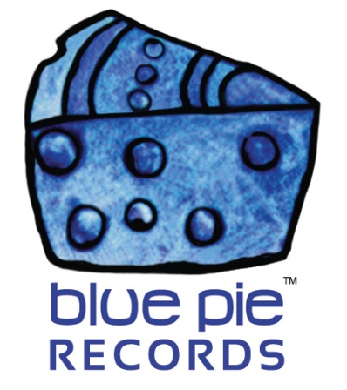

Standaard redefining the industry standard!

PRESS RELEASE EFFECTIVE IMMEDIATELY 24 May 2019:

STANDAARD have joined the DJ Central roster and we’re suitably excited about this awesome cooperation! They have some of the funkiest tracks since the days of Black Box, SNAP, or Incognito! We’re sure they’ll fit in with some of our other artists in similar veins, like the fresh sound heard in ‘Falling’ by Funky P. STANDAARD’s unique sound can be heard immediately when one samples even a few seconds of their work, so let’s do just that!
WITHOUT YOU BY MY SIDE: https://open.spotify.com/album/3Dvwgs3i2O96DBYPW5Mk0i
Inspired by artists such as Parcels, Jamiroquai, and Daft Punk, STANDAARD is a musical duo that has a deep appreciation of the modern world’s answer to funky beats, as you can hear just from that sample!
Need more? Here’s STANDAARD’s spotify!
https://open.spotify.com/artist/3Q3mz98JfV25HU5441uSDN?si=R95A39eVQKyFCKXEyiJSmg
What about their social media? Got you covered, here’s their Facebook!
https://www.facebook.com/STANDAARDmusic/
And fret not, more is on the way- the up and coming STANDAARD album, simply titled STANDAARD should be populating Spotify, iTunes and all other major stores and sources within the next few days, so keep your eyes on their Spotify for that, and your ears out for that distinct vibe that makes you think of colourful and funky sunset parties by the beach or the poolside. But what can we expect in this upcoming album! Only the best, my friends, only the best. Not only are we going to be treated once again to Without You By My Side like in the Spotify preview above, but a whole host of European dance delights! Check the list here!
- De Zomer Is Van Ons (Club Mix)
- De Zomer Is Van Ons (Party Remix)
- Der Sommer Ist Bei Uns
- Één Op Oneindig
- Geloof In Mij
- Last Try Before Goodbye
- Niets Blijkt Echt Te Zijn (Radio Edit)
- One In A Million
- Twijfel Niet
- Without You By My Side
- Zonder Jou Aan Mijn Zij
Definitely an album to be hype for if you’re interested in any sort of European anthems that you can really dance to, or chill out with a cold drink to!
We’re incredibly excited to have a duo of as many talents as STANDAARD joining our team, and we can’t help but feel we’ll go to whole new levels of sonic bliss once we make the most of it!

============================================
ABOUT BLUE PIE THE RECORD LABEL:

Blue Pie Records are one of the world’s leading independent record Labels and publishing houses. Blue Pie's priority artists include Josh Young, Toyanna Rae, Missy Crissy, Raz B, Down3r, LadyDice, The East Side Boyz, Jah Mason, Burning the Day, Jack Derwin, Terry Oldfield, Phil Manzanera, Johnny Bennett, Suzanna Lubrano, The Objex, Gordon Waller, Dave Evans, Dale Bozzio, and Jessy Tomsko to name a few.

Blue Pie distributes over 300 small to medium sized labels including e ConcertHouse Music, TRAX Records, Destiny Records, Apple Media Africa, Nedjon Entertainment, Idyllium Muisc, Sugo Music, Deluxe Records, Reality Entertainment, and Raz Beatz Media Group to name a few.

Our live concert and video clip library continues to expand and includes live albums, video clips, and video concerts from artists including, Chicago, The Cars, Steve Aoki and Dave Evans to name a few.

In 2019, Blue Pie's roster of artists continues to gain worldwide recognition with chart success in the USA, Canada, Europe and Australia. Blue Pie is continually developing new markets for our artists, labels, content partners to connect and reach new consumers and fans for their music.

For more information, visit the official Blue Pie Records USA website: www.bluepierecords.com

Press and Media Contact:

Press and Media Manager
Blue Pie Records USA
Clarence House
Unit 6 No 9 Clarence Street
Moss Vale NSW 2015
AUSTRALIA
P: + 61 2 9310 0155
F: + 61 2 9310 0166
E: pr@bluepie.com.au
W: www.bluepierecords.com

============================================

