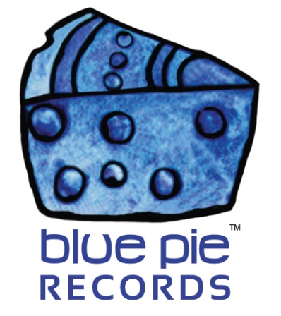

Save the date! The 3rd Annual Henry Turner Jr Day approaches!

PRESS RELEASE EFFECTIVE IMMEDIATELY 24 May 2019:

It may only be a few months away in the grand scheme of things but it’ll be tough for us to wait until October at the end of the year for the Henry Turner Jr Day festival. This is how the event organisers describe it!
“Over the years, Henry Turner has earned quite a reputation not only as the spark behind his band, Flavor but also as the producer of the Baton Rouge Mardi Gras Festival & the Baton Rouge Soul Food Festival. He first gained national recognition during his years as a regular on the Annual Bob Marley Tour and later as the founder of Baton Rouge’s Mardi Gras Festival.
For the last 2 years, the City of Baton Rouge has honored Henry with his own day. As a bandleader, singer/songwriter, promoter and musical entrepreneur Henry Turner Jr. is well known for
mentoring musical talent. The event is FREE to the public.
For additional information, please visit the web site: www.htjday.com.
This year the Festival is joining with Rocktoberfest.
Henry Turner Jr. Day was established to salute individuals, organizations and companies, in the greater Baton Rouge area, for their ongoing philanthropic efforts to improve the quality of life for people in the community. As a direct result of this honor, Henry Turner Jr. Day will now, in turn, pay homage to others in the city whose continuing efforts make Baton Rouge a better place for everyone.”
It’s certainly a wholesome state of affairs, but the third annual festival is still very much in the preparation stages, and they’re looking for vendors to help get it all up and running. So consider this more of an excitement from the folks at Blue Pie for Henry Turner Jr‘s sake rather than a tourist brochure about the event, as much of it is still being thought up! But we considered it worthy to talk about it at this early stage as a means of forecasting a fantastic event this year. And for an event to be dedicated to Henry Turner Jr, and for Henry Turner Jr to humbly and generously dedicate himself right back to the community is most certainly a heartwarming occasion. Speaking of things that are good for the soul, Henry’s music itself is sure to find its way there, after all what would Henry Turner Jr day be without some Henry Turner Jr And Flavor music! Louisiana aesthetic, Mardis Gras mood, and blues funk all rolled into one collection of magical music that’s sure to enhance your musical life! Have a sample on us while we wait for more details about Henry Turner Jr day. And if you can’t wait, remember Henry’s listening room is ready and waiting for you!
LOUSIANA GUMBO COMBO: https://open.spotify.com/album/7E4fh7KK4OCFNUOHV6skv0?si=zQcF3RN-RHilIoJM2w6T7A

Artist Links:
Website – henryturnerjr.com/bio.htm
Facebook – facebook.com/HenryTurnerJrListeningRoom

============================================
ABOUT BLUE PIE THE RECORD LABEL:

Blue Pie Records are one of the world’s leading independent record Labels and publishing houses. Blue Pie's priority artists include Josh Young, Toyanna Rae, Missy Crissy, Raz B, Down3r, LadyDice, The East Side Boyz, Jah Mason, Burning the Day, Jack Derwin, Terry Oldfield, Phil Manzanera, Johnny Bennett, Suzanna Lubrano, The Objex, Gordon Waller, Dave Evans, Dale Bozzio, and Jessy Tomsko to name a few.

Blue Pie distributes over 300 small to medium sized labels including e ConcertHouse Music, TRAX Records, Destiny Records, Apple Media Africa, Nedjon Entertainment, Idyllium Muisc, Sugo Music, Deluxe Records, Reality Entertainment, and Raz Beatz Media Group to name a few.

Our live concert and video clip library continues to expand and includes live albums, video clips, and video concerts from artists including, Chicago, The Cars, Steve Aoki and Dave Evans to name a few.

In 2018, Blue Pie's roster of artists continues to gain worldwide recognition with chart success in the USA, Canada, Europe and Australia. Blue Pie is continually developing new markets for our artists, labels, content partners to connect and reach new consumers and fans for their music.

For more information, visit the official Blue Pie Records USA website: www.bluepierecords.com

Press and Media Contact:

Press and Media Manager
Blue Pie Records USA
Clarence House
Unit 6 No 9 Clarence Street
Moss Vale NSW 2015
AUSTRALIA
P: + 61 2 9310 0155
F: + 61 2 9310 0166
E: pr@bluepie.com.au
W: www.bluepierecords.com

============================================

