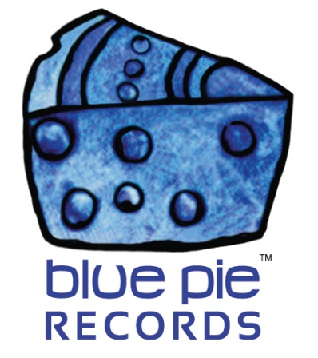

Success after success! Suga Boom Boom passes 9 MILLION PLAYS!

PRESS RELEASE EFFECTIVE IMMEDIATELY 24 May 2019:

Recently, we reported that Down3r’s music was at the top of the Swedish charts and just shy of 9 million plays on Spotify…
READ MORE ABOUT THE SWEDISH CHARTS: http://www.djcentral.tv/hej-hej-to-the-top-dl-down3r-is-number-one-in-sweden/
But it’s finally happened now. That threshold has been crossed and we made it! Just like we said, it was just a matter of time really, and it turns out we were right- it’s not exactly a surprise that the number one song for the Swedish spotify charts is this popular, but it’s welcome nonetheless!
And of course, it’s also not a surprise that Down3r’s most popular song is making waves like this, given that one of his lesser known songs made it into a movie soundtrack along with some bangin’ Miracle West Entertainment beats, but like we said, it’s absolutely welcome!

READ MORE ABOUT THE MOVIE PLACEMENT: https://www.bluepierecords.com/news/invinceable-and-dl-down3rs-tracks-get-movie-placement/

The honour that is an artist’s music making it this far and going this insanely viral on Spotify is something unparalleled- a sign that Down3r truly produces verifiable quality, and that he struck gold on the day when he made the acapella version by knocking a beat on his fridge!
JAMES WILLIAMS FREESTYLE: https://www.youtube.com/watch?v=Gc0XkZ38qFE

That’s a classic throwback for many of you Down3r fans, we’re sure. And it is for us as well! The moment that an artist discovers their successful formula is an occasion that is worth preserving for all eternity, as is the evolution of that formula over time- with that being said, let’s drop by far the most viral Suga Boom Boom video out there and celebrate its existence and what it means in hip hop history! And would you believe this video is still not as viral on youtube as the Spotify song is?! Completely incredible.
SUGA BOOM BOOM LIVE AT THE GYPSY TATTOO PARLOUR- A TRULY VIRAL DOWN3R VIDEO: https://www.youtube.com/watch?v=Sr5_BEqGNuI

But let’s cut to the chase and get to what you’ve all been waiting for. The song that’s making waves in Sweden and on Spotify in general… The main Suga Boom Boom that you all know and love!
https://open.spotify.com/album/41qc6xKH6w0hENmUTC9lSa
Just what you wanted right? It’d be what any fan wants, it truly is Down3r’s best song. One of the catchiest ever made, and these numbers and successes prove it. Suga Boom Boom may be about chasing dragons, but chasing success is definitely something it’s truly skilled at!
Check out DL Down3r at the following official links:
- www.down3r.com
- www.facebook.com/DLDown3r
- www.facebook.com/bluepierecordsusa
- www.jango.com/music/Down3r
And check out DL’s cover of River below!
https://www.youtube.com/watch?v=8Dtl_eyePqk

============================================
ABOUT BLUE PIE THE RECORD LABEL:

Blue Pie Records are one of the world’s leading independent record Labels and publishing houses. Blue Pie's priority artists include Josh Young, Toyanna Rae, Missy Crissy, Raz B, Down3r, LadyDice, The East Side Boyz, Jah Mason, Burning the Day, Jack Derwin, Terry Oldfield, Phil Manzanera, Johnny Bennett, Suzanna Lubrano, The Objex, Gordon Waller, Dave Evans, Dale Bozzio, and Jessy Tomsko to name a few.

Blue Pie distributes over 300 small to medium sized labels including e ConcertHouse Music, TRAX Records, Destiny Records, Apple Media Africa, Nedjon Entertainment, Idyllium Muisc, Sugo Music, Deluxe Records, Reality Entertainment, and Raz Beatz Media Group to name a few.

Our live concert and video clip library continues to expand and includes live albums, video clips, and video concerts from artists including, Chicago, The Cars, Steve Aoki and Dave Evans to name a few.

In 2019, Blue Pie's roster of artists continues to gain worldwide recognition with chart success in the USA, Canada, Europe and Australia. Blue Pie is continually developing new markets for our artists, labels, content partners to connect and reach new consumers and fans for their music.

For more information, visit the official Blue Pie Records USA website: www.bluepierecords.com

Press and Media Contact:

Press and Media Manager
Blue Pie Records USA
Clarence House
Unit 6 No 9 Clarence Street
Moss Vale NSW 2015
AUSTRALIA
P: + 61 2 9310 0155
F: + 61 2 9310 0166
E: pr@bluepie.com.au
W: www.bluepierecords.com

============================================

