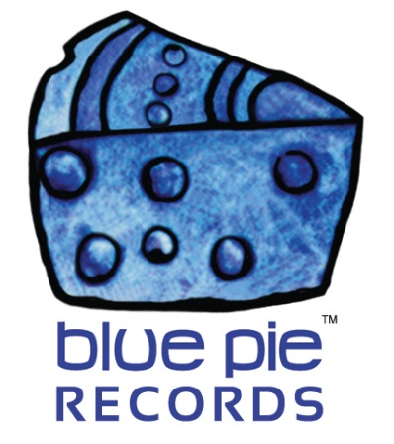

The Naked Truth makes it to the TOP TEN of ReverbNation!

PRESS RELEASE EFFECTIVE IMMEDIATELY 24 May 2019:

https://www.reverbnation.com/nakedtruth1991
See that profile link?
That profile link belongs to a band that recently made it to the top 10 on the ReverbNation charts! The email heralding this news is what The Naked Truth woke up to on Wednesday, and we at Blue Pie couldn’t be happier to deliver this awesome news to all you metalheads out there. Those who don’t know The Naked Truth will now have a means to be introduced to one of the best metal punk bands on the planet. Those who do know The Naked Truth can be satisfied that the quality of their work is cemented with this accomplishment. This is a big day in metal history as far as The Naked Truth is concerned, so let’s celebrate by checking out some of the best hits of their music! But before that… check this out. You could consider it a trophy, a symbol of how much the band’s fans love them! And The Naked Truth is most grateful for that fact! So check out this link to see the email!
https://www.bluepierecords.com/wp-content/uploads/2019/05/top-10.jpg
That’s truly an excellent email to receive. The Naked Truth may be green with rage but we’re pretty sure they’ll be pretty happy to get this news. Time to “message the fans” in a different way- with this celebratory article!
NAKED TRUTH- BLACK: https://www.youtube.com/watch?v=K8EYaDU1wWk
This is a classic that we can’t help but draw attention to a second time. Like we said last time, it’s moody, powerful, angry stuff, which is just the perfect sort of blend for the subject matter and music style- this isn’t the typical fun metal of hating the world and expressing raw anger and little else… this has a social context behind it, which you can read about here!
https://www.bluepierecords.com/news/the-naked-truth-are-still-going-strong/

There’s even more info on their website.
http://www.thenakedtruthband.com/

Let’s continue this nostalgia trip with one of their best and most popular songs, Read Between The Lines!

NAKED TRUTH- READ BETWEEN THE LINES: https://www.youtube.com/watch?v=BNh02th1qxc

Music videos only go so far with appreciating excellent music though. Any serious music lover has to have their music in a playlist to listen to on the go… like, say, a Spotify, and a playlist of the best they have to offer! This band is absolutely iconic, and this playlist is the perfect way to bring that to the modern music world once more!
https://open.spotify.com/artist/6EJwU4HedBaYjkgCYxTOc2?si=7st6r3yORzW1fdJl1gY4KA
You can also check out their Spotify artist profile!
https://open.spotify.com/artist/6EJwU4HedBaYjkgCYxTOc2?si=7st6r3yORzW1fdJl1gY4KA

Chillingly good songs that you can easily bang your head to. Beyond that, check out their social media and official links below, and bring back the good old angry days of 90s metal! Or drop them an email if you want their excellent presence for any gigs you’re planning. Until then… this is an auspicious day in metal history and it’s time we all took a moment to soak it in. So play your music loud, bang your head until your neck aches, and get lost in the punk thrashing of this excellent group of talented performers!
Click these links for more on The Naked Truth!
- www.thenakedtruthband.com
- www.twitter.com/TheNTBand
- www.myspace.com/thentband
- www.reverbnation.com/nakedtruth1991
- The Naked Truth Facebook- https://www.facebook.com/The-Naked-Truth-Band-279003202253236/
- The Naked Truth email- greenwithrage1991@hotmail.com
============================================
ABOUT BLUE PIE THE RECORD LABEL:

Blue Pie Records are one of the world’s leading independent record Labels and publishing houses. Blue Pie's priority artists include Josh Young, Toyanna Rae, Missy Crissy, Raz B, Down3r, LadyDice, The East Side Boyz, Jah Mason, Burning the Day, Jack Derwin, Terry Oldfield, Phil Manzanera, Johnny Bennett, Suzanna Lubrano, The Objex, Gordon Waller, Dave Evans, Dale Bozzio, and Jessy Tomsko to name a few.

Blue Pie distributes over 300 small to medium sized labels including e ConcertHouse Music, TRAX Records, Destiny Records, Apple Media Africa, Nedjon Entertainment, Idyllium Muisc, Sugo Music, Deluxe Records, Reality Entertainment, and Raz Beatz Media Group to name a few.

Our live concert and video clip library continues to expand and includes live albums, video clips, and video concerts from artists including, Chicago, The Cars, Steve Aoki and Dave Evans to name a few.

In 2019, Blue Pie's roster of artists continues to gain worldwide recognition with chart success in the USA, Canada, Europe and Australia. Blue Pie is continually developing new markets for our artists, labels, content partners to connect and reach new consumers and fans for their music.

For more information, visit the official Blue Pie Records USA website: www.bluepierecords.com

Press and Media Contact:

Press and Media Manager
Blue Pie Records USA
Clarence House
Unit 6 No 9 Clarence Street
Moss Vale NSW 2015
AUSTRALIA
P: + 61 2 9310 0155
F: + 61 2 9310 0166
E: pr@bluepie.com.au
W: www.bluepierecords.com

============================================

