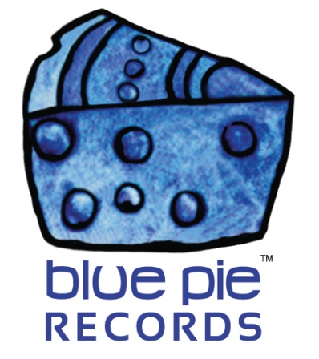

Zya Mou continues to surge in growth!

PRESS RELEASE EFFECTIVE IMMEDIATELY 24 May 2019:

Zya Mou has increased her listener fanbase on the Radio Airplay and Jango networks to over 24,000 new fans! And it’s little wonder that this has happened, considering Zya’s past with her history of creating techno bangers!
https://www.bluepierecords.com/news/zya-mou-moves-in-a-new-direction-with-new-hit-single-shake-the-ground/

https://www.bluepierecords.com/news/zya-mou-creates-and-earthquake-with-her-awesome-new-track-shake-the-ground/

CLICK HERE TO SEE THE GROWTH IN LISTENERS: https://www.bluepierecords.com/wp-content/uploads/2019/03/large.jpg

The results are clear from people gradually discovering Zya through her growing social media presence and also from recalling her amazing past work- it’s crazy to think we’re working with someone who opened the Chinese Olympics! Zya doesn’t show any signs of slowing down, and it’s a good thing too- a repertoire like this deserves to be noticed in the spotlight!
ZYA’S FACEBOOK IS GROWING DAILY!: https://www.facebook.com/ZyaMouChina/
WATCH ZYA AT THE CHINESE OLYMPICS!:
https://www.youtube.com/watch?v=4pe_Ya0-3OM

If you wanna check out Zya’s music for yourself, we have a bonus EP of one of her latest works here, Shake The Ground! Get ready to dance, because once this one comes on you won’t be able to resist.

SHAKE THE GROUND BONUS EP: https://open.spotify.com/album/5UUkWHpPsZlNRvUPM1US9f?si=YHjlwNLTSl2Up7GG-9fCDQ
Or, if you’re extra interested and wanted to peruse a Spotify playlist of ALL her work, we also got you covered! Check it out:
https://open.spotify.com/playlist/2totzEYmdh2xQOXZn1olWF

============================================
ABOUT BLUE PIE THE RECORD LABEL:

Blue Pie Records are one of the world’s leading independent record Labels and publishing houses. Blue Pie's priority artists include Josh Young, Toyanna Rae, Missy Crissy, Raz B, Down3r, LadyDice, The East Side Boyz, Jah Mason, Burning the Day, Jack Derwin, Terry Oldfield, Phil Manzanera, Johnny Bennett, Suzanna Lubrano, The Objex, Gordon Waller, Dave Evans, Dale Bozzio, and Jessy Tomsko to name a few.

Blue Pie distributes over 300 small to medium sized labels including e ConcertHouse Music, TRAX Records, Destiny Records, Apple Media Africa, Nedjon Entertainment, Idyllium Muisc, Sugo Music, Deluxe Records, Reality Entertainment, and Raz Beatz Media Group to name a few.

Our live concert and video clip library continues to expand and includes live albums, video clips, and video concerts from artists including, Chicago, The Cars, Steve Aoki and Dave Evans to name a few.

In 2019, Blue Pie's roster of artists continues to gain worldwide recognition with chart success in the USA, Canada, Europe and Australia. Blue Pie is continually developing new markets for our artists, labels, content partners to connect and reach new consumers and fans for their music.

For more information, visit the official Blue Pie Records USA website: www.bluepierecords.com

Press and Media Contact:

Press and Media Manager
Blue Pie Records USA
Clarence House
Unit 6 No 9 Clarence Street
Moss Vale NSW 2015
AUSTRALIA
P: + 61 2 9310 0155
F: + 61 2 9310 0166
E: pr@bluepie.com.au
W: www.bluepierecords.com

============================================

