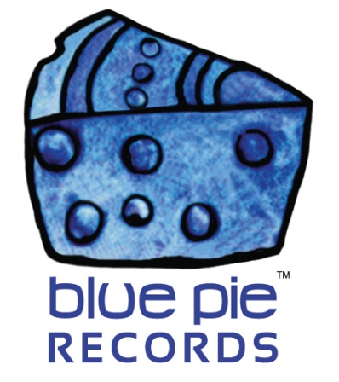

Fans rediscover Barry Crocker all over again and again and again!

PRESS RELEASE EFFECTIVE IMMEDIATELY 24 May 2019:

Barry Crocker will need no introduction to those among us who are well-versed in Australian entertainers. His name evokes a mile-long list of credentials and achievements throughout the years which you can read about here: www.bluepierecords.com/artist/barry-crocker-2 Throughout the past 15 years he has been an essential help to us at the Blue Pie studios. He has been a wonderful supporter to us, and has worked on various projects and causes such as The Argues, Dealing With Destiny, various remix projects, and a colossal amount of charity work. He is always willing to help those in need, and incredible Australian icon.
We’re so glad to have him on the label, but we are even more overjoyed to know that his work is gaining traction with a new audience, perhaps old fans rediscovering him, or newer ones encountering him in this digital age for the first time!
Yes, that’s right, the golden age is the digital age ladies and gentlemen- the age of music streaming has introduced and reintroduced plenty of Barry Crocker fans via services such as Spotify! Skyrocketing to the top of the public’s attention is “Come On The Cats”, a fantastic throwback to Crocker’s tributes in the name of the famous Geelong Football Club.
Plenty of Victorians will be playing these anthems with pride! There are two Cats mixes available and both are ready to experience on Spotify, and available for your scrutiny and preference. Which do you like better?
COME ON THE CATS – THE UNOFFICIAL ANTHEM: https://open.spotify.com/album/5SxkmsskhDWiyqj4jl3zlG
COMPOSITE BARRY CROCKER PLAYLIST: https://open.spotify.com/artist/0esD7V3K0DRse43S4l0bP0

These releases in particular showcase a golden age in Barry’s career, and it doesn’t stop there. Everything from his famous Neighbours theme to a remastering of With A Song In My Heart, there’s plenty for the diehard fan to browse, all of which establishes the scale of Barry Crocker’s impressive influence on Australian entertainment!
We’ve constructed a comprehensive playlist full of the best hits on Spotify that we could find, so have at it, fans new and old! Discover away!
His website is also being revamped, so stay tuned for that- it’s always a fantastic journey reading about Barry’s history and exploits throughout the years! If you can’t wait, his bio says it all. Keep shining on, Bazza! You’ve made your mark and we’re glad to have been on this journey with you! Here’s to new discoveries, old friends, and new audiences the world over!
Check out the official links below for more information on Barry:
www.barrycrocker.net
www.youtube.com/user/bazzaonetube
www.imdb.com/name/nm0188347
www.facebook.com/barry.h.crocker
https://en.wikipedia.org/wiki/Barry_Crocker

We hope you like these clips on YouTube:
ONE EYED TROUSER SNAKE – BARRY CROCKER: https://www.youtube.com/watch?v=49MOcTv3Wgs
BARRY CROCKER ON GMA WITH BERT NEWTON – LOGIES DAY 1993: https://www.youtube.com/watch?v=g0Abd72TpaU

============================================
ABOUT BLUE PIE THE RECORD LABEL:

Blue Pie Records are one of the world’s leading independent record Labels and publishing houses. Blue Pie's priority artists include Josh Young, Toyanna Rae, Missy Crissy, Raz B, Down3r, LadyDice, The East Side Boyz, Jah Mason, Burning the Day, Jack Derwin, Terry Oldfield, Phil Manzanera, Johnny Bennett, Suzanna Lubrano, The Objex, Gordon Waller, Dave Evans, Dale Bozzio, and Jessy Tomsko to name a few.

Blue Pie distributes over 300 small to medium sized labels including e ConcertHouse Music, TRAX Records, Destiny Records, Apple Media Africa, Nedjon Entertainment, Idyllium Muisc, Sugo Music, Deluxe Records, Reality Entertainment, and Raz Beatz Media Group to name a few.

Our live concert and video clip library continues to expand and includes live albums, video clips, and video concerts from artists including, Chicago, The Cars, Steve Aoki and Dave Evans to name a few.

In 2019, Blue Pie's roster of artists continues to gain worldwide recognition with chart success in the USA, Canada, Europe and Australia. Blue Pie is continually developing new markets for our artists, labels, content partners to connect and reach new consumers and fans for their music.

For more information, visit the official Blue Pie Records USA website: www.bluepierecords.com

Press and Media Contact:

Press and Media Manager
Blue Pie Records USA
Clarence House
Unit 6 No 9 Clarence Street
Moss Vale NSW 2015
AUSTRALIA
P: + 61 2 9310 0155
F: + 61 2 9310 0166
E: pr@bluepie.com.au
W: www.bluepierecords.com

============================================

