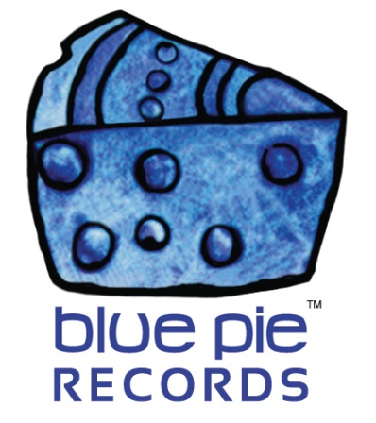

Metal Central TV is now LIVE on Vimeo On-Demand!

PRESS RELEASE EFFECTIVE IMMEDIATELY 24 May 2019:

Metal Central TV features the best international and Australian metal and rock acts from around the globe. We have documentaries, crazy tour videos, live concerts from the global independent music scene and of course some of the finest metal, heavy metal, classic rock, hard core and rock music from your favourite rock and metal acts… all in the comfort of your home! Streaming sure has made the music life nice, right? You’ll wanna watch this series again and again, so sit back and rock out here with Metal Central TV!
You want Vimeo On-Demand? Right here chief, all the metal central on vimeo you can handle: https://vimeo.com/ondemand/metalcentraltv
But what about elsewhere? We got you. It’s also available on Amazon Prime! Click this article right here to get started with that! https://www.bluepierecords.com/news/get-ready-to-rock-with-metal-central-tv-on-amazon-prime/

Can’t get enough?!
For the latest news on Metal Central TV please visit metalcentraltv.com
If you would like to license Metal Central TV for your TV or Cable Network then please email support@bluepie.com.au

============================================
ABOUT BLUE PIE THE RECORD LABEL:

Blue Pie Records are one of the world’s leading independent record Labels and publishing houses. Blue Pie's priority artists include Josh Young, Toyanna Rae, Missy Crissy, Raz B, Down3r, LadyDice, The East Side Boyz, Jah Mason, Burning the Day, Jack Derwin, Terry Oldfield, Phil Manzanera, Johnny Bennett, Suzanna Lubrano, The Objex, Gordon Waller, Dave Evans, Dale Bozzio, and Jessy Tomsko to name a few.

Blue Pie distributes over 300 small to medium sized labels including e ConcertHouse Music, TRAX Records, Destiny Records, Apple Media Africa, Nedjon Entertainment, Idyllium Muisc, Sugo Music, Deluxe Records, Reality Entertainment, and Raz Beatz Media Group to name a few.

Our live concert and video clip library continues to expand and includes live albums, video clips, and video concerts from artists including, Chicago, The Cars, Steve Aoki and Dave Evans to name a few.

In 2019, Blue Pie's roster of artists continues to gain worldwide recognition with chart success in the USA, Canada, Europe and Australia. Blue Pie is continually developing new markets for our artists, labels, content partners to connect and reach new consumers and fans for their music.

For more information, visit the official Blue Pie Records USA website: www.bluepierecords.com

Press and Media Contact:

Press and Media Manager
Blue Pie Records USA
Clarence House
Unit 6 No 9 Clarence Street
Moss Vale NSW 2015
AUSTRALIA
P: + 61 2 9310 0155
F: + 61 2 9310 0166
E: pr@bluepie.com.au
W: www.bluepierecords.com

============================================

