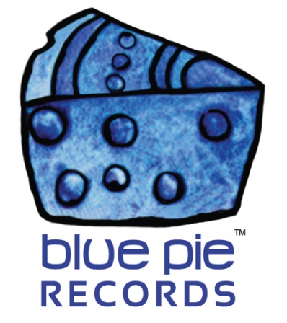

sixeightw0lf donates royalties to Autism Australia!

PRESS RELEASE EFFECTIVE IMMEDIATELY 24 May 2019:

sixeightw0lf, one of our newer sign-ons at DJ Central and Blue Pie Records, has selflessly donated his royalties to Autism Australia. This selfless act has pleasantly surprised us all, to the point that we have also contributed to his donation, topping the total amount off at $115.

CLICK HERE TO SEE THE DONATION: https://www.bluepierecords.com/wp-content/uploads/2019/03/autism-australia.jpg

As Aspect themselves say, “Autism Spectrum Australia (Aspect) is an Australian not-for-profit provider of services and supports working with people on the autism spectrum and their families. From diagnosis and assessments, early intervention and therapies, to specialised schooling, social groups and employment mentoring; Aspect provides advice and support for the whole family throughout the life stages, from the early years to adulthood.” That quote was sourced from their website, which you can check out for yourself by clicking here. https://www.autismspectrum.org.au/content/how-we-help-0
Damien of Blue Pie and sixeightw0lf are proud to have donated to such a noble cause, and all the Blue Pie and DJC staff would like to extend their thanks and applause to sixeightw0lf for thinking of it first. The man can produce some bangers that amass thousands of plays on Soundcloud and Spotify, but it’s good to know he can produce compassion of this level as well.
If you’d like to know more about sixeightw0lf check out his Soundcloud or have a listen to his latest Spotify hit below, Siege!
SOUNDCLOUD: https://soundcloud.com/sixeightw0lf
SIEGE: https://open.spotify.com/album/57xrjvJN0Bse932gB1HmPI

============================================
ABOUT BLUE PIE THE RECORD LABEL:

Blue Pie Records are one of the world’s leading independent record Labels and publishing houses. Blue Pie's priority artists include Josh Young, Toyanna Rae, Missy Crissy, Raz B, Down3r, LadyDice, The East Side Boyz, Jah Mason, Burning the Day, Jack Derwin, Terry Oldfield, Phil Manzanera, Johnny Bennett, Suzanna Lubrano, The Objex, Gordon Waller, Dave Evans, Dale Bozzio, and Jessy Tomsko to name a few.

Blue Pie distributes over 300 small to medium sized labels including e ConcertHouse Music, TRAX Records, Destiny Records, Apple Media Africa, Nedjon Entertainment, Idyllium Muisc, Sugo Music, Deluxe Records, Reality Entertainment, and Raz Beatz Media Group to name a few.

Our live concert and video clip library continues to expand and includes live albums, video clips, and video concerts from artists including, Chicago, The Cars, Steve Aoki and Dave Evans to name a few.

In 2019, Blue Pie's roster of artists continues to gain worldwide recognition with chart success in the USA, Canada, Europe and Australia. Blue Pie is continually developing new markets for our artists, labels, content partners to connect and reach new consumers and fans for their music.

For more information, visit the official Blue Pie Records USA website: www.bluepierecords.com

Press and Media Contact:

Press and Media Manager
Blue Pie Records USA
Clarence House
Unit 6 No 9 Clarence Street
Moss Vale NSW 2015
AUSTRALIA
P: + 61 2 9310 0155
F: + 61 2 9310 0166
E: pr@bluepie.com.au
W: www.bluepierecords.com

============================================

