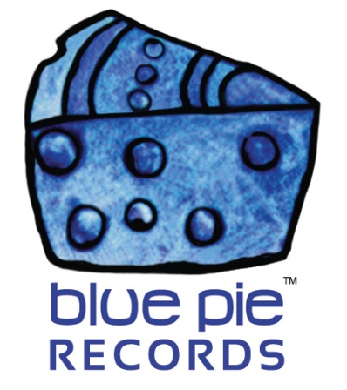

The Doctor Is In- MC Breed making waves with "The Fharmacist"!

PRESS RELEASE EFFECTIVE IMMEDIATELY 24 May 2019:

MC Breed is throwing down on Spotify and hundreds of thousands of people are tuning in to listen!
THE FHARMACIST: https://open.spotify.com/album/2PtHikYpWrD1YOwBRQXYad
Listen to this hard hitting flow. MC Breed ain’t afraid to pull punches and it’s clear that this is true here too. The album dropped just two years ago and it’s already grabbing massive clout on Spotify! Check out those numbers!
MC Breed’s been making huge waves with his number one track, “Gotta Get Mine”. It’s already up to over 4 million plays!
GOTTA GET MINE: https://open.spotify.com/album/63fBdGVcKoOOcI1eLOoDwT

We’re sure with this level of quality, all the tracks on “The Fharmacist” will follow suit eventually. The number one track currently on the 14 track album is “Lets Go To The Club” with over 100 thousand plays! Only time will tell, but with how fresh MC Breed’s flow is, and how competent Christopher Light Records is, we’re pretty confident that it won’t be long!
Check out MC Breed’s Spotify by clicking here! https://open.spotify.com/artist/63727CmmJ8oWFh8eAHvDYq?si=_OLI57_JTLWQj0uGlAAKzw

============================================
ABOUT BLUE PIE THE RECORD LABEL:

Blue Pie Records are one of the world’s leading independent record Labels and publishing houses. Blue Pie's priority artists include Josh Young, Toyanna Rae, Missy Crissy, Raz B, Down3r, LadyDice, The East Side Boyz, Jah Mason, Burning the Day, Jack Derwin, Terry Oldfield, Phil Manzanera, Johnny Bennett, Suzanna Lubrano, The Objex, Gordon Waller, Dave Evans, Dale Bozzio, and Jessy Tomsko to name a few.

Blue Pie distributes over 300 small to medium sized labels including e ConcertHouse Music, TRAX Records, Destiny Records, Apple Media Africa, Nedjon Entertainment, Idyllium Muisc, Sugo Music, Deluxe Records, Reality Entertainment, and Raz Beatz Media Group to name a few.

Our live concert and video clip library continues to expand and includes live albums, video clips, and video concerts from artists including, Chicago, The Cars, Steve Aoki and Dave Evans to name a few.

In 2019, Blue Pie's roster of artists continues to gain worldwide recognition with chart success in the USA, Canada, Europe and Australia. Blue Pie is continually developing new markets for our artists, labels, content partners to connect and reach new consumers and fans for their music.

For more information, visit the official Blue Pie Records USA website: www.bluepierecords.com

Press and Media Contact:

Press and Media Manager
Blue Pie Records USA
Clarence House
Unit 6 No 9 Clarence Street
Moss Vale NSW 2015
AUSTRALIA
P: + 61 2 9310 0155
F: + 61 2 9310 0166
E: pr@bluepie.com.au
W: www.bluepierecords.com

============================================

