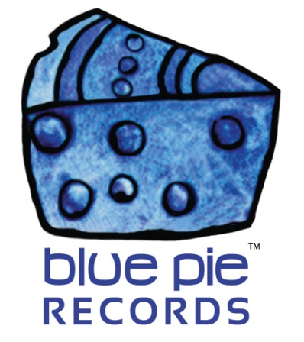

Atop the Steps is a Sam Pollard radio campaign that’ll make a World Of Difference!
…………………………………………

PRESS RELEASE EFFECTIVE IMMEDIATELY: 28th February 2020

We’ve frequently gushed about both Steps and World Of Difference by Sam Pollard recently, and who can blame us? They’re both excellent works by a truly passionate musical individual. For anyone not up to speed, why not take a Step towards an enriched musical future and find Sam Pollard’s work on your major online retailer of choice? They’re up there!
World Of Difference has been getting a radio campaign of its own for a while now. But today, we can happily report that the ingenious “Steps” is getting the same treatment, which they both deserve!
That means you can look forward to hearing it on radios worldwide! Can you imagine just doing your shopping or working out at the gym and then those catchy tracks come on? You’ll be doing your OWN track-by-track reviews before you know it, just like we did when we first heard it! You music bloggers out there – we’re watching you!
World Of Difference will also bring beauty to the airwaves, of course. These twin stingers will drive a musical pincer operation unlike anything we’ve seen before, and we can’t wait to be there as it unfolds! We’ve been in Sam’s corner for the longest time now, and it’s beautiful to see this develop as it has been, while reminiscing on the tributes we’ve made for him in the past.
He’s going further and further every year, and it’s going to be a stellar experience for Sam himself of course! It’s a beautiful thing to see an artist’s vision becoming recognised, and it’s our pleasure to be driving the campaign that takes Sam one step further towards this in the public eye. Sam Pollard is a DJ Central Records and Blue Pie Records USA artist. Sam is published by Blue Pie Publishing USA (ASCAP).
SOCIAL MEDIA LINKS
- Website | www.sampollard.com.au
- Triple J Unearthed | www.triplejunearthed.com/artist/sam-pollard
- Facebook | www.facebook.com/SamPollardMusic
- Twitter | www.twitter.com/sampollardmusic
- SoundCloud | www.soundcloud.com/sampollardofficial
- YouTube | www.youtube.com/user/Sampollardmusic
- MySpace | www.myspace.com/sampollardmusic
- Reverb Nation www.reverbnation.com/sampollard
PRODUCTION CREDITS
- Album Title: Steps
- Producers: David Nicholas | Damien Reilly
- Artist: Sam Pollard | www.sampollard.com.au
- Song Writer: Sam Pollard | All tracks
- Publisher: Blue Pie Publishing USA ( ASCAP )
- Record Label: Blue Pie Records USA
- Album Artwork: Concept by Sam Pollard | Artwork by Rochelle Morris + Damien Reilly.
- Supporting Engineer: Anna Laverty
- Recorded: 30th April to 30th June 2011.

ABOUT BLUE PIE THE RECORD LABEL:

Blue Pie Records are one of the world’s leading independent record labels and publishing houses. Blue Pie's priority artists include Josh Young, Tekno, Obesere, Toyanna Rae, Obesere, BlackFaceNaija, Missy Crissy, Raz B, DL Down3r, LadyDice, Sean Tizzle, The East Side Boyz, Kay L, Standaard, Jah Mason, Burning the Day, Jack Derwin, Terry Oldfield, Phil Manzanera, Johnny Bennett, Suzanna Lubrano, The Objex, Gordon Waller, Danny Saber, Dave Evans, Dale Bozzio, and Danny Vash to name a few.

Blue Pie distributes over 400 small to medium sized labels including ConcertHouse Music, Destiny Records, Premier Records, Tizzle Nation, Apple Media Africa, Nedjon Entertainment, Idyllium Muisc, Pride Music, Spaghetti Music, G.I Records, Powderworks Records, Deluxe Records, Reality Entertainment, and Raz Beatz Media Group to name a few.

For more information, visit the official Blue Pie Records USA website: www.bluepierecords.com

Press and Media Contact:

Press and Media Manager
Blue Pie Records USA
Clarence House
Unit 6 No 9 Clarence Street
Moss Vale NSW 2015
AUSTRALIA
P: + 61 2 9310 0155
F: + 61 2 9310 0166
E: pr@bluepie.com.au
W: www.bluepierecords.com

============================================

